

# Singapore Cloud Payroll Software

# [www.adaptivepay.com.sg](http://www.adaptivepay.com.sg)

+65 6708 9398



**INDEX**

**1. Employee.**

1.1. Info:

1.2. Work Details:

1.3. Earnings:

1.4. Leave:

1.5. Claim:

1.6. Expiry info:

1.7. Dependent:

1.8. Approvers:

1.9. Employee History:

1.10. Employee Training:

1.11. Skill set/Employment history:

1.12. Vaccination status:

1.13. Log:

**2. Master table.**

2.1. Locations:

2.2. Zone:

2.3. Approver Groups:

2.4. Department:

2.5. Employee Types:

2.6. Earnings Types:

2.7. Leave Types:

2.8. Leave planner:

2.9. Loan Types:

2.10. Public Holidays:

2.11. Work Shifts:

2.12. Claim Types:

2.13. OT Types:

2.14. Pass Expiry:

2.15. Training:

2.16. Biometric devices:

2.17. Banks:

2.18. Leave Template:

2.19. Dynamic Payslip:



**INDEX**

**3. Rosters.**

3.1. Current Roster

3.2. Employee week off

3.3. Monthly View

3.4. Monthly Comparison

**4. Recruitment.**

4.1. Resume template:

4.2. Job type

4.3. Job Postings:

4.4. Recruitment Process:

4.5. Resume Master:

4.6. Job Application:

5.e-Leave

6. e-Claim

7. e-Timesheet

8.e-appraisal

9.Approval

9.1. e-Claim Approval:

9.2. e-Leave Approval:

9.3. e-Timesheet Approval:

9.4. e-Appraisal Approval:

9.5. e-Timesheet OT Approval:

9.6. e-Loan Approval:

10.Application Settings

10.1. Country:

10.2. Picklist:

10.3. System Settings:

10.4. Auto numbers:

11.Transactions

11.1. Employee attendance:

11.1.1. Monthly attendance:

11.1.2. Daily attendance:

11.1.3. Daily clock In-Out:

11.2. Leave Management:

11.3. Leave Carry Forward:

11.4. Loan management:

11.5. Earnings and Deductions:

11.6. Claim management:

11.7. Pay Generation:

12. Admin

12.1. Users:

**Log in page**

* Open the browser and enter the link below.

[**Adaptive Biz App | Adaptive**](https://dev1.adaptivebizapp.com/PCM/Account/Login?ReturnUrl=%2fPCM%2fPayroll%2fHREmployee%2fDetails%3fidE%3da813A3IGqT%252Fy%252BLYCywMddfb0NwYZP3f%252B7wkeeTJXXhCdjILRpcZvJtNwEnL4XxKJbF4ZNZiIXflNdKS84EtK%252FPT49i%252BKT11cHO6lOXj3eKc%253D&idE=a813A3IGqT%2Fy%2BLYCywMddfb0NwYZP3f%2B7wkeeTJXXhCdjILRpcZvJtNwEnL4XxKJbF4ZNZiIXflNdKS84EtK%2FPT49i%2BKT11cHO6lOXj3eKc%3D)

* Then enter the credentials to log in.
* Enter the company code.
* Enter the user name.
* Enter the password and then click the log in button.

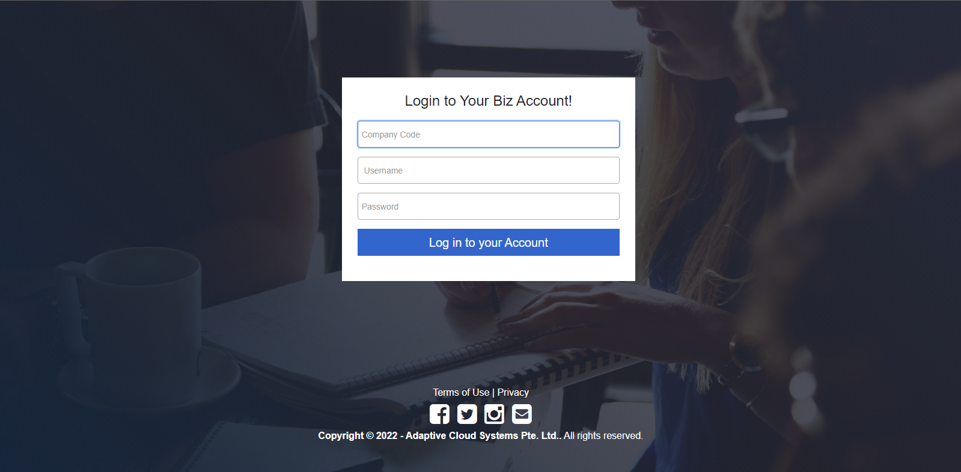

* After the login, the screen shows the Dashboard.

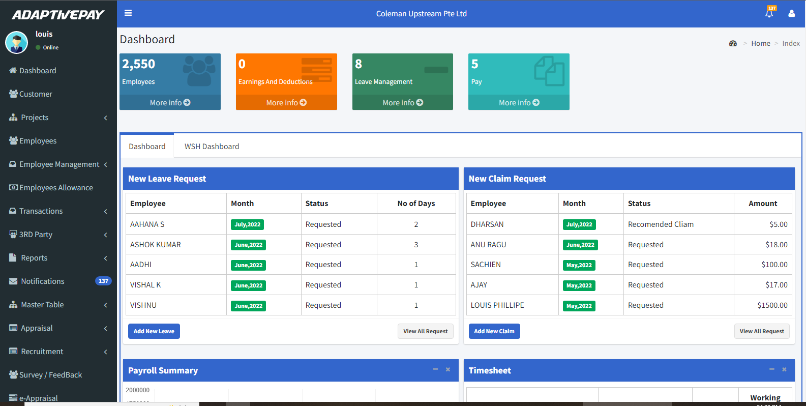

**1. Employee**

* Go to the employee module.
* We can use filters such as Department, Active & Inactive employees, Employee Code and Employee’s Name to narrow the list of employees.
* Then  Icon is added to the lists which means to add user login for the employee. The user Id will be the email Id saved for the employee. You can use normal user name for this value as well.
* **Previous employee** and **Next employee** button used navigate back and forth in Edit view.
* **Print KET** button can print the Key Employment Terms (KET) as well by clicking on it.
* You can change the column visibility by clicking on the icon.
* Click the “**Create** **New**” icon.

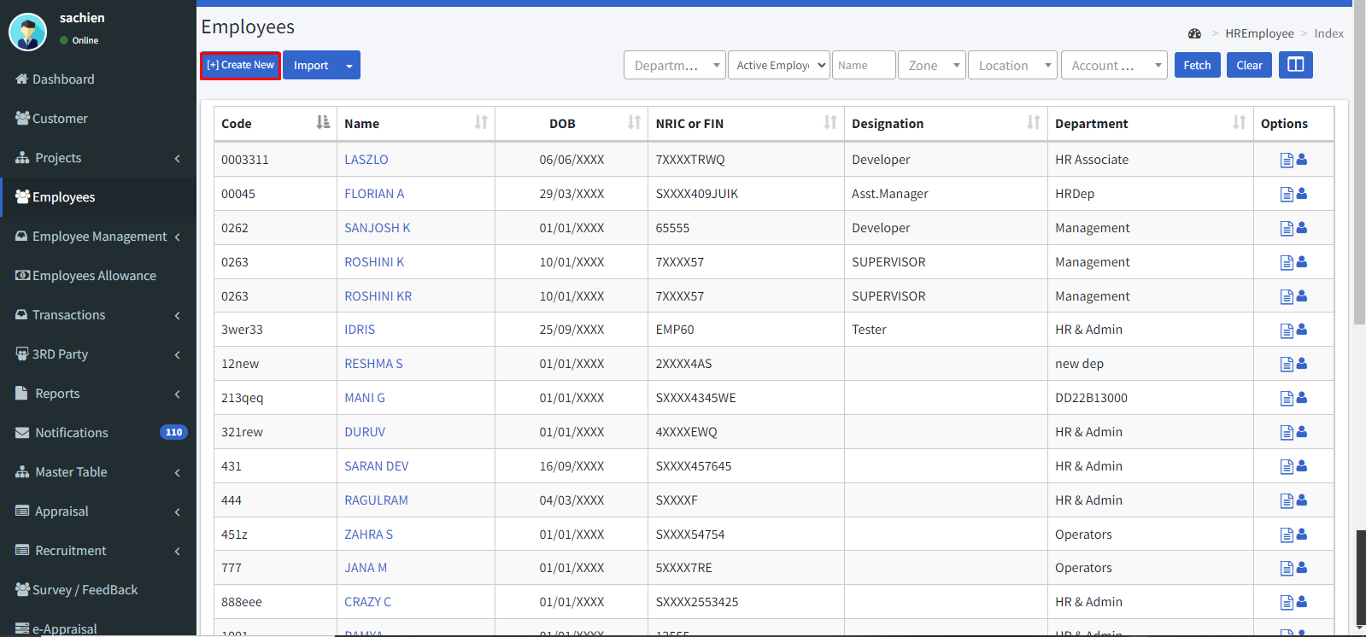

**1.1. Info:**

The **Info** page contains personal info like name, age, ID type, address, emergency contact, and attachments.

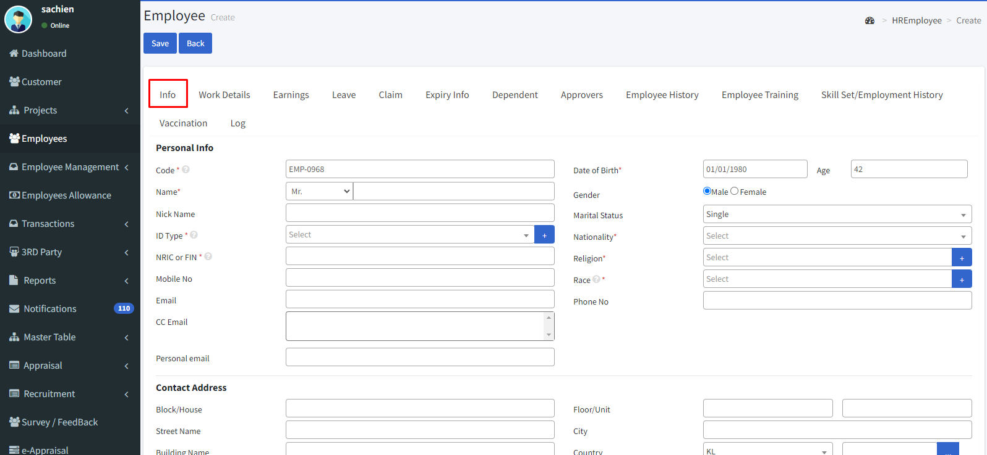

**Code:**

Enter the Employee code. Each employee has a unique code.

**First Name:**

Enter the first name of the employee.

**Last name:**

Enter the last name of the employee.

**Id type:**

Select the type of ID of the employee from the drop-down.

**NRIC FIN:**

Enter the confidential NRIC or FIN number of the employee.

**Mobile No:**

Enter the personal mobile number of the employee.

**Email:**

Enter the professional and active email ID of the employee for communication.

**Date of birth:**

Enter the employee’s date of birth and the age was automatically calculated by the system.

**Gender:**

Select the employee’s gender.

**Marital Status:**

Select the marital status from the drop-down such as single, married, divorced, or widowed.

**Religion:**

Select the religion of the employee from the drop-down.

**Race:**

Select the race to which the employee belongs.

**Phone No:**

Enter the Phone number of the employee.

**Contact address:**

Enter the address of the employee.

**Emergency contact:**

Enter the address of the emergency contact person.

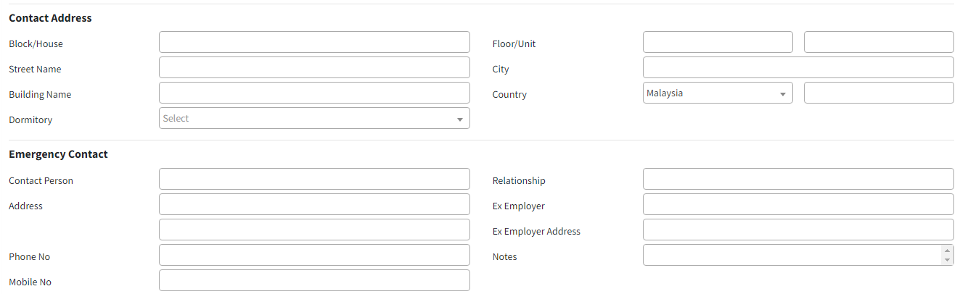

**1.2. Work Details:**

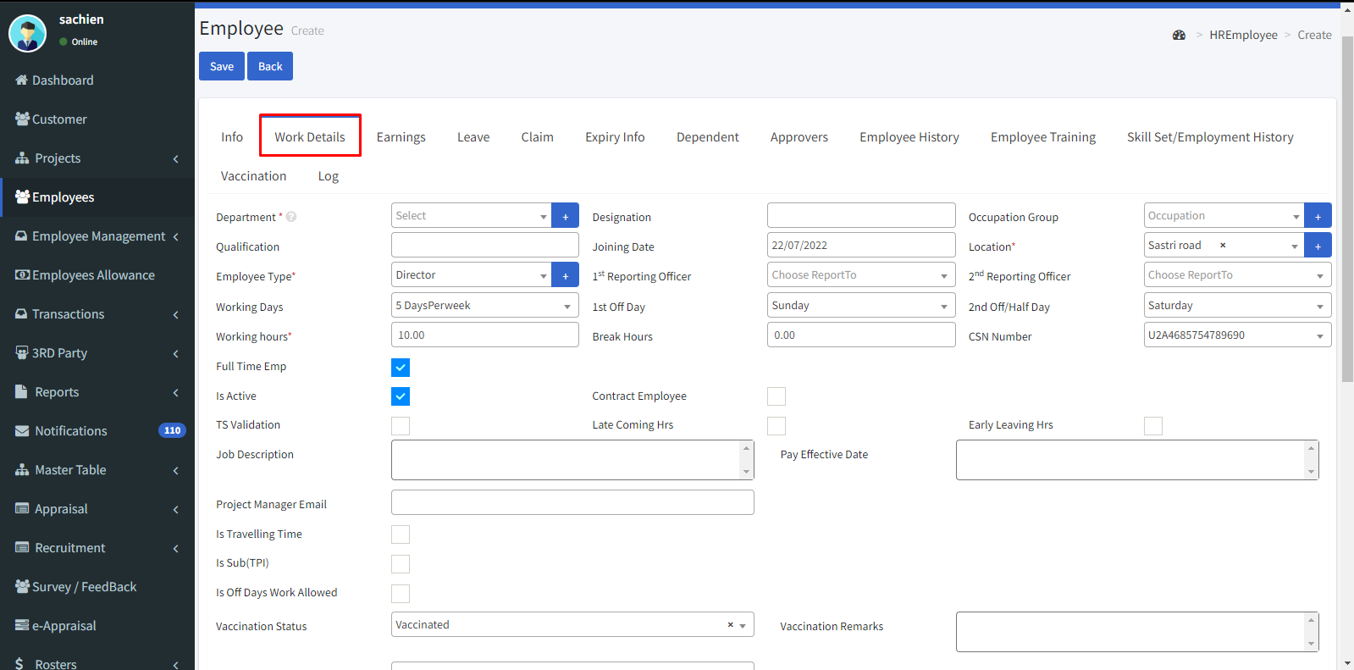

**Department:**

Select the department from the drop-down which the employee has going to work.

**Qualification:**

Enter the educational qualification acquired by the employee.

**Employee type:**

Enter the hierarchy of the employee from the drop-down, such as senior, manager, staff, or others.

**Working days:**

Select the working days from the drop-down.

**Working hours:**

Enter the working hours.

**Full-Time Emp:**

Click the check box whether the employee is a full-time employee.

**Is Active:**

This check box shows the active status of the employee.

**Job Description:**

Enter the job description of the employee job.

**Project manager email:**

Enter the email id of the project manager.

**Project:**

Enter the project name in which the employee going to work.

**Designation:**

Enter the designation details of the employee.

**Occupation group:**

Enter the occupation group.

**Joining date:**

Enter the joining date of the employee.

**Location:**

Choose the location where the employee going to work.

**1st Reporting officer:**

Choose the officer's name from the drop-down who the employee is to report first.

**2nd Reporting officer:**

Choose the officer's name from the drop-down who the employee is to report second.

**1st Off day:**

From the drop-down list select the 1st off day for the employee.

**2nd Off day:**

From the drop-down list select the 2nd off day for the employee.

**Break hours:**

Assign the time limit in hours format for break time to the employee.

**CSN Number:**

Enter the CSN number of the employee.

**Contract Employee:**

Click the check box whether the employee was hired from a contract base.

**Vaccination Status:**

Enter the vaccination status.

**Vaccination Remarks:**

Enter remarks for the vaccination.

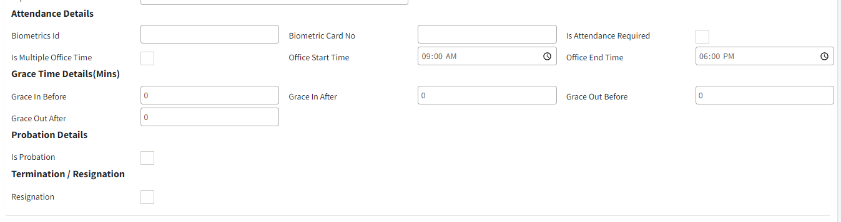

**Biometrics ID:**

Enter the ID number of the biometric.

**Biometric card No:**

Enter the unique number of the biometric card.

**Is Attendance required:**

Click the check box for requiring attendance.

**Office start time:**

Enter the start time of the office.

**Office end time:**

Enter the end time of the office.

**Grace in before:**

Enter the grace in time before the actual time.

**Grace in after:**

Enter the grace in time after the actual time.

**Grace out before:**

Enter the grace-out time before the actual time.

**Grace out after:**

Enter the grace-out time before the actual time.

**Is Probation:**

Select this if the employee performing on a probation period.

**Resignation:**

Select this if the employee resigns from the job.

**1.3. Earnings:**

**Pay frequency:**

Select the pay frequency whether the employee is paid monthly or Bi-weekly.

**Pay Basis:**

Enter the basis of pay whether monthly, daily, or hourly.

**Payment Mode:**

Enter the mode of payment through bank or cash.

If the payment mode can be done through bank means enter the bank account details.

**Transaction Type:**

Select the type of transaction such as direct debit, internet banking, Cheque, or credit card.

**Employer Bank:**

Select the bank.

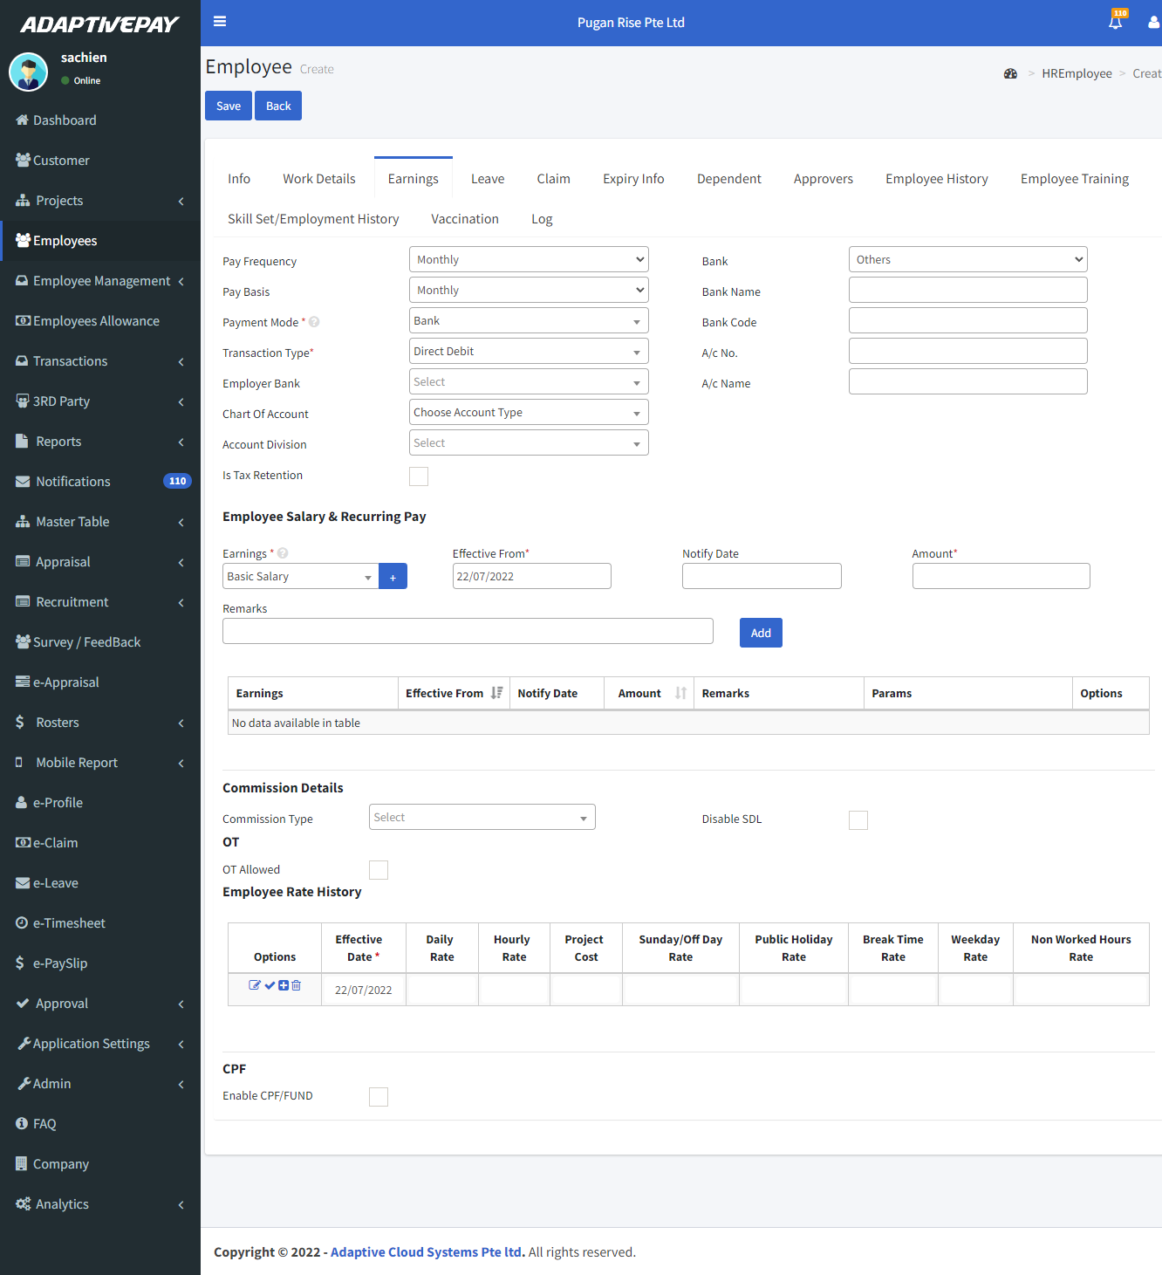

**Chart of Account:**

Enter the chart of account.

**Account Division:**

Select the location of the account division.

**Is Tax Retention:**

Click the check box to deduct the tax.

**Is Tax Retention Percentage:**

Click the check box to enable the percentage.

#### **Employee Salary & Recurring Pay:**

Select the earnings from the drop-down then select the date of effective and enter the amount.

**OT:**

Click the **“OT Allowed”** check box if the employee is eligible for OT**.**

Select the OT Type.

#### **Employee Rate History**

Click the icon to calculate the OT automatically.

**CPF:**

* Click the **“Enable CPF/FUND”** to assign CPF to the employee.
* Select the type of CPF.
* Select the fund type.

**1.4. Leave:**

* Select the leave name the total leave were automatically calculated by the system.
* Then click the **Add** button.

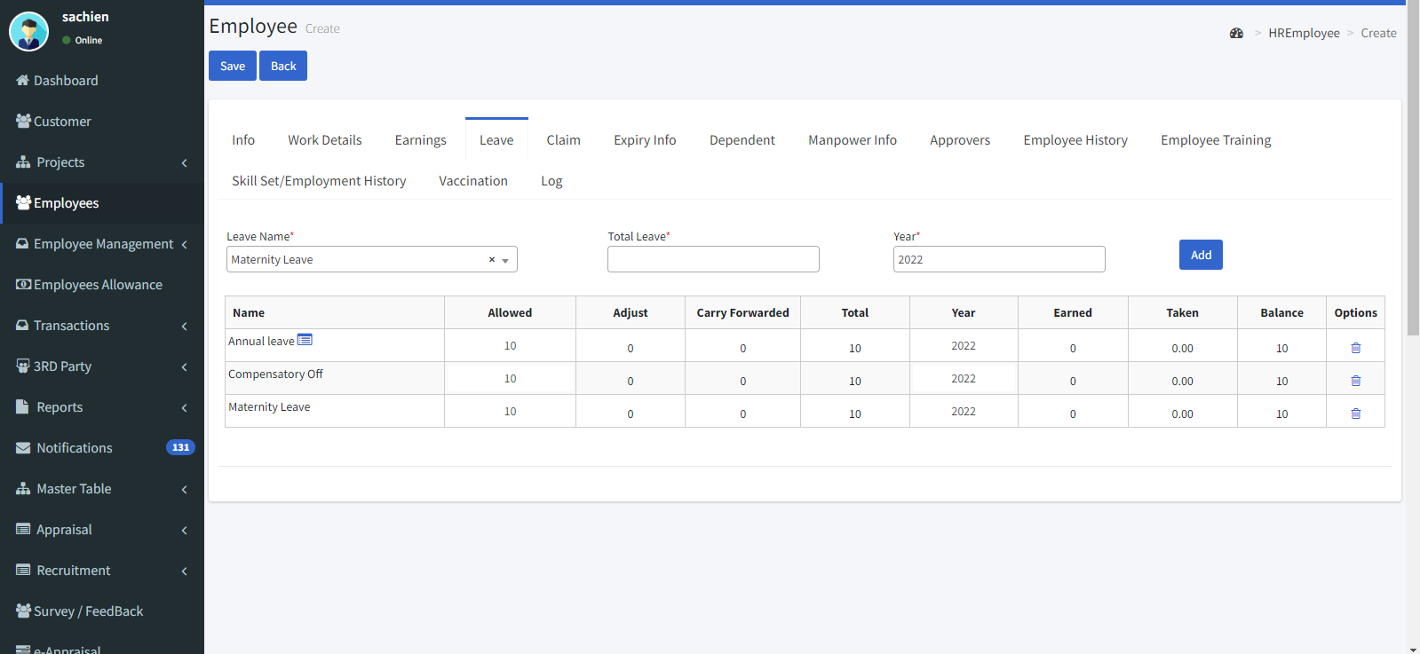

**1.5. Claim:**

* Select the claim name.
* Enter the allowed amount per annum.
* Enter the allowed amount per instance.
* Enter the allowed month.

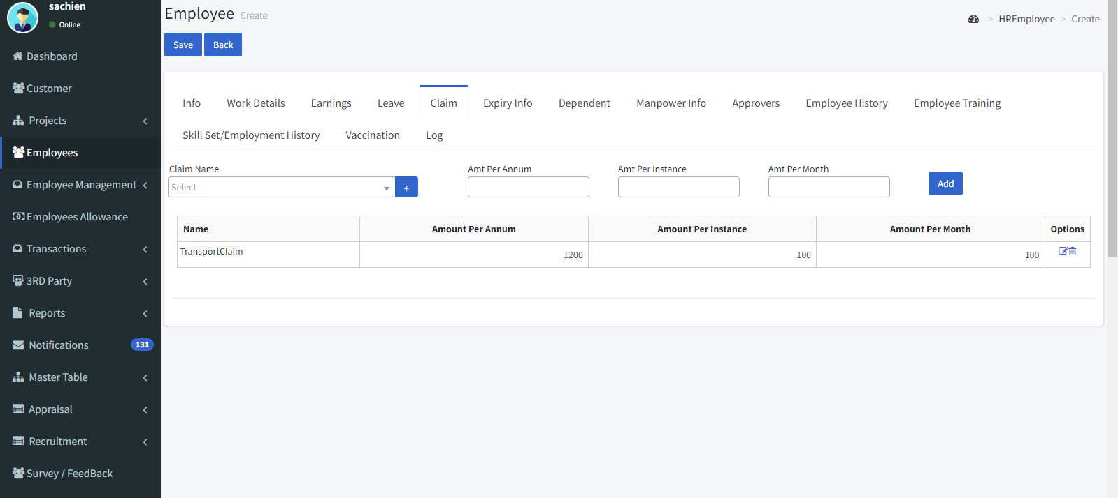

**1.6. Expiry info:**

This module consists of the details of ID such as passport, work permit, and SIC this acts as a reminder to renew the employee ID.

**Passport:**

Enter the passport details such as passport number, issue, and expiry date.

**Work permit:**

Enter the work permit details.

**SIC:**

Enter the SIC number, issue date, and expiry date.

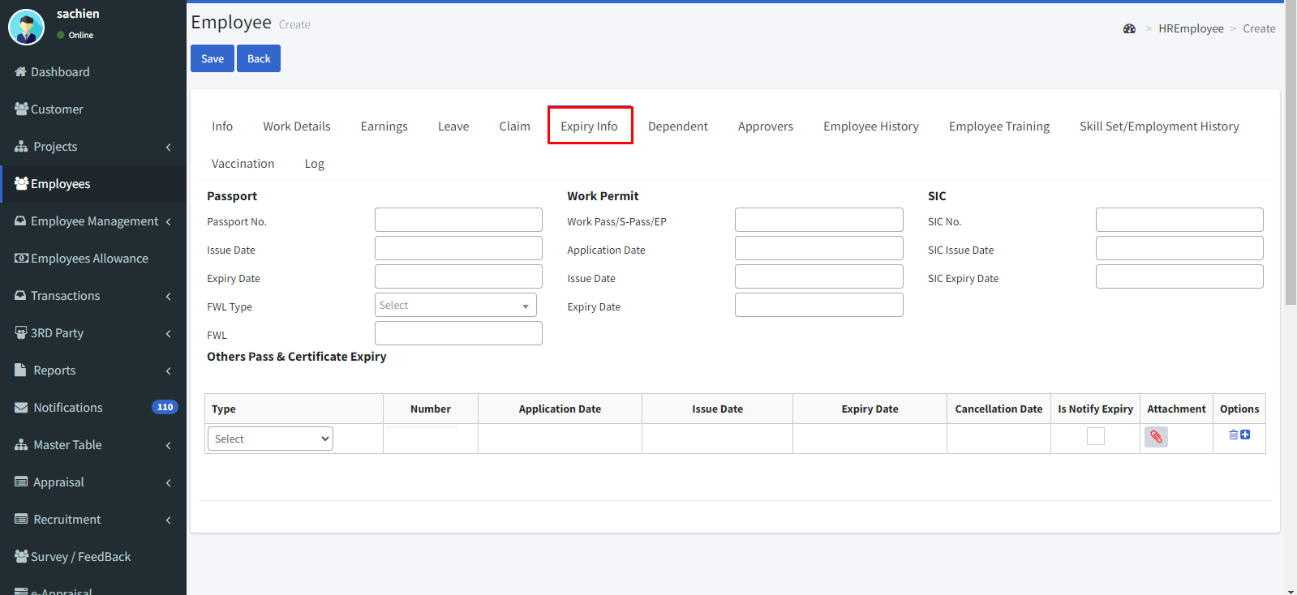

#### **Others Pass & Certificate Expiry:**

You can add any other pass and certificate details from the drop-down.

**1.7. Dependent:**

* This contains the dependent details.
* Enter the details such as name, NRIC number, and date of birth then click the **“Add”** button.

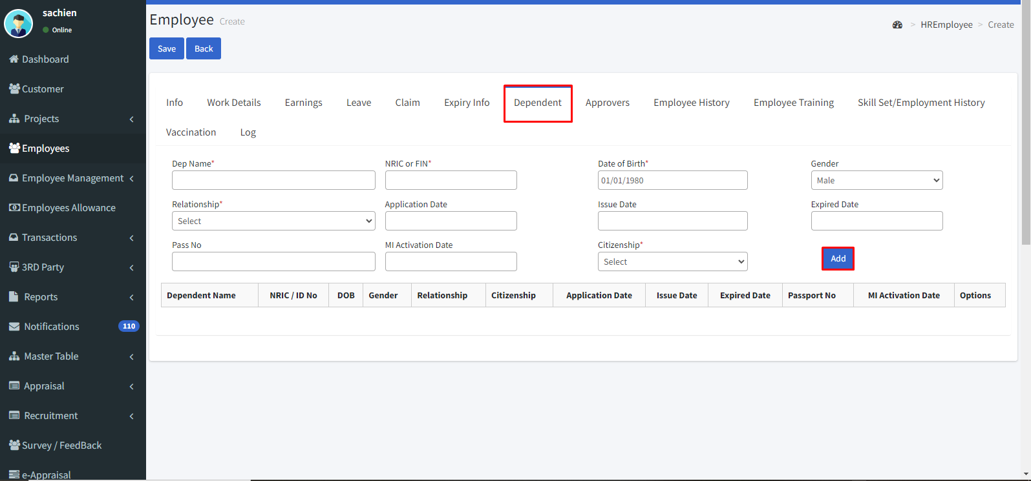

**1.8. Approvers:**

The approver menu contains the approving stream of leave, claim, appraisal,

loan which is requested by the employee.

* Select the approver group.
* Enable the check boxes as per your needs.
* Then select the employee type, employee name, and the approving level such as recommender or approver.
* If u want to add more than one approver or recommender click on the **“+”** icon then click the **“load”** button

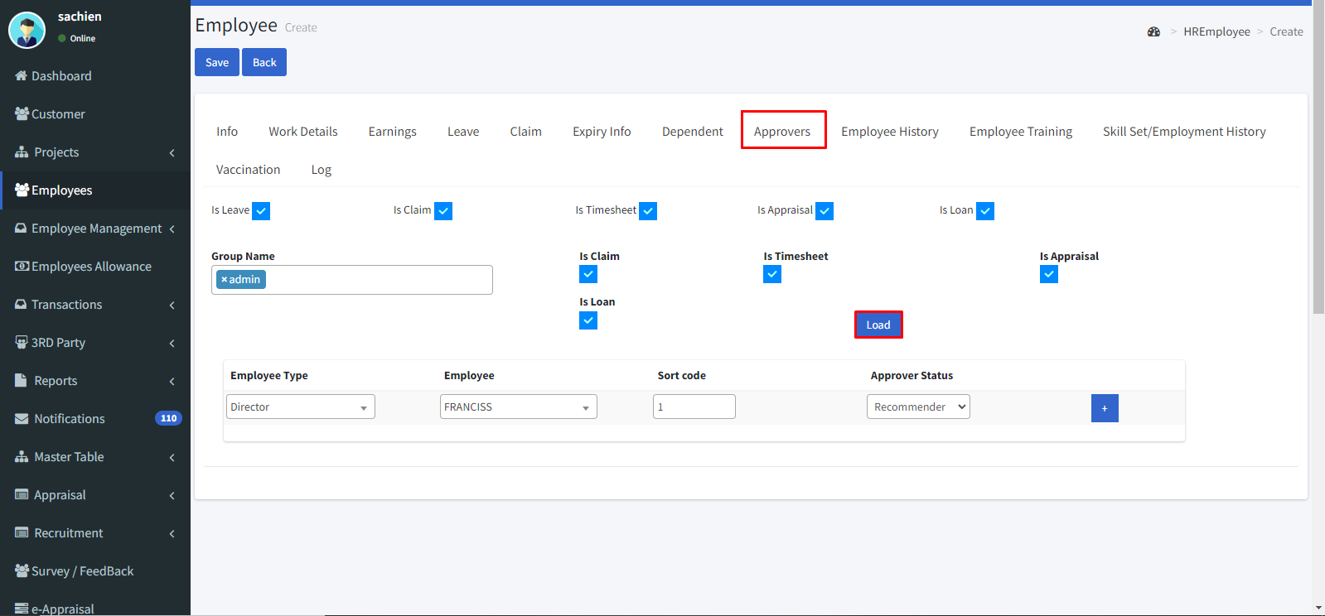

**1.9. Employee History:**

It shows the history of the employee such as joining date, served department, designation, and employee type.

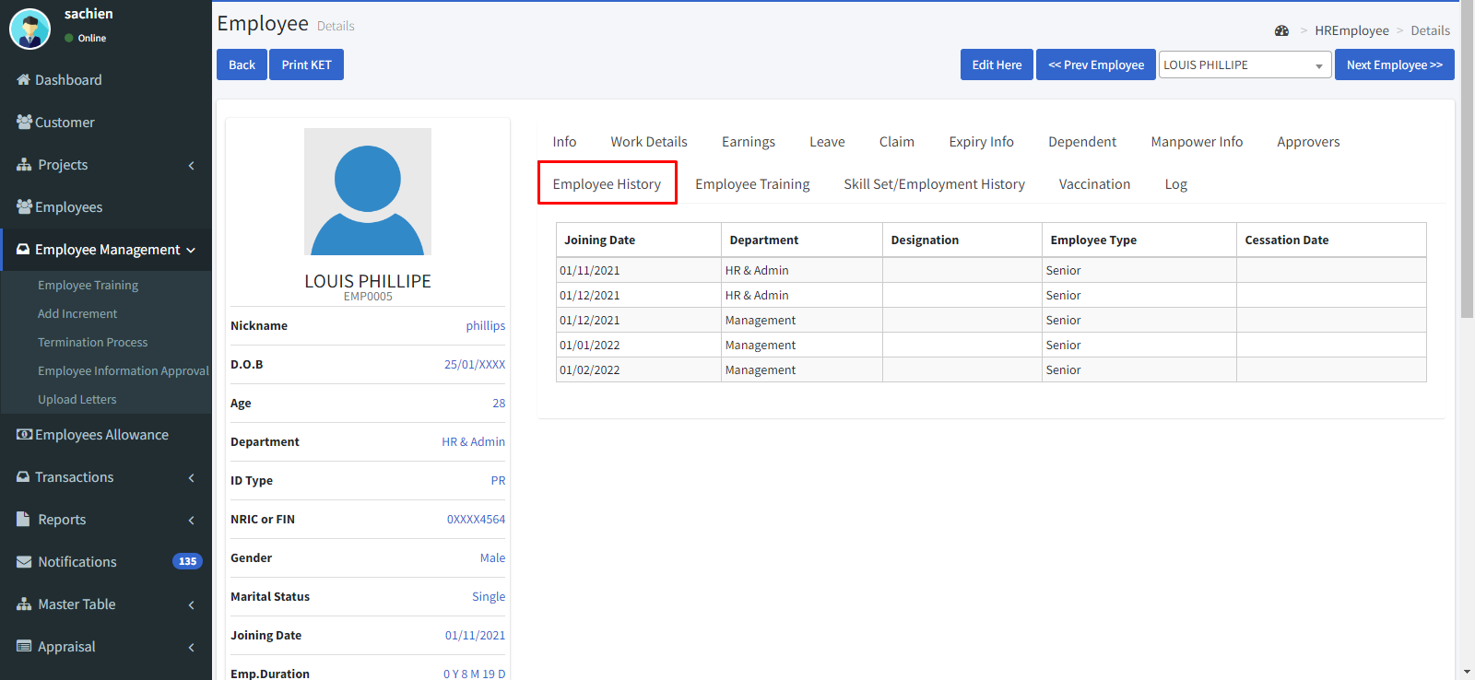

**1.10. Employee Training:**

This feature helps to track the professional training taken by employees.

It shows the training, scheduling, status, and fees details.

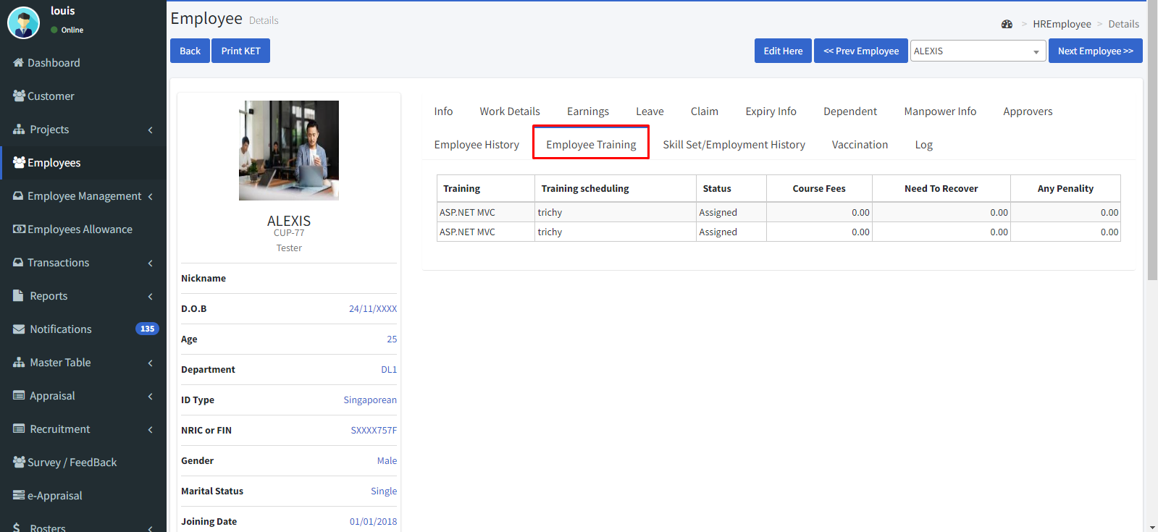

**1.11. Skill set/Employment history:**

**Educational and other professional qualifications:**

* Enter the from date and to date.
* Enter the name of the institution.
* Enter the country and attained qualifications.

**Employment history:**

* Enter the from date and to date.
* Enter the company name and position held.
* Give reasons for leaving.
* Enter the basic salary and allowance.
* Then click the **“Add”** icon.

**Skills:**

* Enter the skill set you’ve attained.

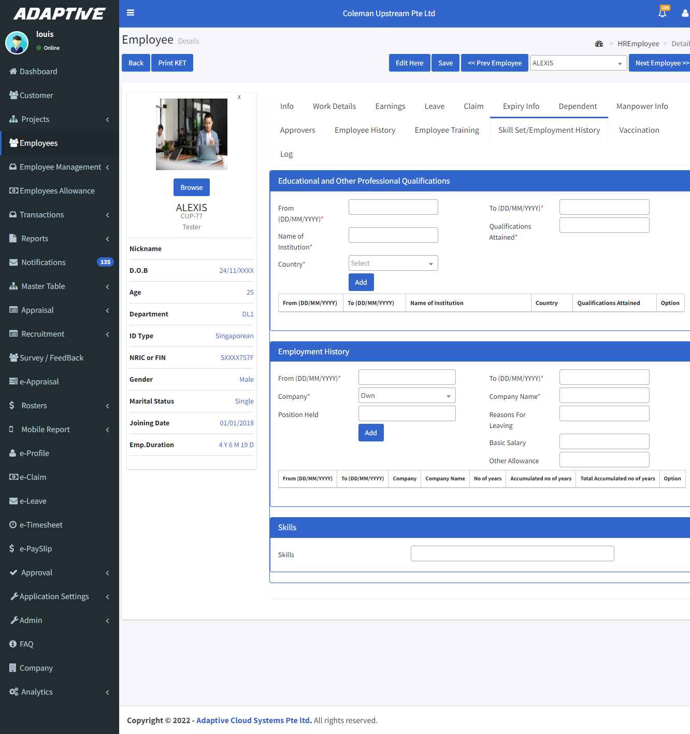

**1.12 Vaccination status:**

* Enter the vaccine name and date of vaccination.
* Select the vaccine type.
* Add remarks then click the **“Add”** button.

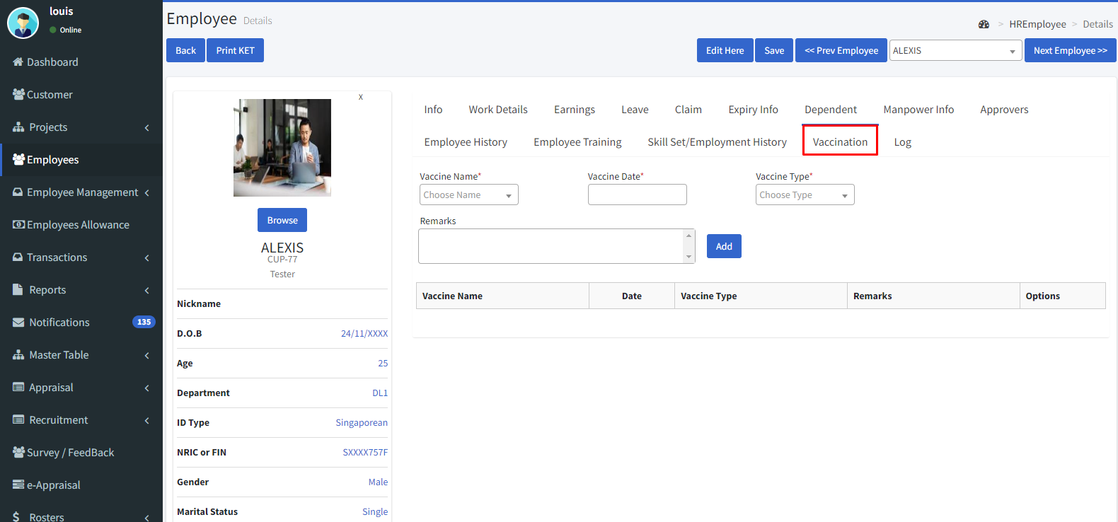

**1.13 Log:**

It shows the field changes details such as changes made by the person’s name and time.

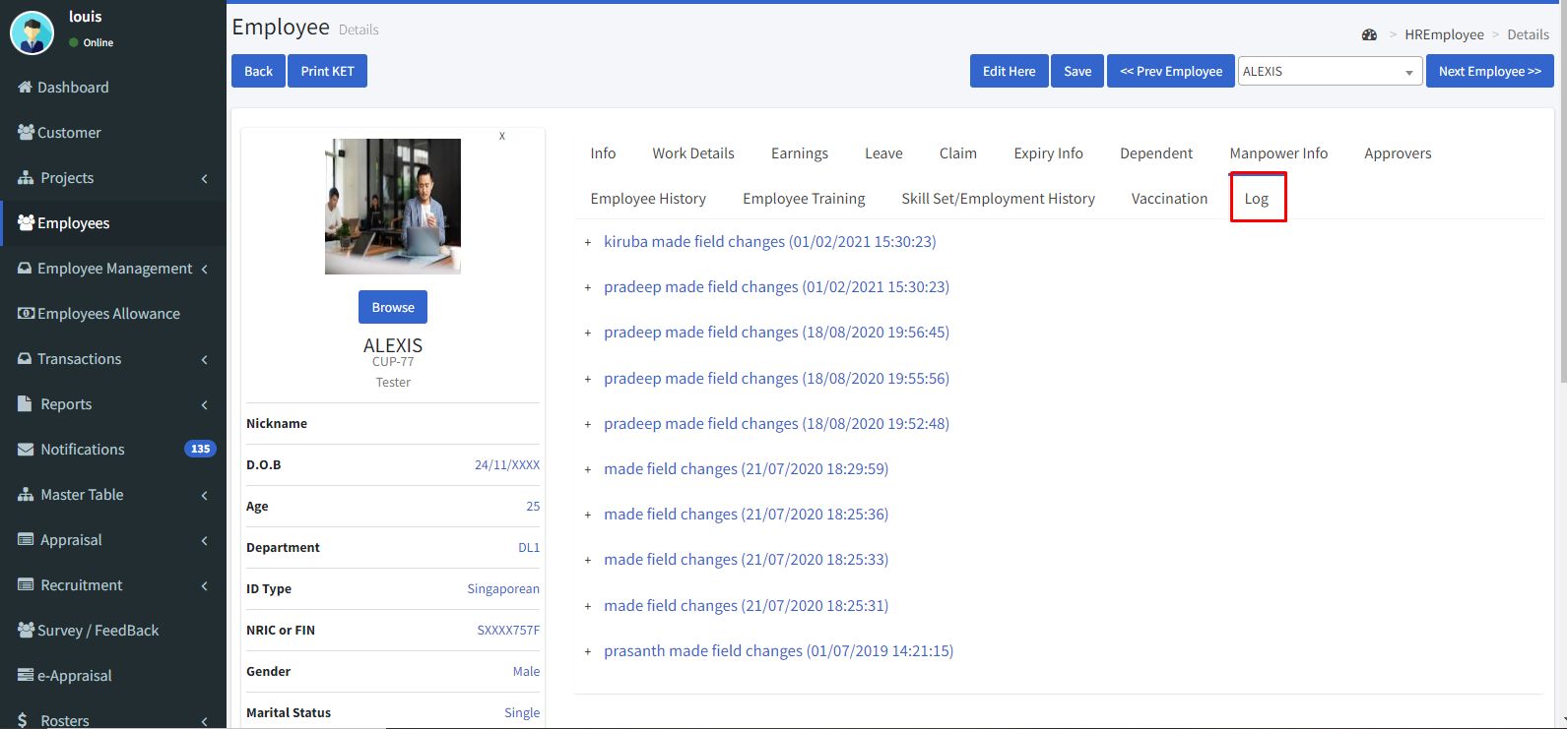

**2. Master Table**

The master table is the control unit of the payroll module; it allows us to create, remove and modify the data in the master table.

**2.1. Locations:**

* Go to Master table 🡪 Locations.
* You can filter the list by active and inactive locations by clicking the fetch button.
* By clicking the clear button, it turns the filter to the initial stage.
* If we need a print copy of the locations click the Print button.
* By clicking the icon we can edit the location you can download the QR code in this option by click the icon then click the 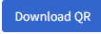.
* You can create your working location by clicking the “Create New” icon in the top left corner.

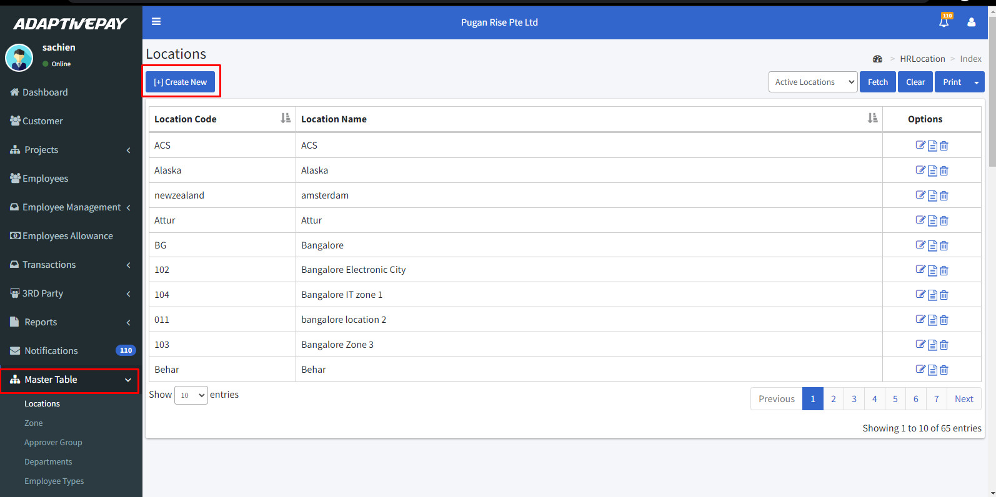

* Enter the location code of your location for example if your location is Kuala Lumpur enter the location code as KL.
* Then enter the location name, address, city, country, telephone and postal code.
* Next, select the zone.
* Enter the office start and end time.
* Enter the break hours.
* Enter the grace period in minutes format.
* After filling, in all the details click the “Save & Close” button to save.

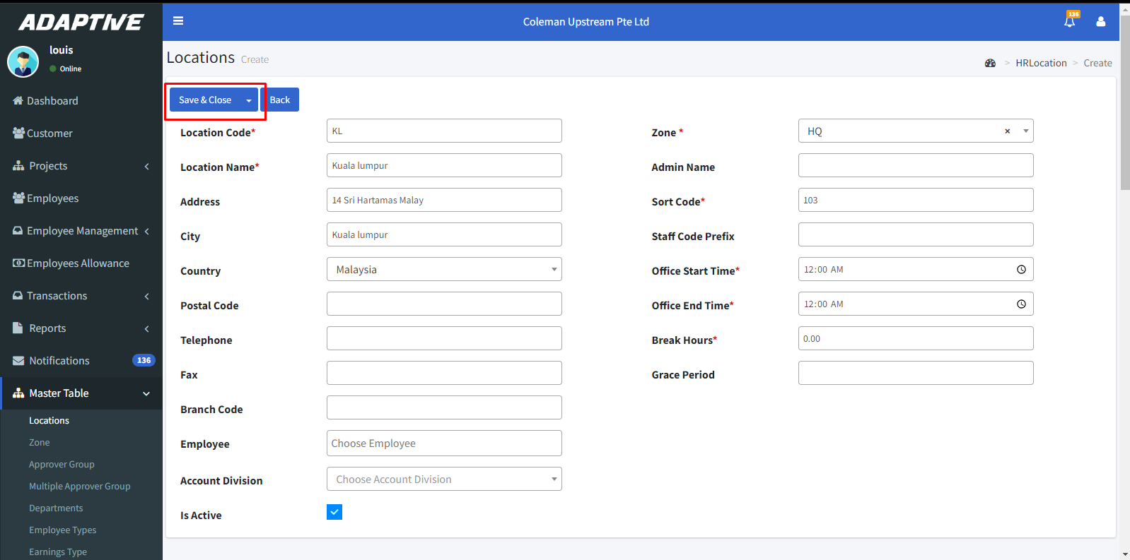

* By clicking the icon we can view the details of the locations.

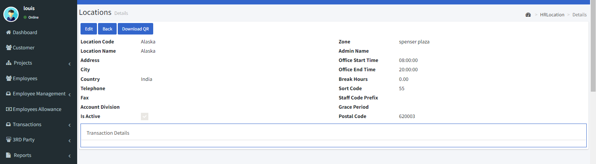

* By clicking the icon we can delete.

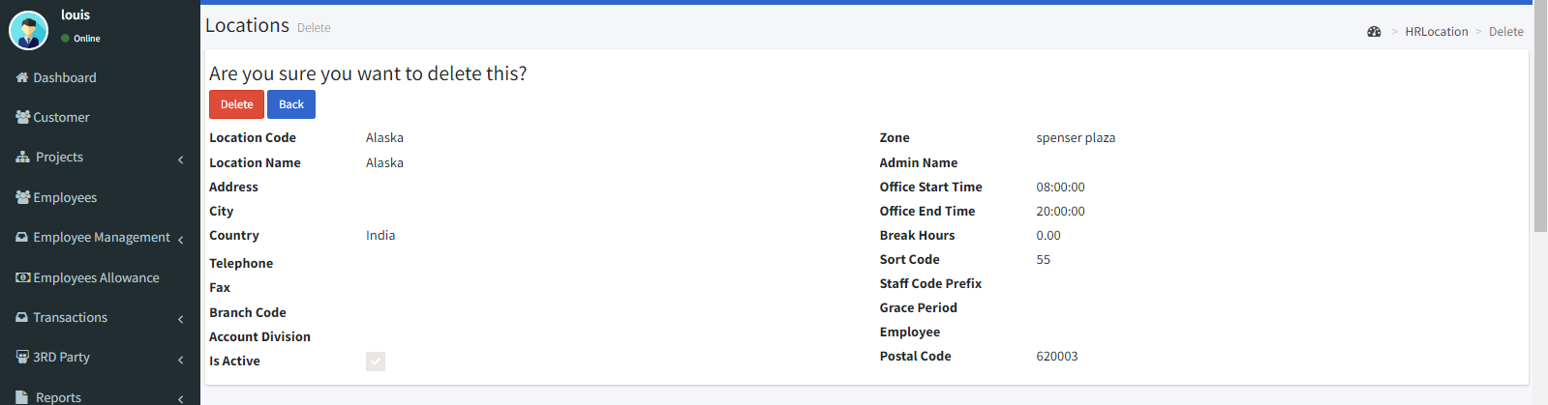

**2.2. Zone**:

* Go to Master table > Zone.
* By clicking the icon we can edit the zone
* Click the **“Create new”** icon**.**
* You can search zone by name in the find name column then click fetch button to fetch the zone and Clear icon used to clear the search column to initial stage.
* Enter the Code and name of the zone.
* Then click the “**Save & Close**” button to save.

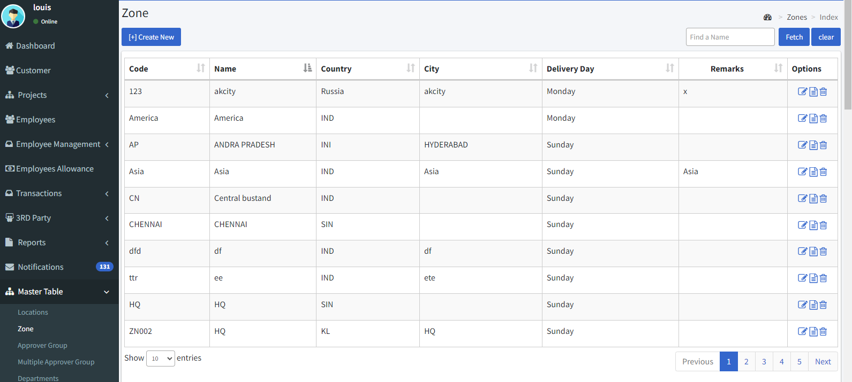

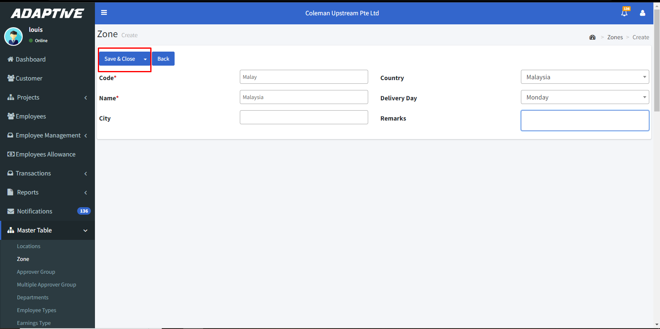

* By clicking the icon we can view the details of the zone.

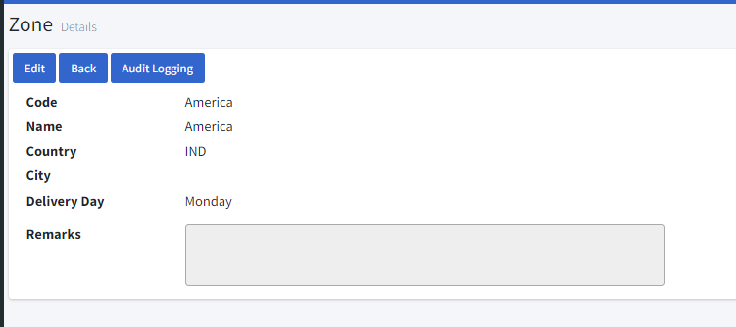

* By clicking the icon we can delete.

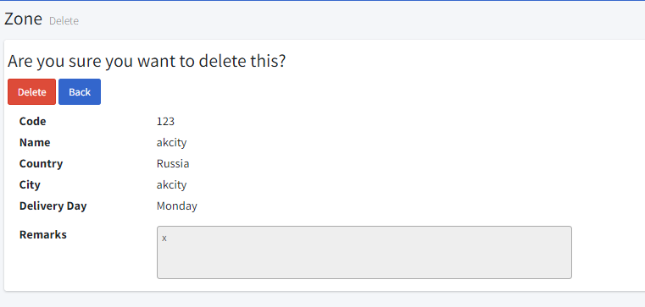

**2.3. Approver Groups:**

* Go to Master table > Approver groups.
* You can filter the list by employee name and approver name and group name by clicking the **fetch** button and clear the filter by **clear** button.
* By clicking the icon we can edit.
* Click the **“Create New”** icon to create a new approver group.

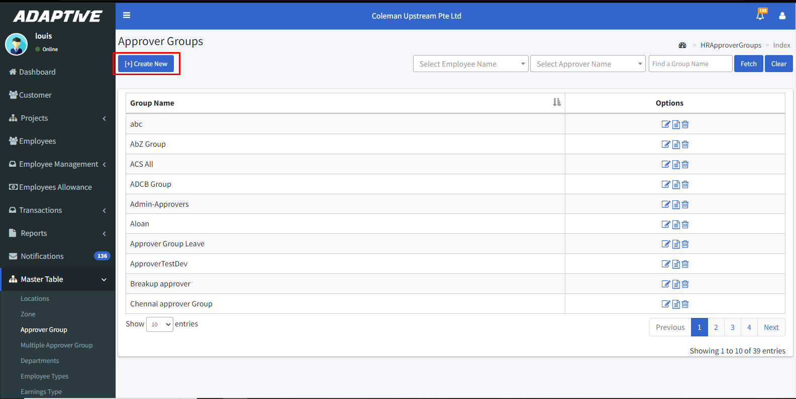

* Enter the approver group name.
* Then enable the check boxes as per your need.
* Select the employee type and employee.
* Then select the approver status.

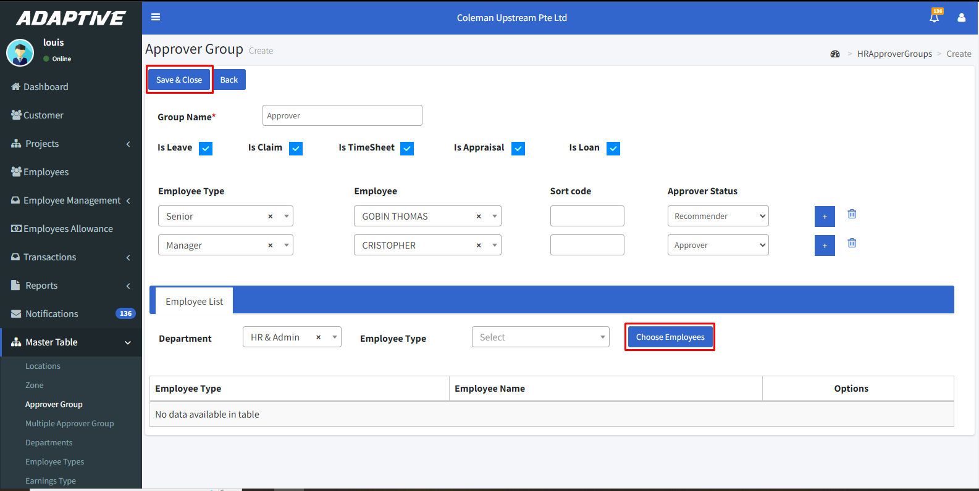

* Then choose the employees by clicking the **“Choose employees”** icon who are lies under this approver group.

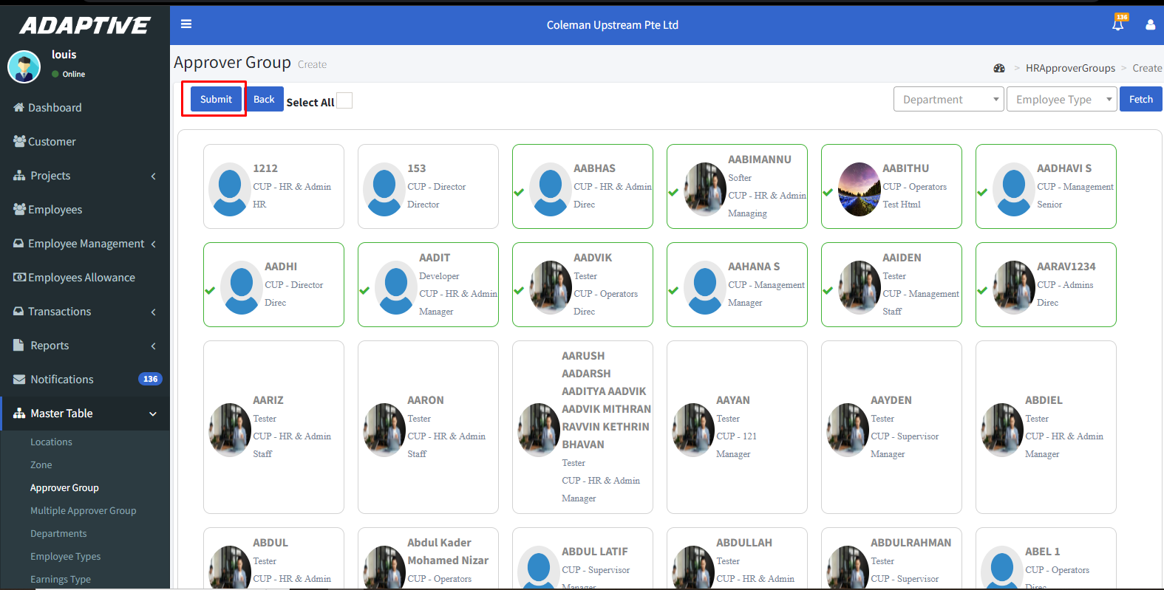

* Select the employees and click the **“Submit”** icon.
* After submitting the screen looks like below then click the **“Save & Close”** button to save.

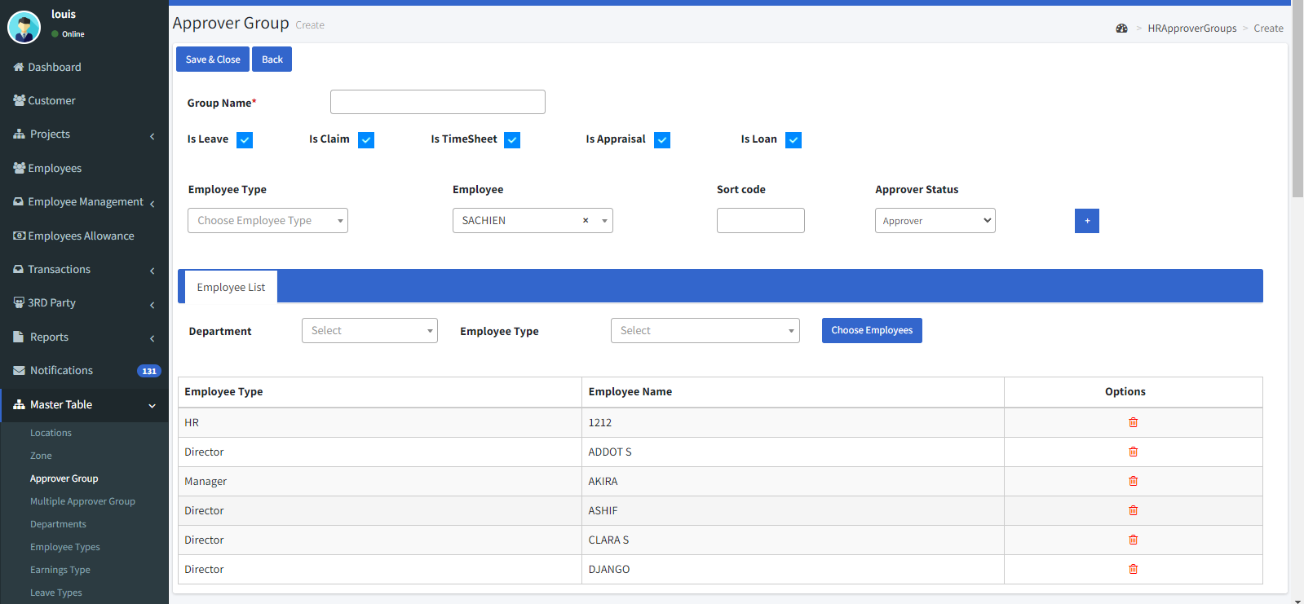

* By clicking the icon we can view the details.

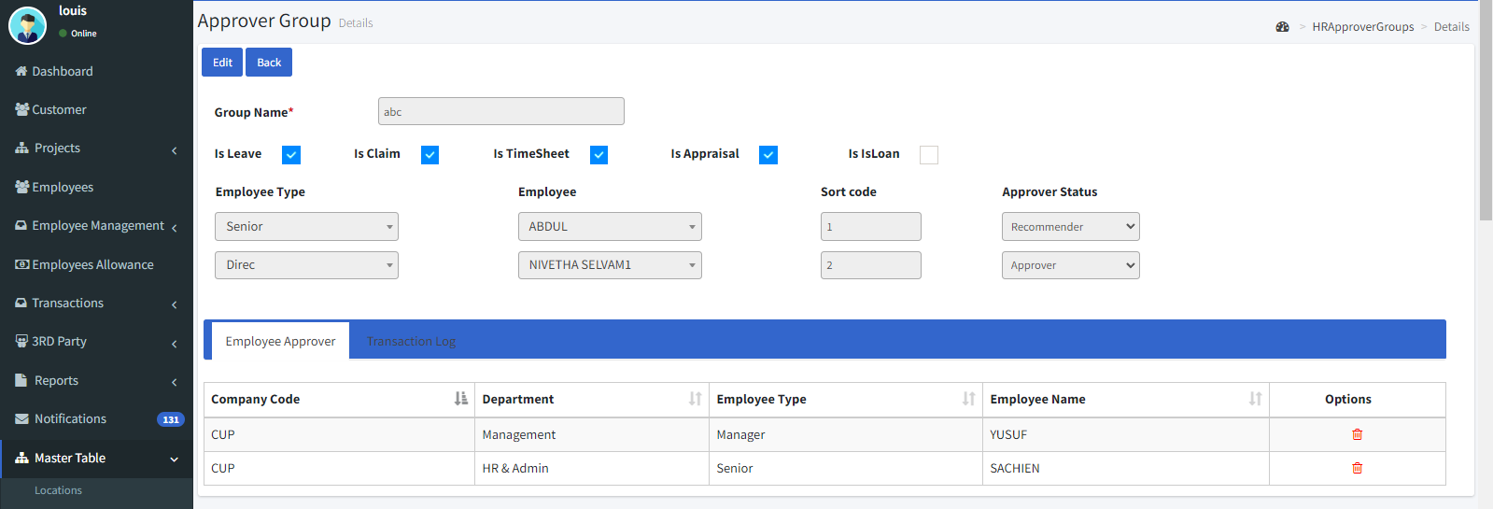

* By clicking the icon we can delete.

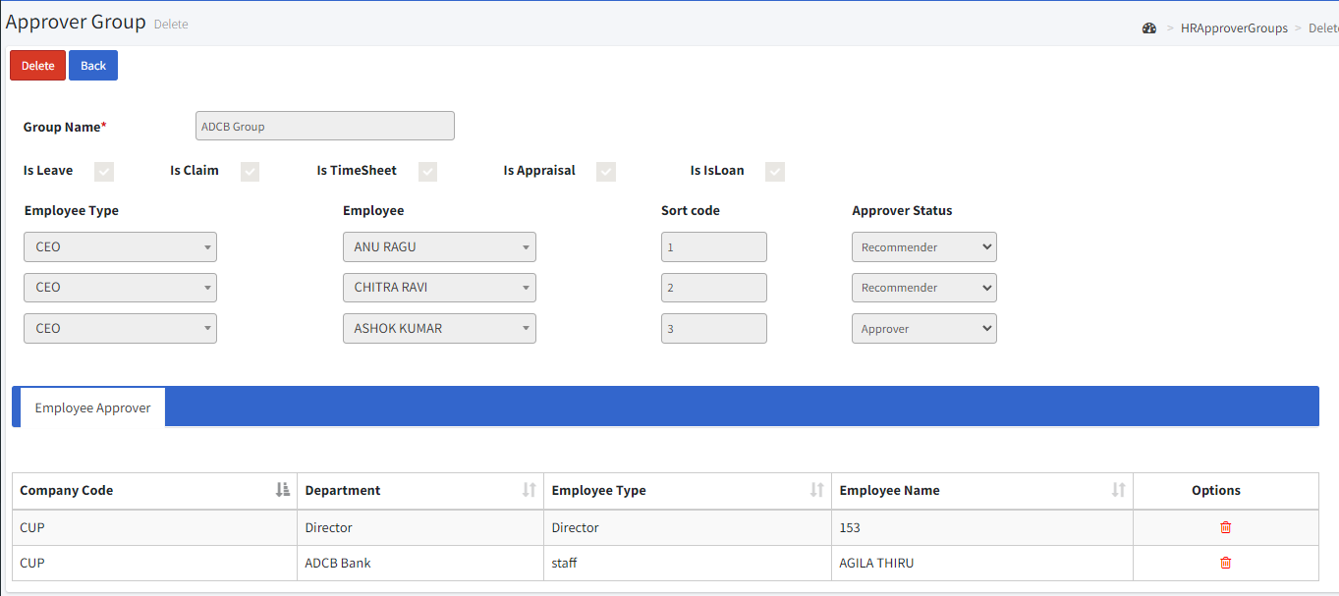

**2.4. Department:**

* Go to Master table > Department.
* You can filter the list by active department and find department by clicking the **fetch** button and clear the filter by **clear** button.
* By clicking the icon we can edit.
* Enter the department code e.g.: HRDept.
* Enter the name of the department.
* Enter the office start and end time.
* Assign the Grace in-out before and after time.
* Then click the “Save & Close” button to save.

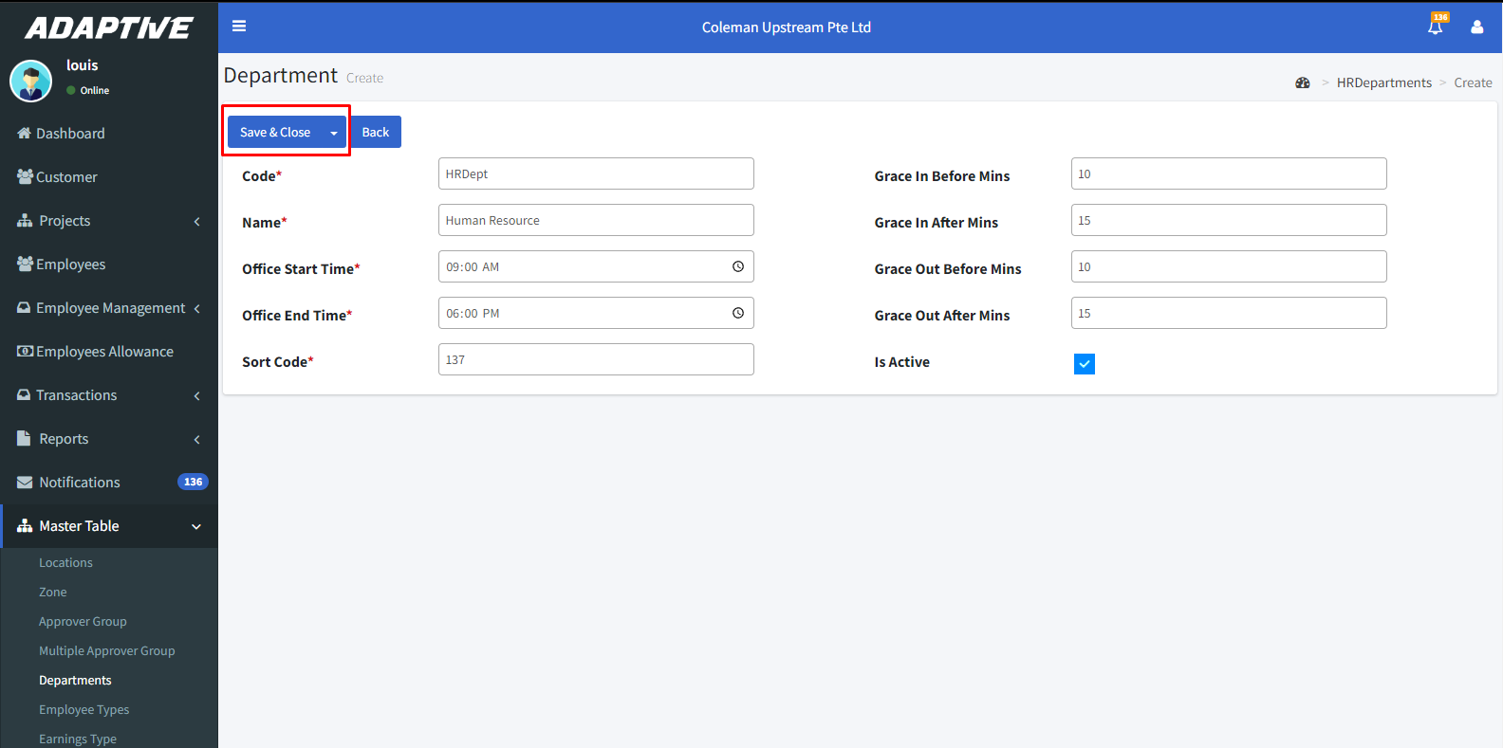

* By clicking the icon we can view the details.

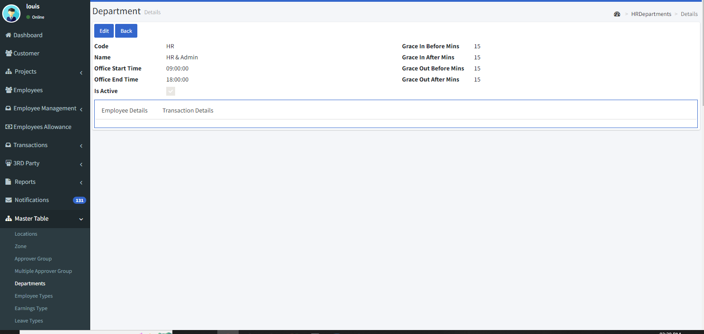

* By clicking the icon we can delete.

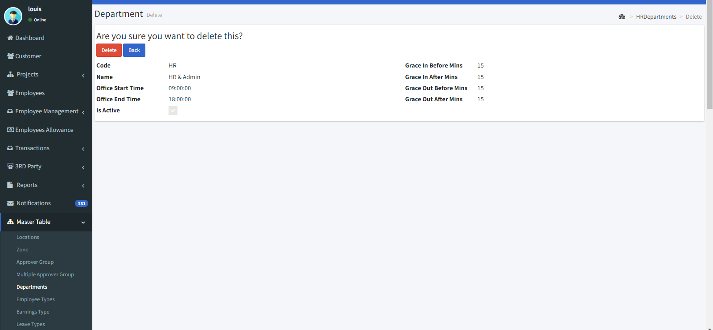

**2.5. Employee Types:**

* Go to Master table > Employee types.
* You can filter the list by active and inactive by clicking the **fetch** button and clear the filter by **clear** button.
* By clicking the icon we can edit.
* Clickthe **“Create New”** button to create a new employee type.

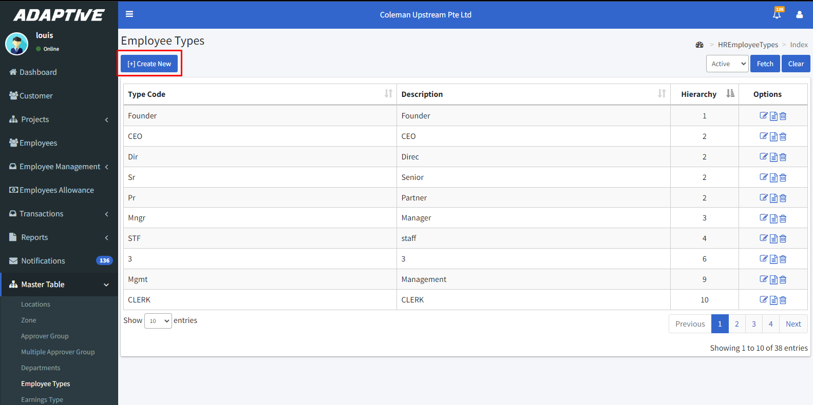

* Enter the type code e.g.: Sr Mgr.
* Enter the description and hierarchy level.
* Then click the **“Save & Close”** icon to save.

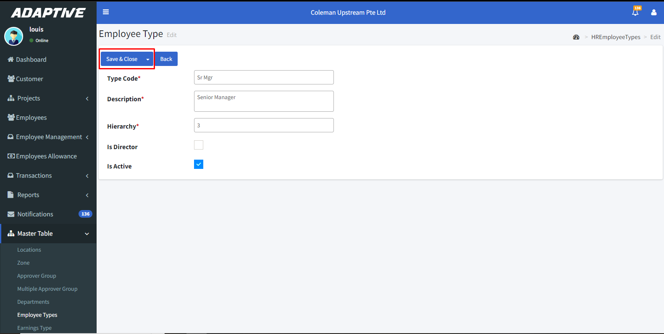

* By clicking the icon we can view the details.

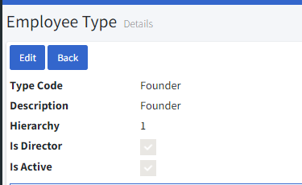

* By clicking the icon we can delete.

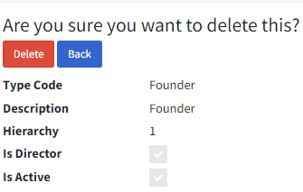

**2.6. Earnings Types:**

* Go to Master table > Earnings types.
* You can filter the list by active earnings types and find a earning type by clicking the **fetch** button and clear the filter by **clear** button.
* By clicking the icon we can edit.
* Click the “Create New” icon to create a new earning type.

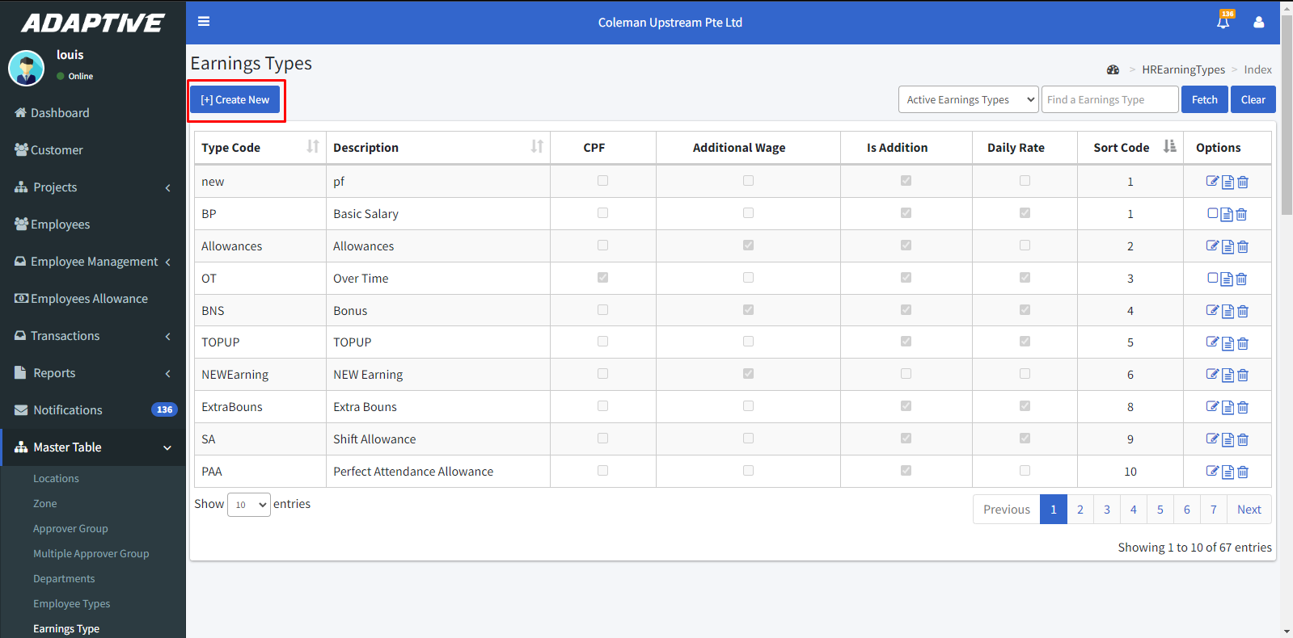

* Enter the type code and Description.
* Choose the IR8A code from the drop-down.
* Then click the **“Save & Close”** icon to save.

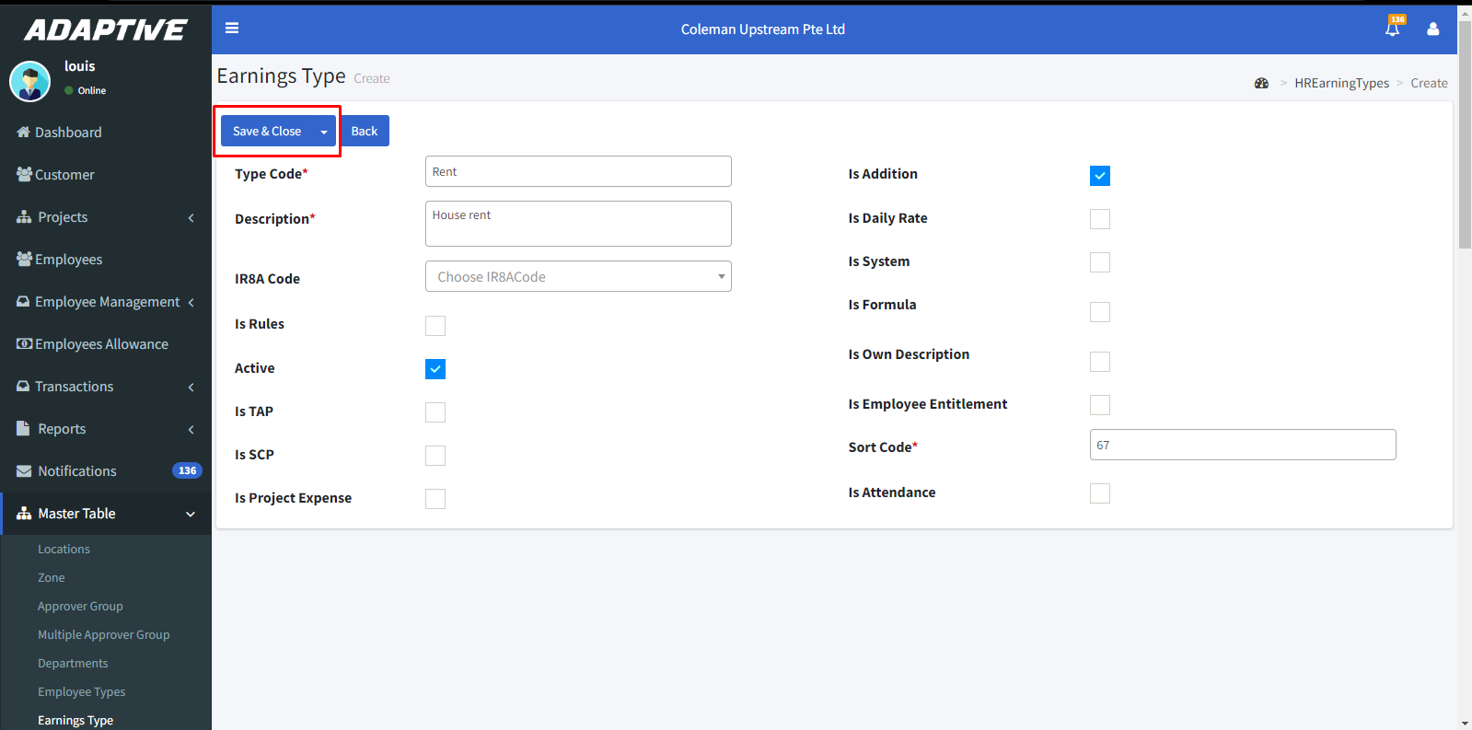

* By clicking the icon we can view the details.

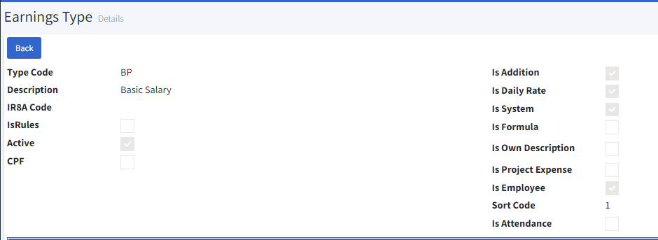

* By clicking the icon we can delete.

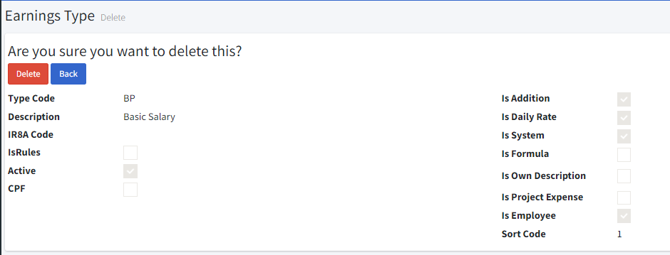

**2.7. Leave Types:**

* Go to Master table > Leave types.
* You can filter the list by active and inactive by clicking the **fetch** button and clear the filter by **clear** button.
* By clicking the icon we can edit.
* Click the “Create New” icon to create a new Leave type.

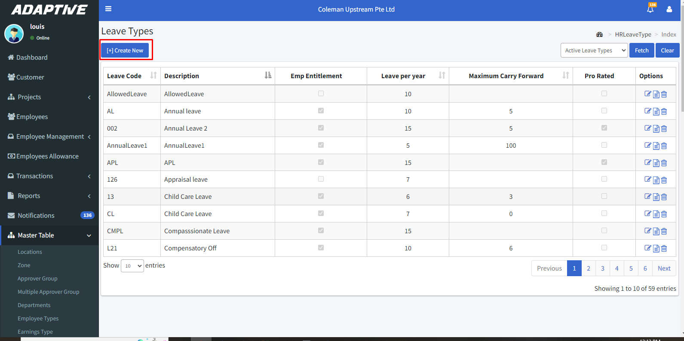

* Enter the leave code and description.
* Assign the no of leave days per year.
* Enter the maximum carry forward days.
* Click yes if to show the no of day’s leave taken on the pay slip.
* Click yes to show the leave balance on the pay slip.

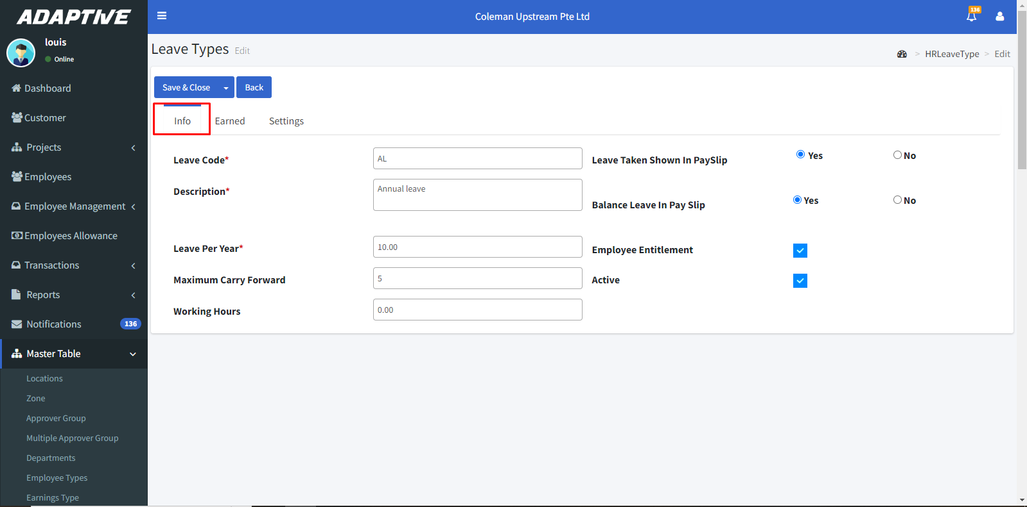

* If the leave type is an earned leave means click the **“Is Earned”** check box.
* Select the type such as joining date, calendar year, or financial year.
* **Pro-rated** works for Calendar year and financial year. E.g.: if a company follows calendar year they assign 2 days leave per month now an employee joined in month of June it allows the employee to take the remaining six months leave that is pro-rated.

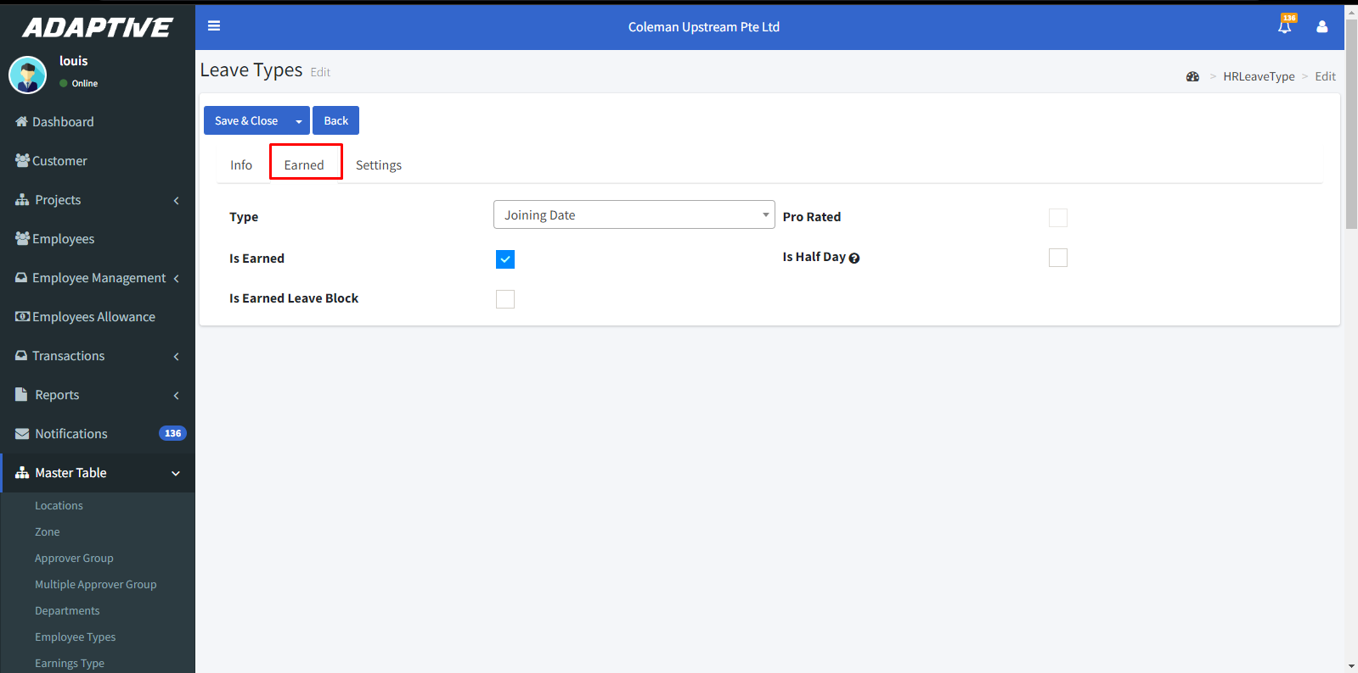

* Enable **“Block on Probation”** to block this leave in the probation period.
* Enable **“Is Paid Leave”** if the leave is paid.
* Enable **“Is Attachment**” if the attachment is required while applying for leave.
* Enable **“Is Only Full Day”** if the leave should be taken only in full days.
* Enable **“Is Off-Day Included”** if the leave should calculate in off days.
* Then click the **“Save &Close”** button to save.

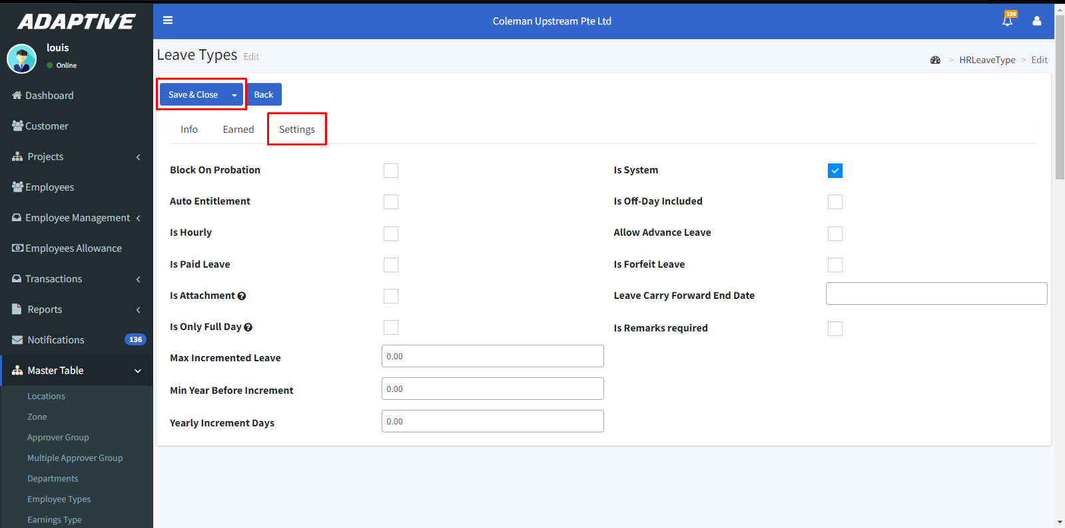

* By clicking the icon we can view the details.

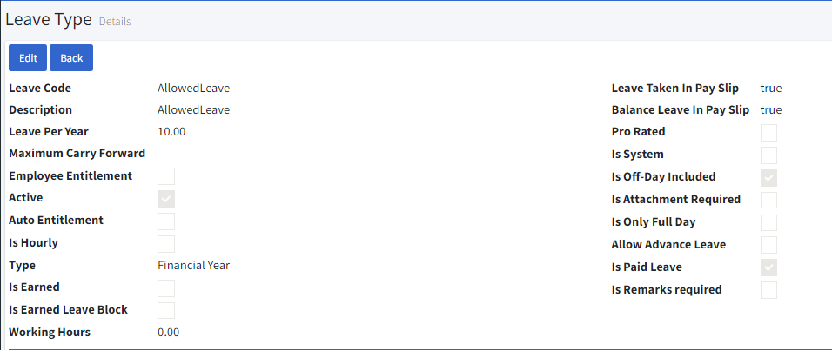

* By clicking the icon we can delete it.

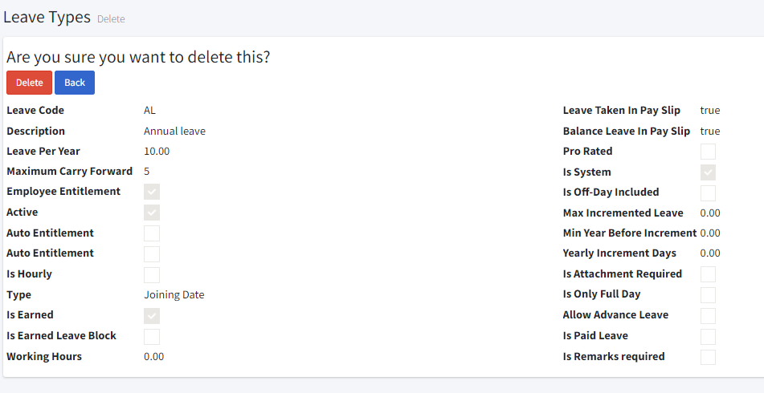

**2.8. Leave planner:**

* Go to Master table > Leave planner.
* You can filter the list by leave type, leave model, active and inactive by clicking the **fetch** button and clear the filter by **clear** button.
* By clicking the icon we can edit.
* Click the **“Create New”** icon to create a new leave planner.

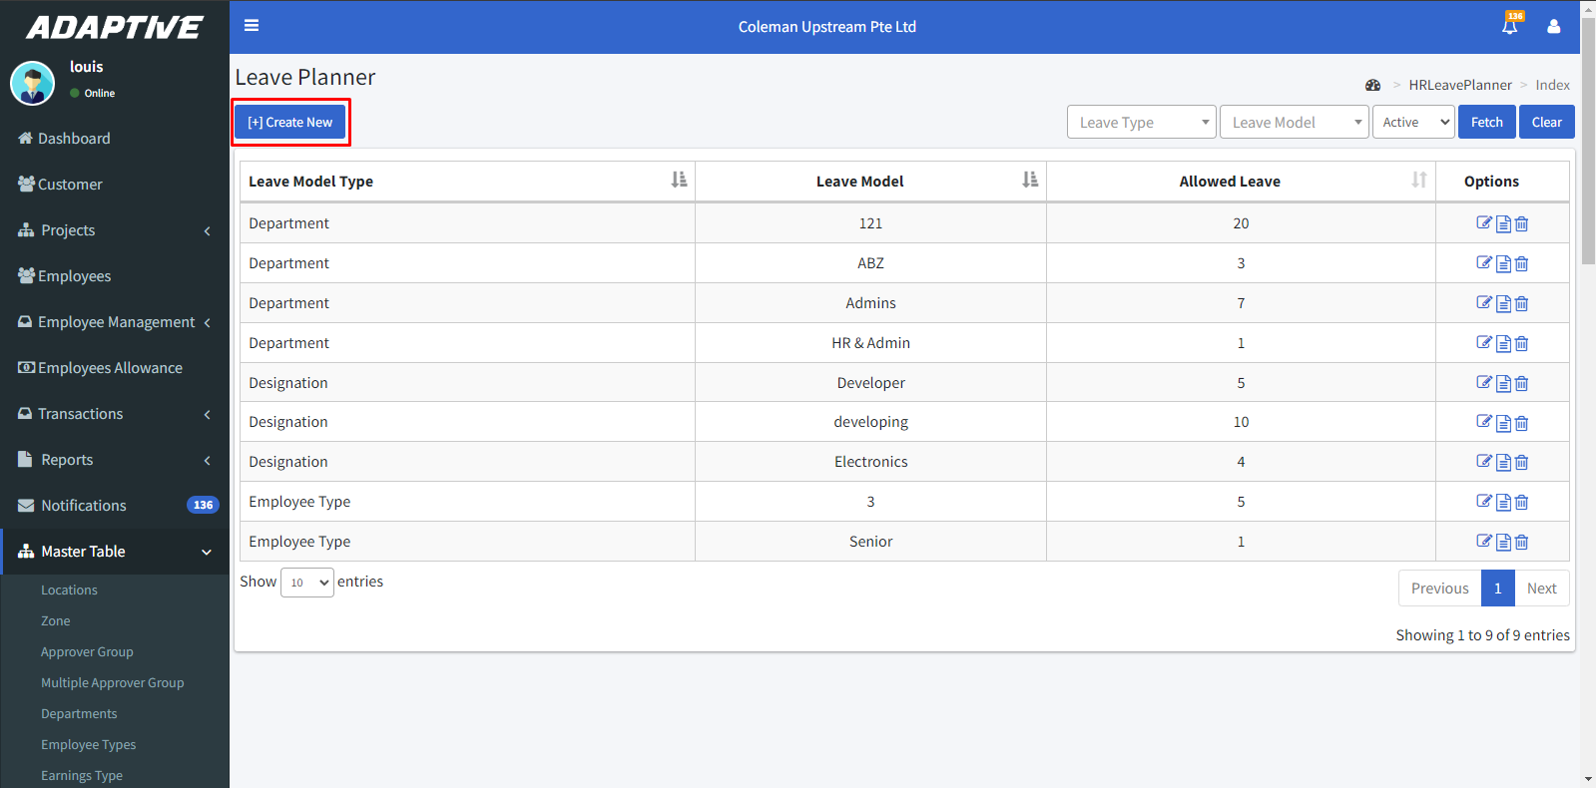

* Select the leave model type.
* Select the leave model.
* Enter the no of employees allowed to take leave on the model.
* Click **“Save & Close”**.

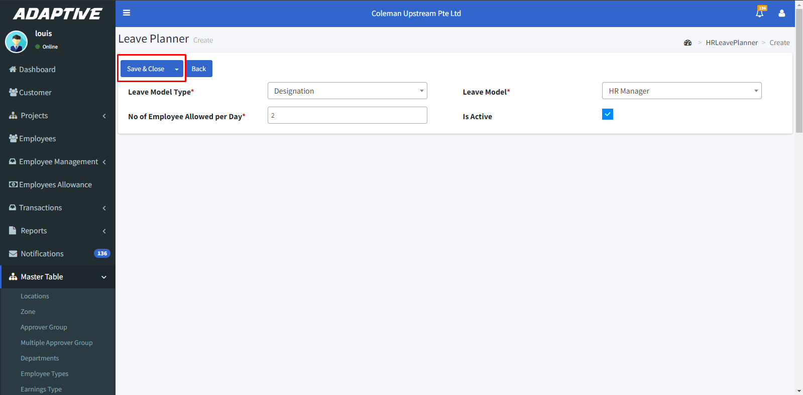

* By clicking the icon we can view the details.

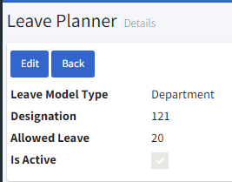

* By clicking the icon we can delete it.

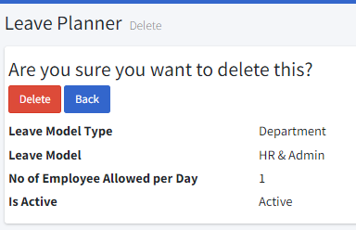

**2.9. Loan Types:**

* Go to Master table > Loan types.
* You can filter the list by active and inactive.
* By clicking the icon we can edit.
* Click the **“Create new”** icon to createa new loan type.

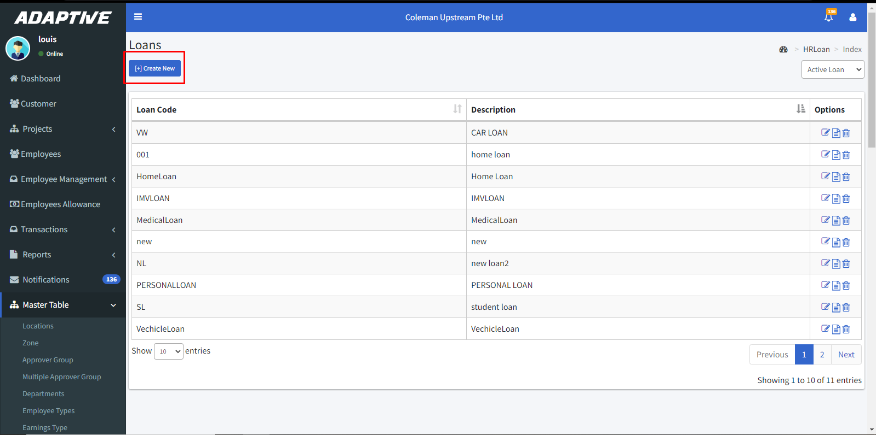

* Enter the Loan code and Description.
* Then click the **“Save & Close”** button to save.

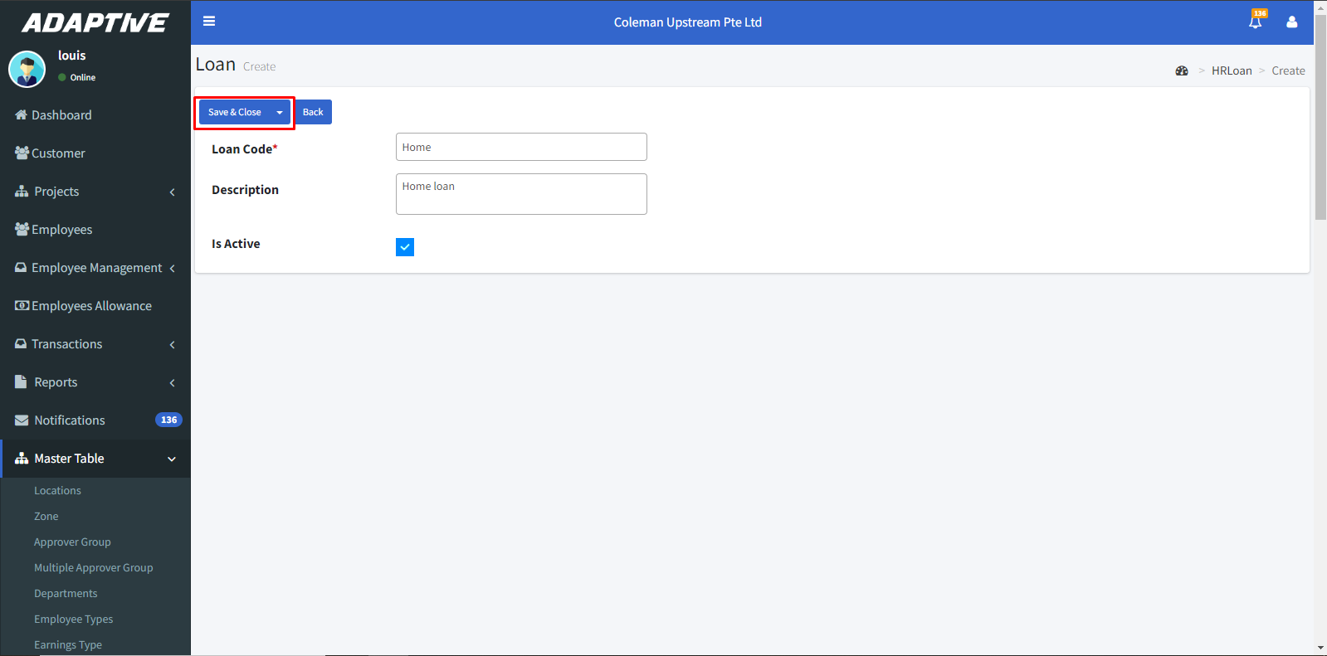

* By clicking the icon we can view the details.

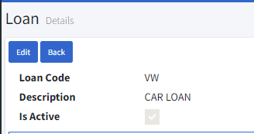

* By clicking the icon we can delete it.

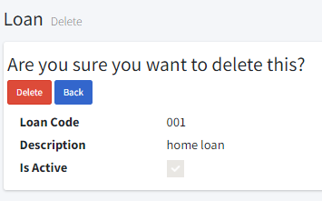

**2.10. Public Holidays:**

* Go to Master table > Public holidays.
* You can filter the list by enter the year by clicking the **fetch** button and clear the filter by **clear** button.
* By clicking the icon we can edit.
* Click the “Create New” icon to create a new public holiday.

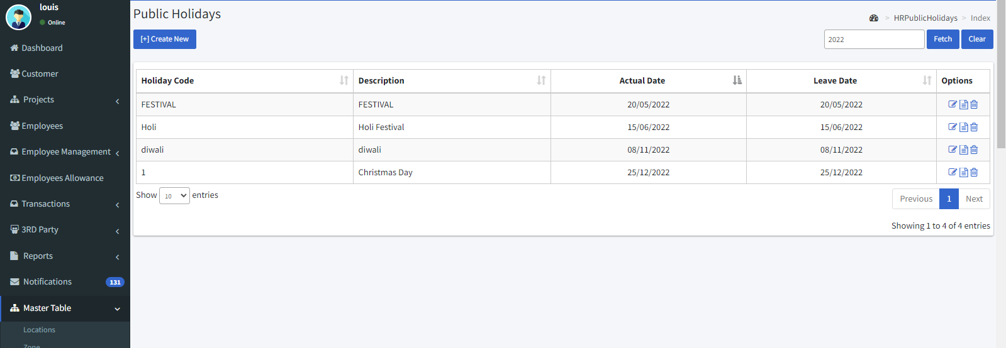

* Enter the holiday code and description.
* Enter the Actual date and leave date.

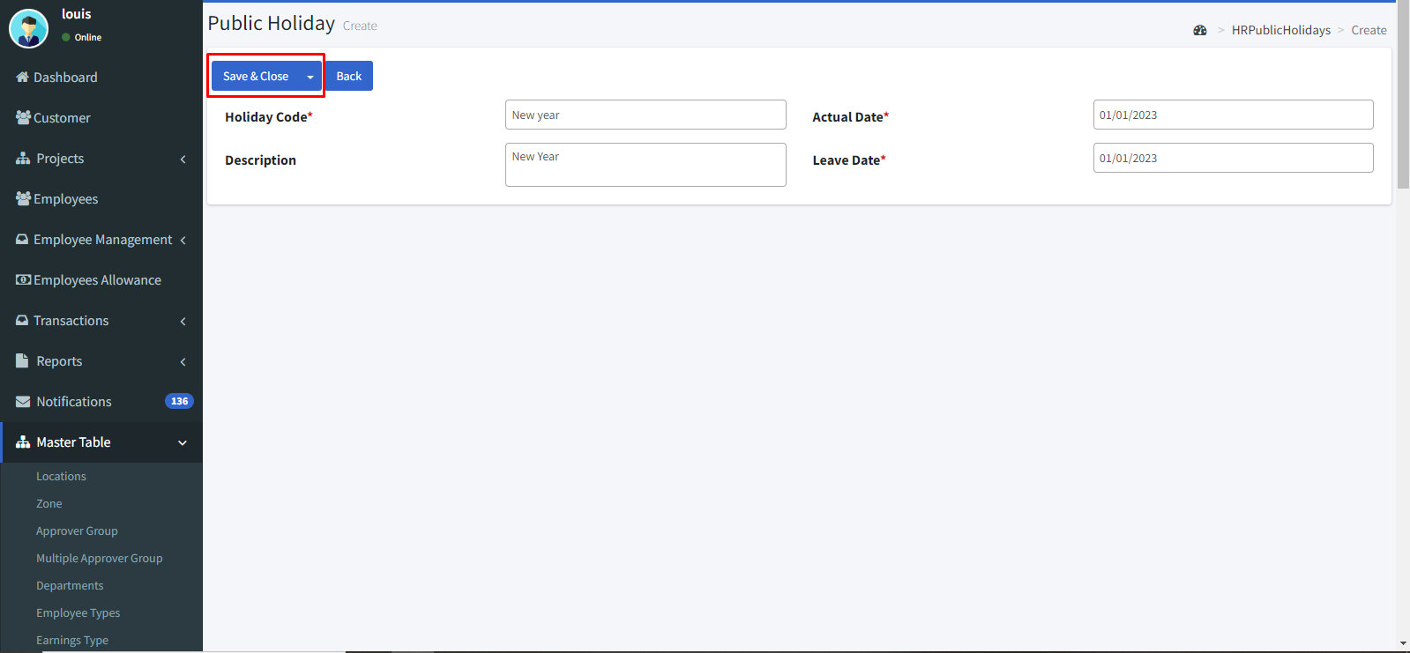

* By clicking the icon we can view the details.

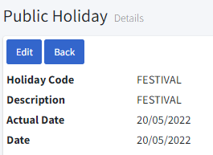

* By clicking the icon we can delete it.

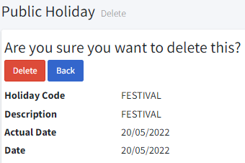

**2.11. Work Shifts:**

* Go to Master table > Work shifts.
* You can filter the list by active and inactive by clicking the **fetch** button and clear the filter by **clear** button.
* By clicking the icon we can edit.
* To create a new shift time, click the **“Create New”** icon.

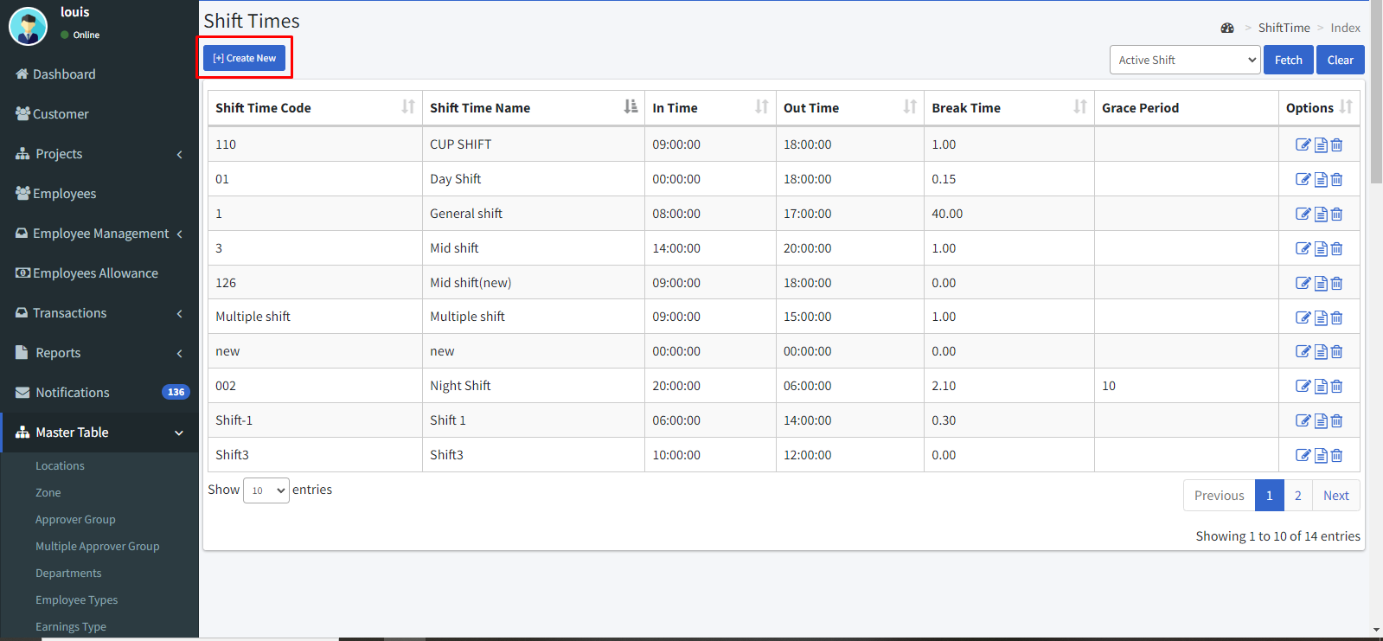

* Enter the shift time code and shift time name.
* Enter the in time and out time.
* Enter the grace in out time.
* Then clickthe **“Save & Close”** icon to save.

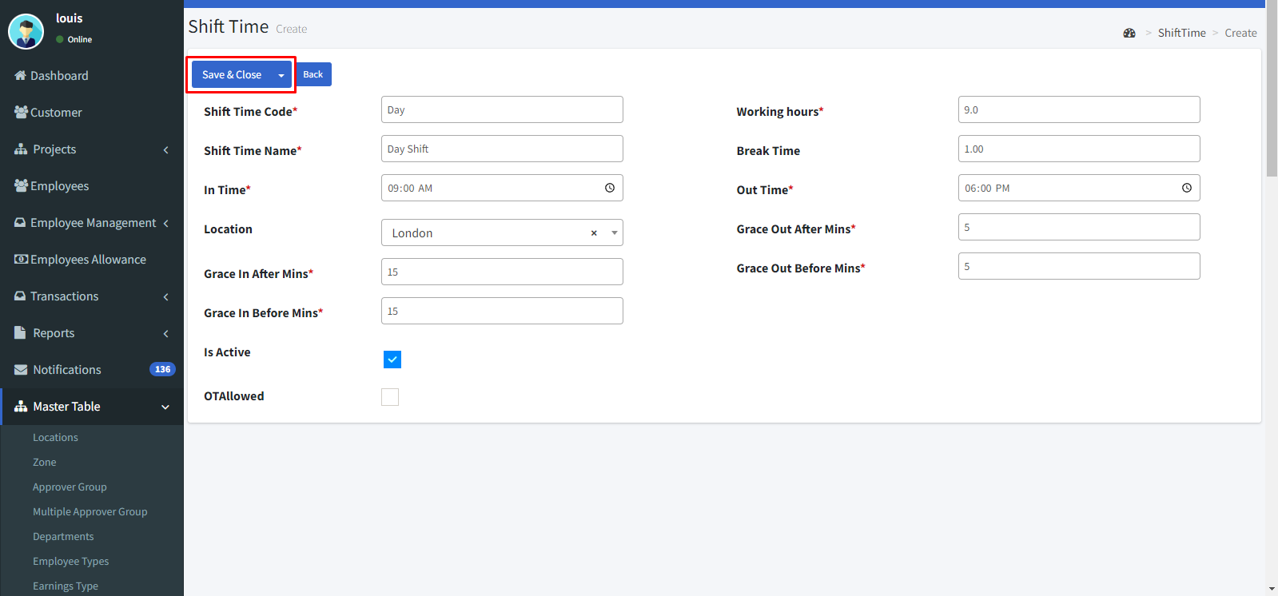

* By clicking the icon we can view the details.

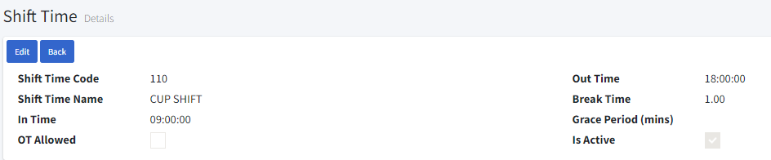

* By clicking the icon we can delete it.

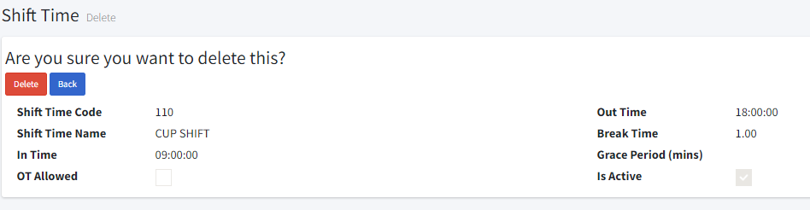

**2.12. Claim Types:**

* Go to Master table > Claim types.
* You can filter the list by active claim by clicking the **fetch** button and clear the filter by **clear** button.
* By clicking the icon we can edit.
* To create a new claim type, click the **“Create New”** icon.

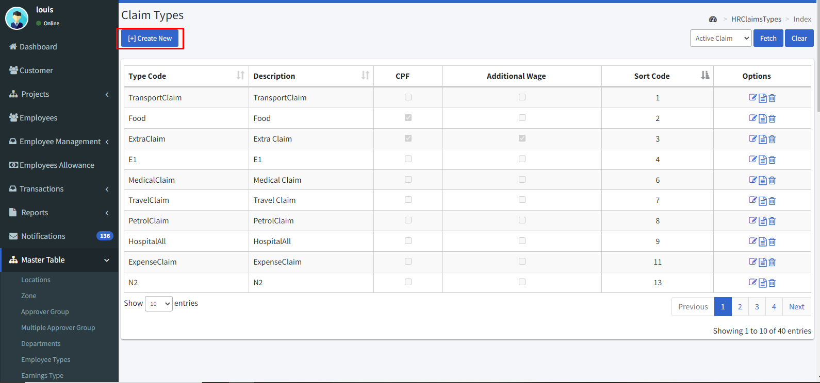

* Enter the type code and description.
* Enter the maximum amount allowed per instance, per annum, per month.
* Enable the **“CPF”** check box if the claim was eligible for CPF payable.
* Enable the **“Is Attachment required”** check boxif the attachment is required for this clam.

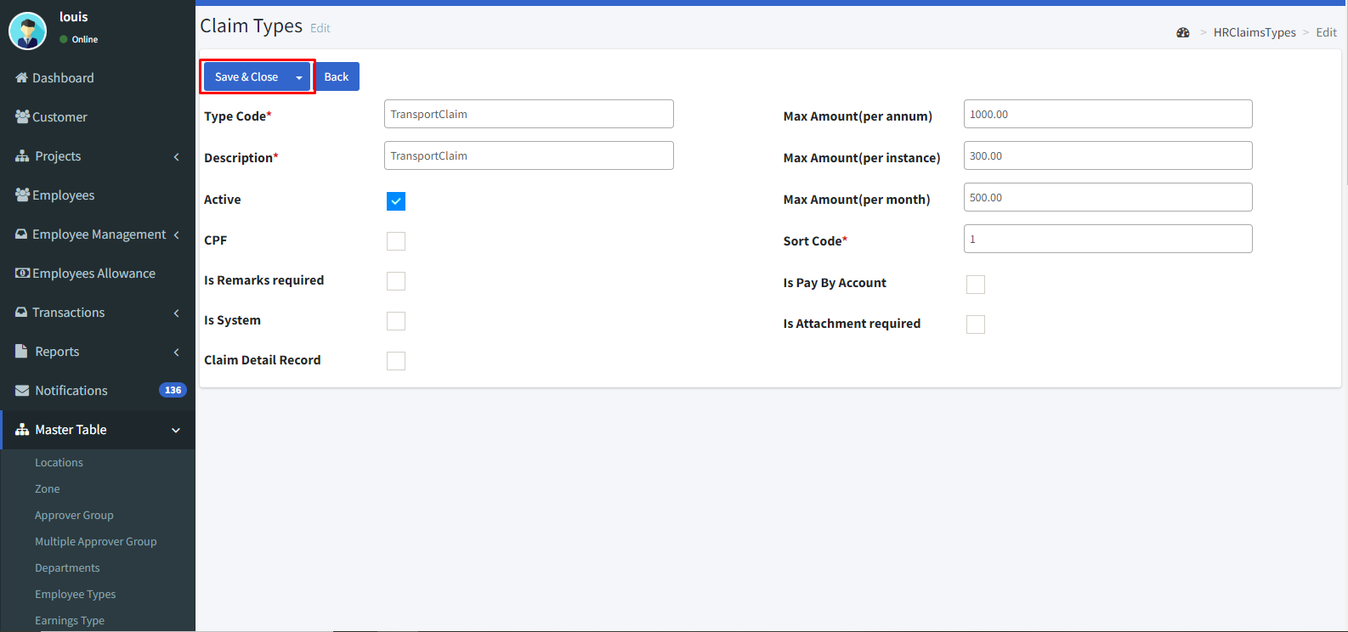

* By clicking the icon we can view the details.

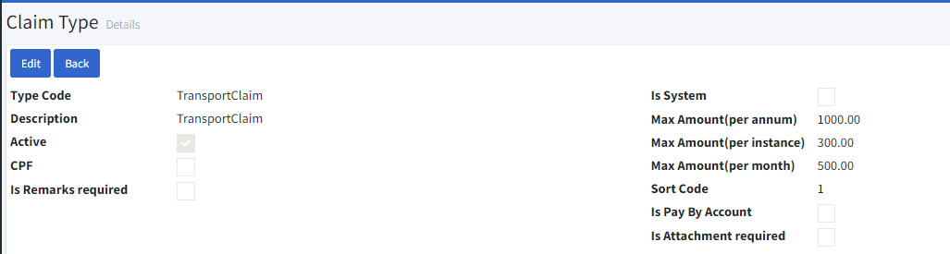

* By clicking the icon we can delete it.

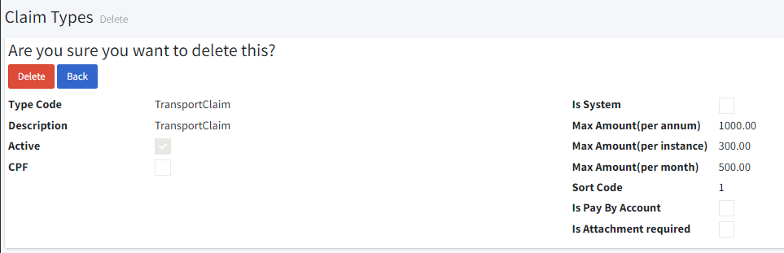

**2.13. OT Types:**

* Go to Master table > OT Types.
* You can filter the list by active and inactive by clicking the **fetch** button.
* By clicking the icon we can edit.
* Click the **“Create new”** icon to create an OT Type.

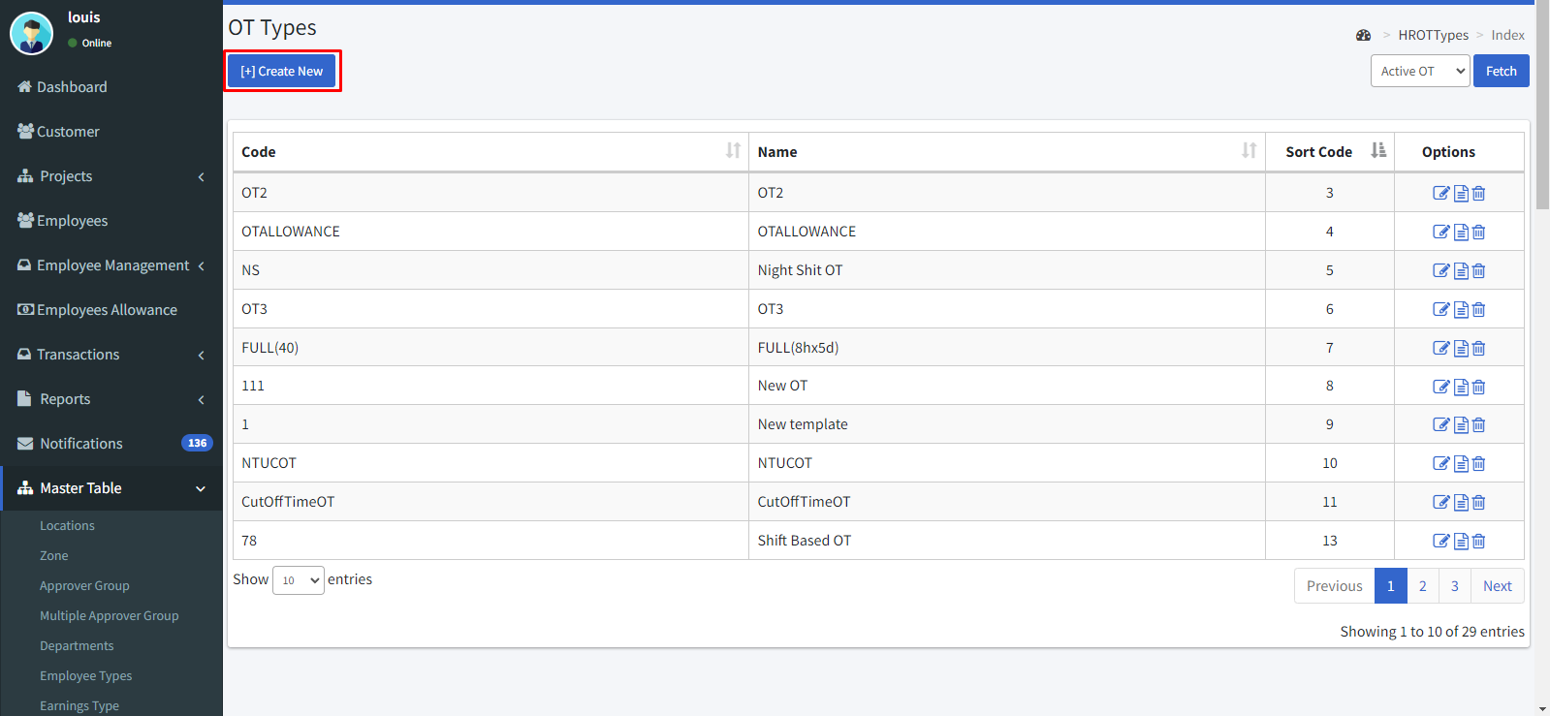

* Enter the OT code and name.
* Assign the minimum hours for the break time.
* Then click the “Save & Close” icon to save.

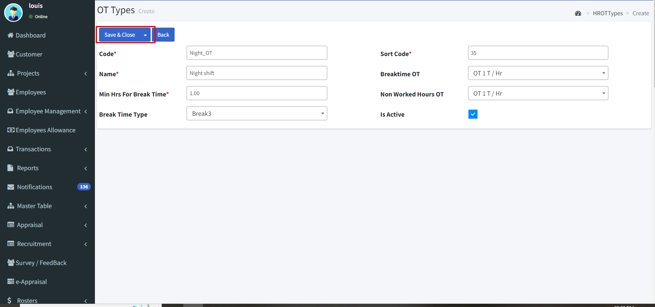

**Multiple break time:**

**In multiple break time**

* Select the break type.
* Click the icon in break time column.

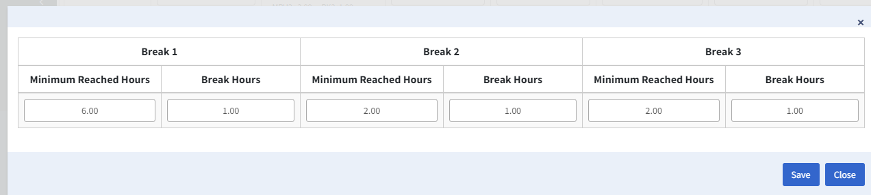

* If the minimum hours reached employee can allowed to take the given break hours.
* Enter the minimum reached hours and break hours then click the **Save** icon.
* By clicking the icon we can view the details.

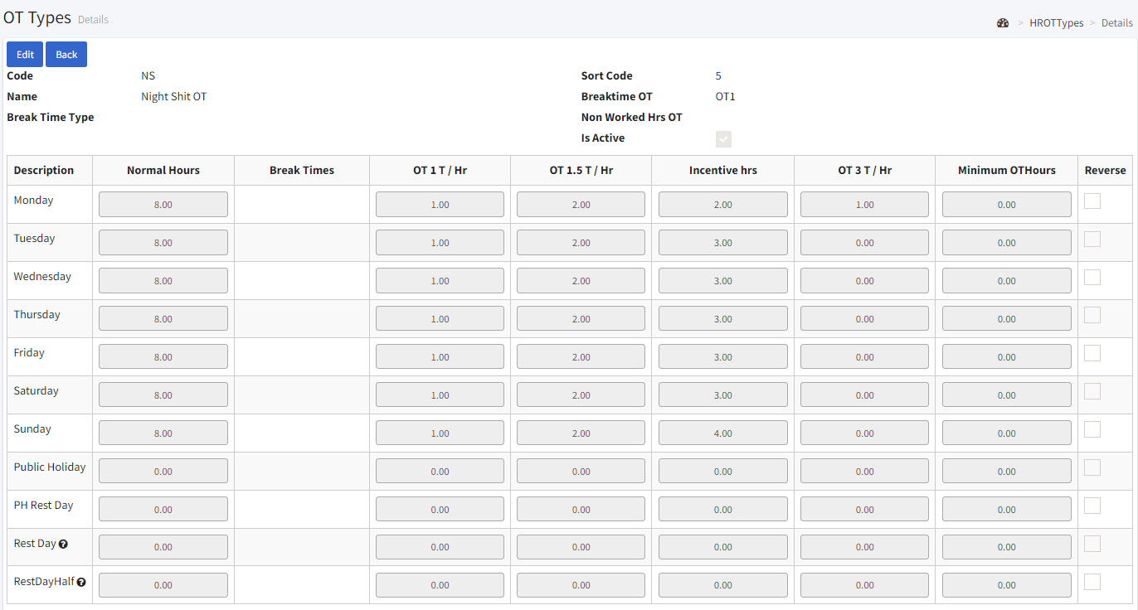

* By clicking the icon we can delete it.

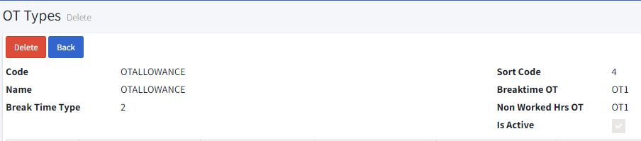

**2.14. Pass Expiry:**

* Go to Master table > Pass expiry.
* You can filter the list by type name by clicking the **fetch** button and clear the filter by **clear** button.
* By clicking the icon we can edit.
* Click the **“Create New”** icon to create a new Pass expiry.

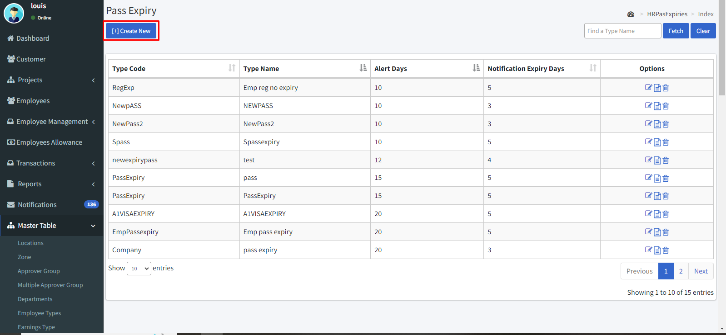

* Enter the type code and name.
* Enter the alert days.
* Then click the **“Save & Close”** icon to save.

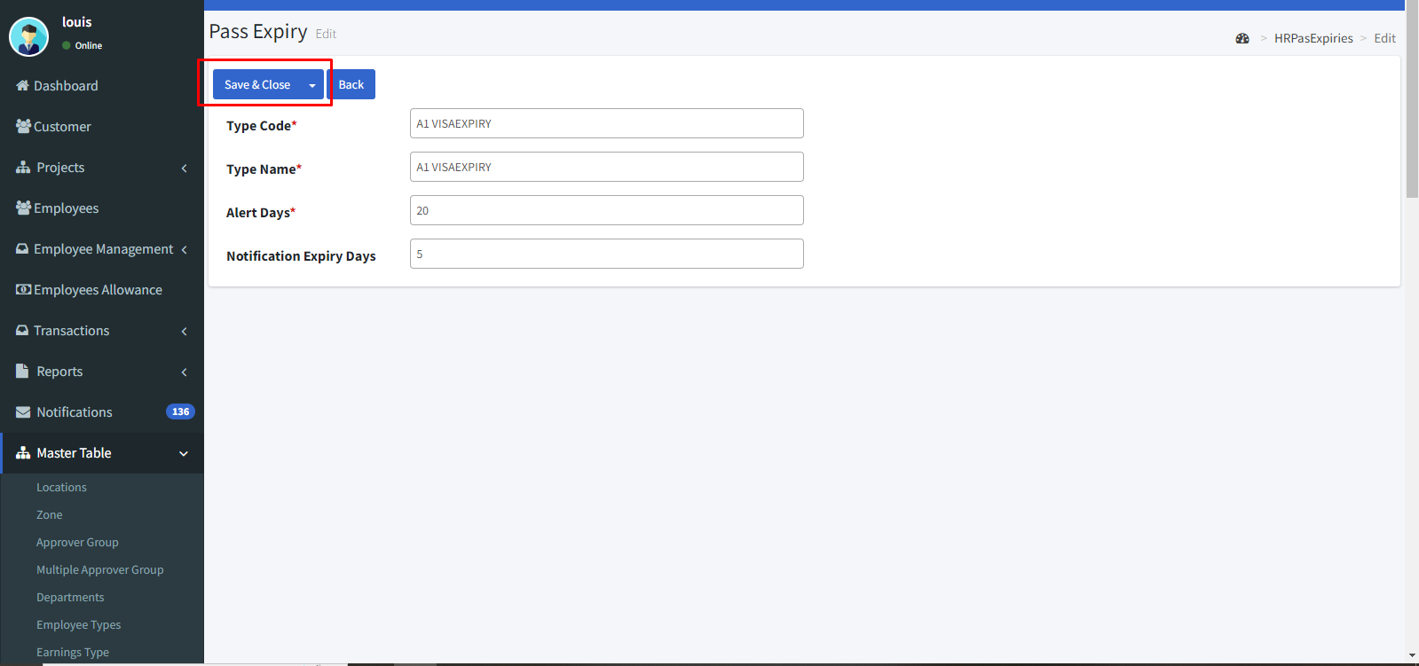

* By clicking the icon we can view the details.

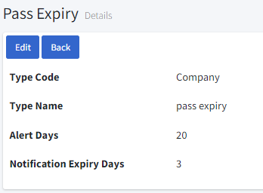

* By clicking the icon we can delete it.

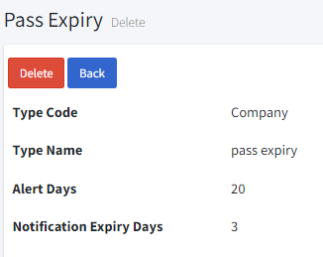

**2.15. Training:**

* Go to Master table > Training.
* You can filter the list by find name code, active by clicking the **fetch** button and clear the filter by **clear** button.
* By clicking the icon we can edit.
* Click the **“Create New”** icon to create.

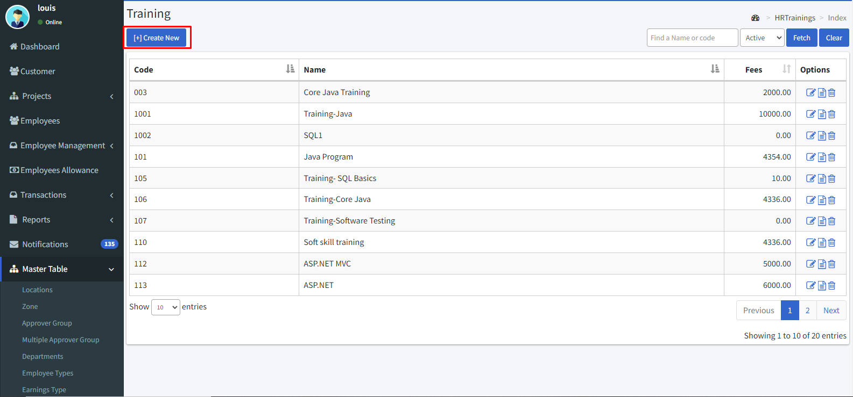

* Give code for the training.
* Enter the Training name and duration period.
* Enter the skills and fees details.
* Enter the subsidy and subsidy person.
* If there are any employee contributions means fill this field.
* Enter the minimal requirement for this training.
* Enable the **“Expiry”** check box when it expires.
* Enable the **“Curriculum”** check box if needed**.**

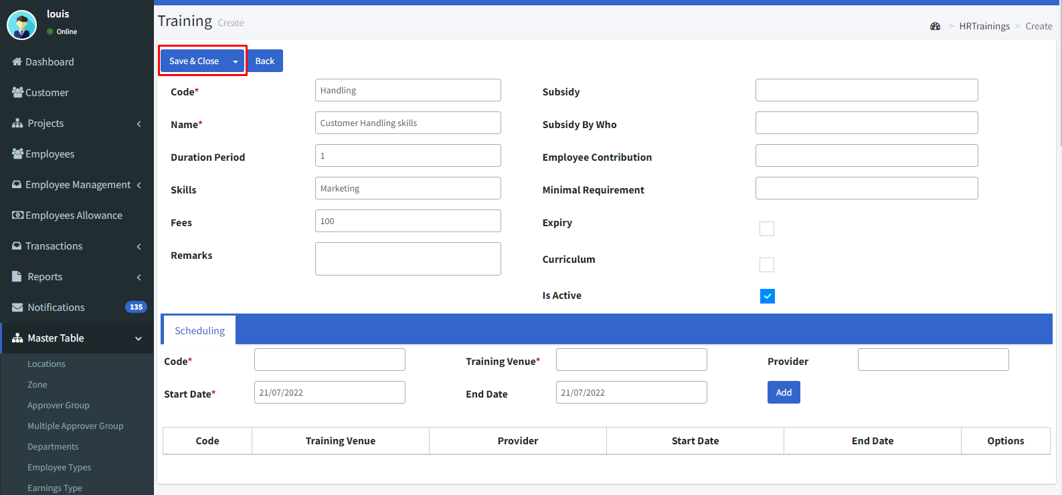

**Scheduling:**

* Give the code and Enter the training venue.
* Enter the training provider name.
* Enter the start and end date.
* Then click the **“Add”** button and the **“Save & Close”** button to save.
* By clicking the icon we can view the details.

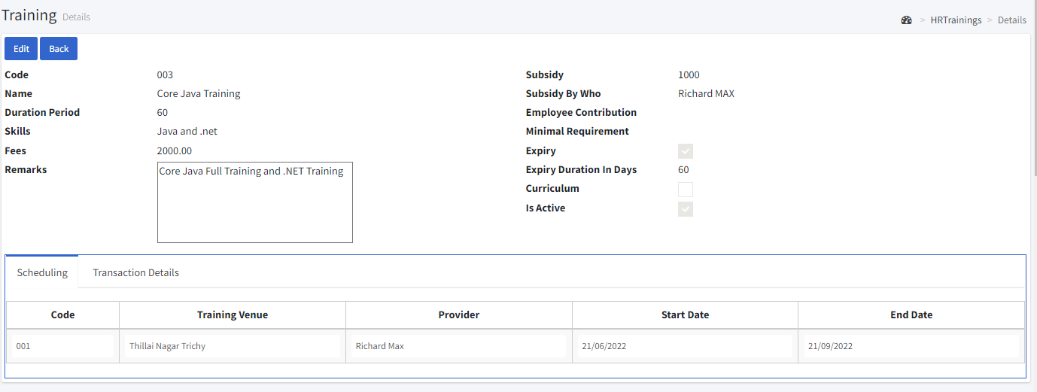

* By clicking the icon we can delete it.

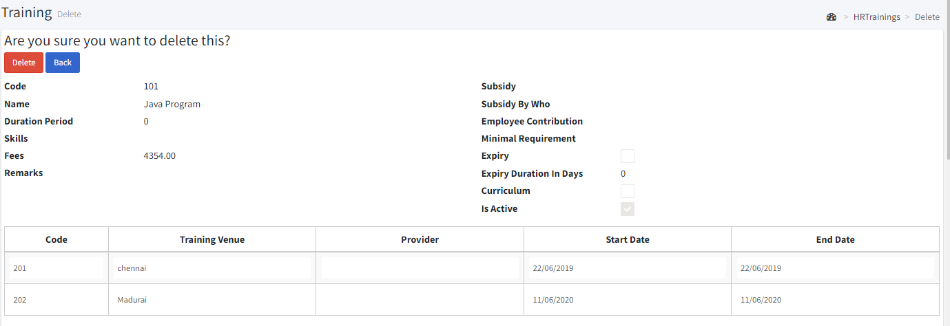

**2.16. Biometric devices:**

* Go to Master table > Bio devices.
* You can filter the list by find a name, chose location name, active and inactive by clicking the **fetch** button and clear the filter by **clear** button.
* By clicking the icon we can edit.
* Click the “Create New” icon.

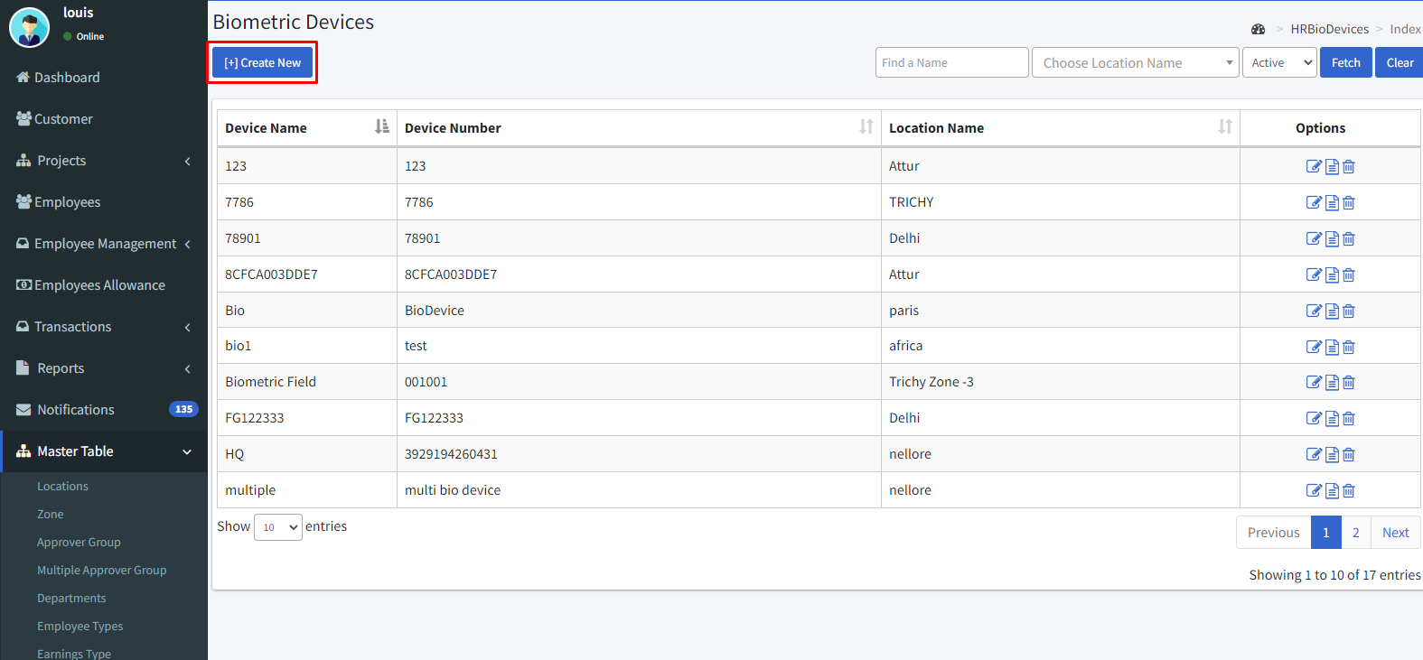

* Then enter the biometric device name and number.
* Enter the location name.
* Enter the project and project location.
* Then click the “Save & Close” button to save.

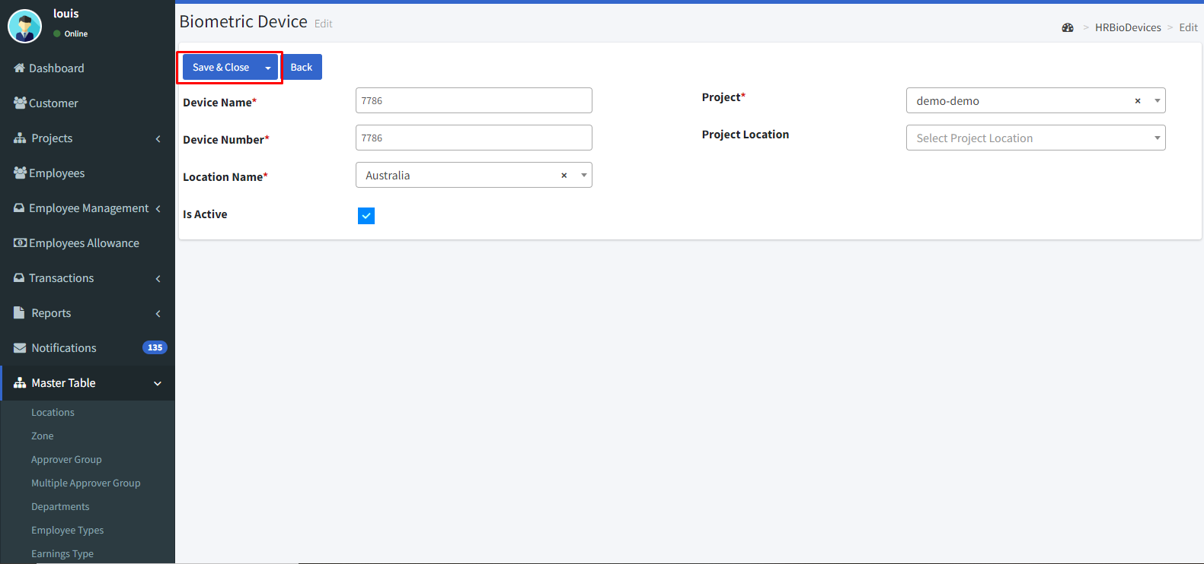

* By clicking the icon we can view the details.

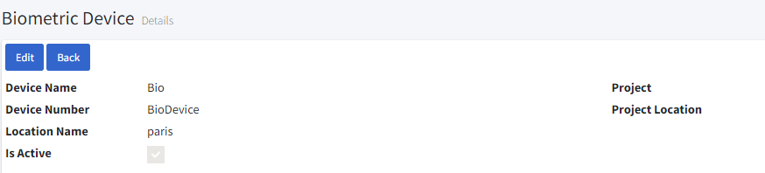

* By clicking the icon we can delete it.

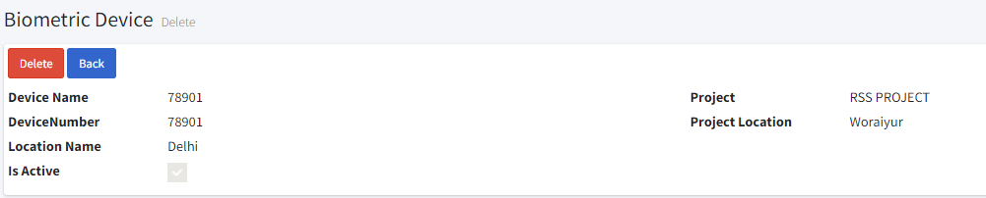

**2.17. Banks:**

* Go to Master table > Banks.
* You can filter the list by active and inactive by clicking the **fetch** button.
* By clicking the icon we can edit.
* Click the “Create New” icon.

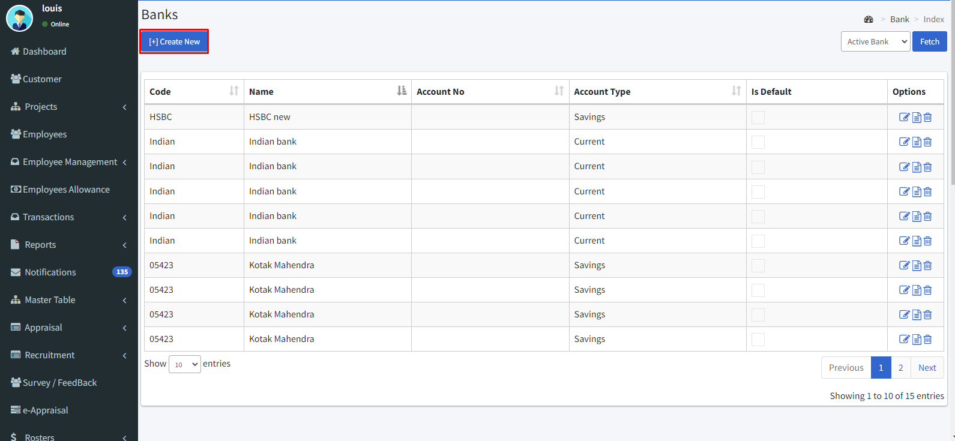

* Enter the bank code and Name.
* Enter the bank account number.
* Give display name and beneficiary name.
* Enter the phone number.
* Enter the branch code.
* Enter the swift code.
* Enter the IFSC code.
* Select the account type.
* Select the file format.
* Select the chart of account.
* Enter address, city, country, and postal code.
* Select currency.
* Then click **“Save & Close”**.

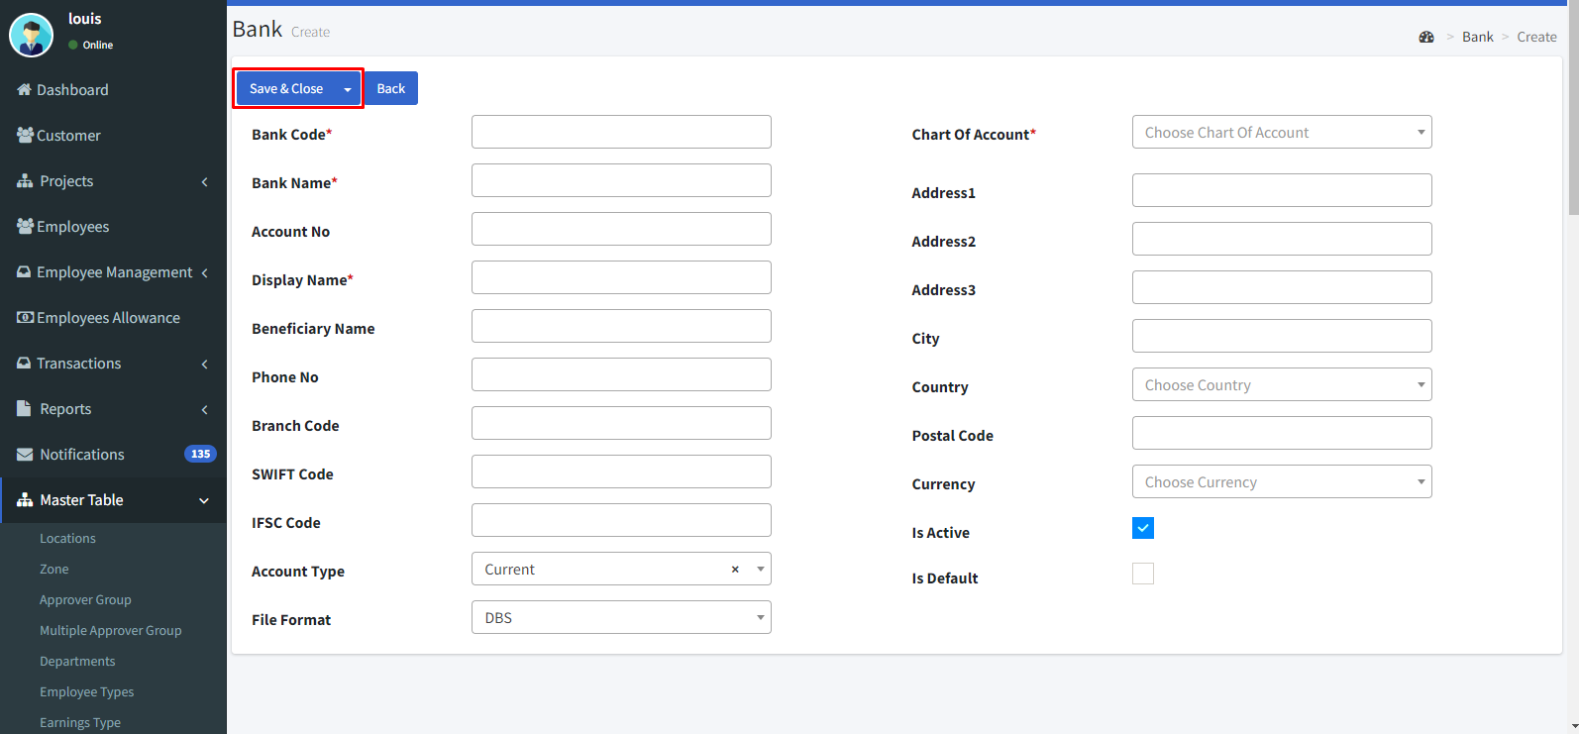

* By clicking the icon we can view the details.

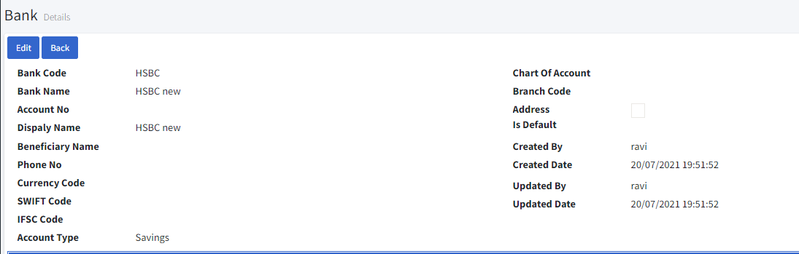

* By clicking the icon we can delete it.

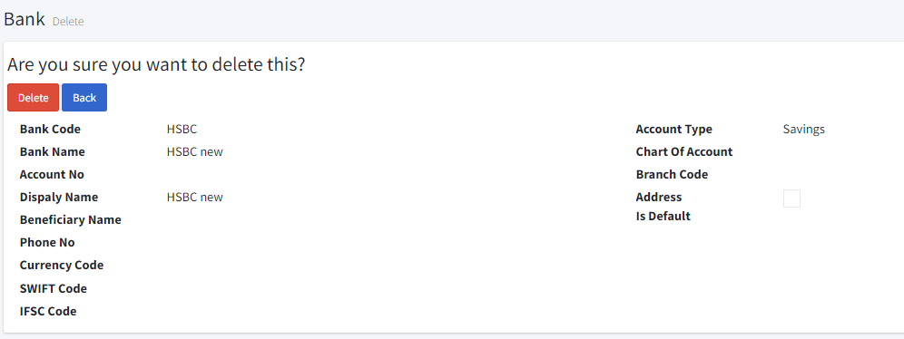

**2.18. Leave Template:**

* Go to Master table > Leave template.
* You can filter the list by find a name by clicking the **fetch** button and clear the filter by **clear** button.
* By clicking the icon we can edit.
* Click the **“Create new”** icon.

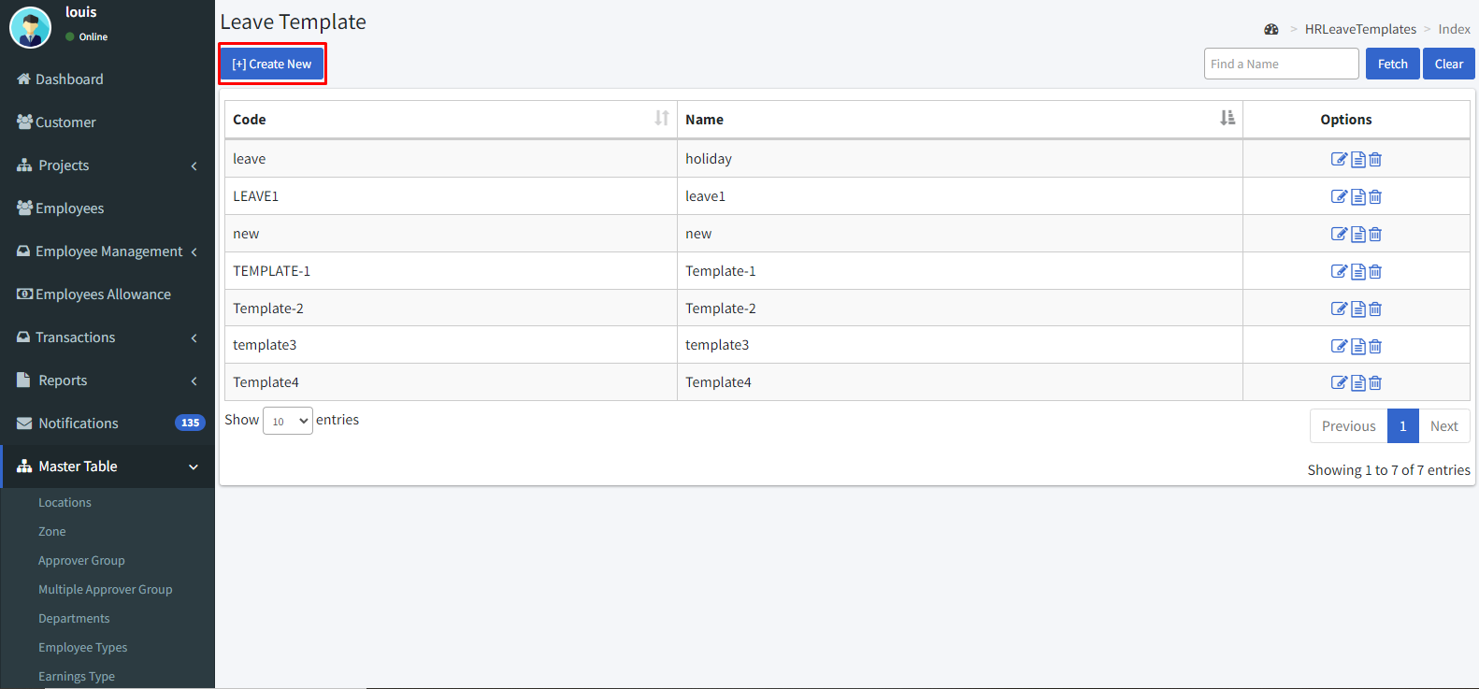

* Enter the code and name.
* Then click the **“Save & Close”** icon.

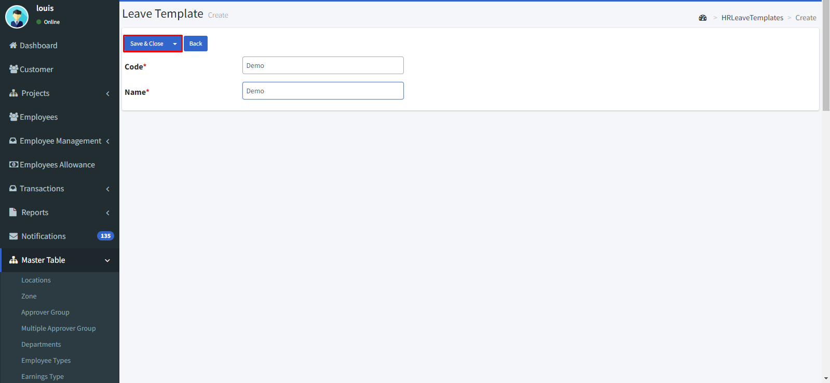

* After saving it click the edit icon.
* Select the Leave types which you want to add to this leave template and click the **“Add”** button.
* Then enable the check boxes as per your norms.

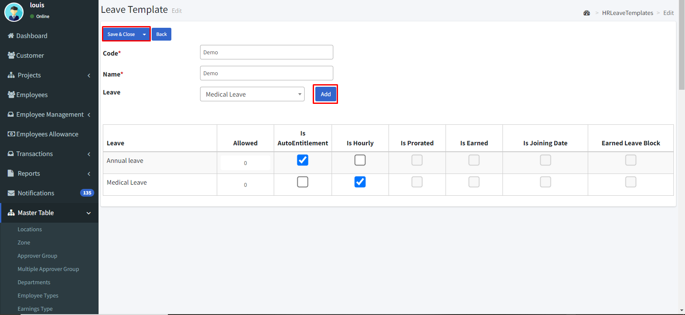

* By clicking the icon we can view the details.

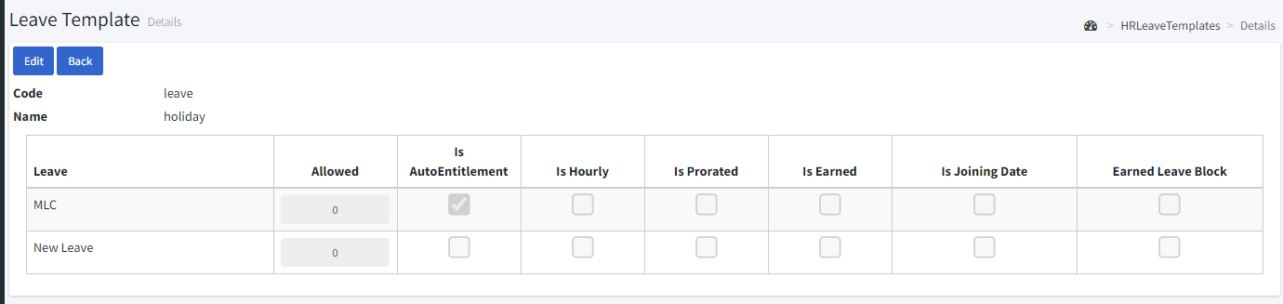

* By clicking the icon we can delete it.

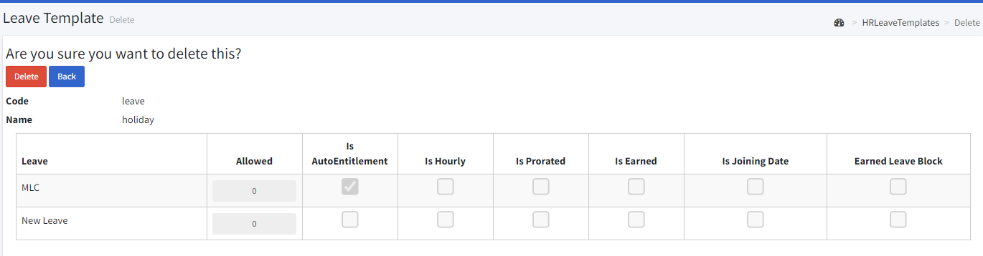

**2.19. Dynamic Pay slip:**

* Go to master table > Dynamic payslip.
* Click **“change column”.**

**Header:**

* Then click the **“Header”** icon.
* Enable each check box that you’d like to show in your payslip. E.g.: if you need to show your email, click the Email check box.
* Left, right, and center boxes are to position the header.

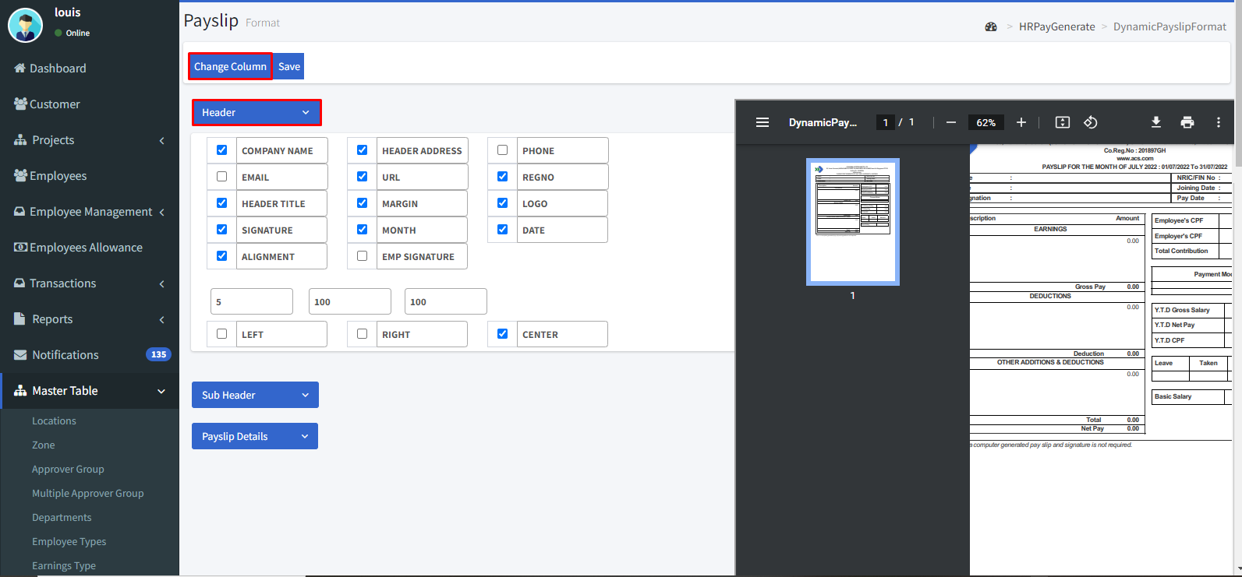

* Then click the **“sub header”** icon.
* Enable the check box which you’d like to show in your payslip.
* Then click the **“Payslip details”**
* Enable the check box which you’d like to show in your payslip.

**Sub Header:**

* Then click the **“sub header”** icon.
* Enable the check box which you’d like to show in your payslip.
* E.g. If Code is needed to show in the pay slip then enable the **code** check box.

**Payslip details:**

* Then click the **“Payslip details”**
* Enable the check box which you’d like to show in your payslip.
* E.g. If pay mode details are needed to show in the pay slip then enable the **pay mode details** check box.

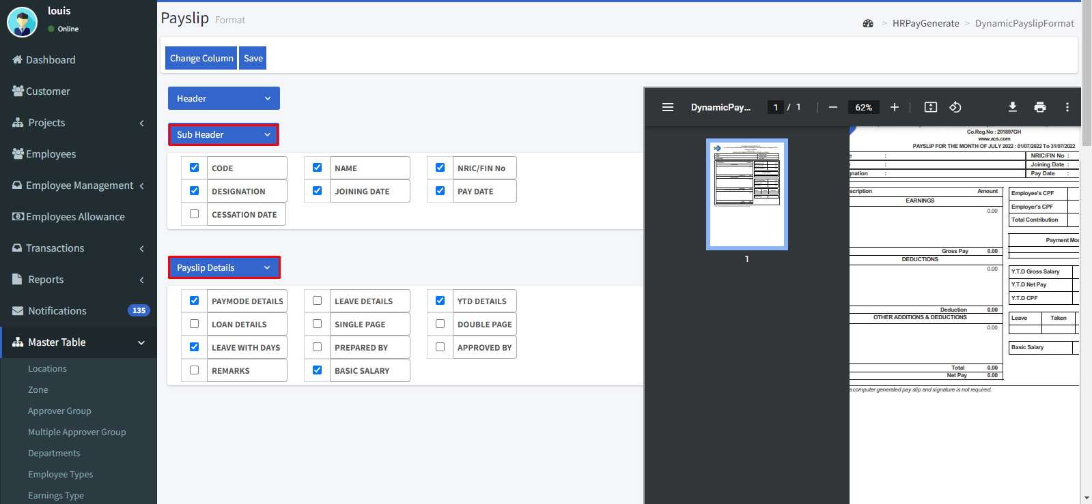

* Then click **the “Save**” icon to save it.

**3. Rosters**

**3.1. Current Roster**

* Go to Rosters > Current rosters.
* You can filter the list by select month and year by clicking the **fetch** button and clear the filter by **clear** button.
* By clicking the icon we can edit.
* Click the **“Create New”** icon.

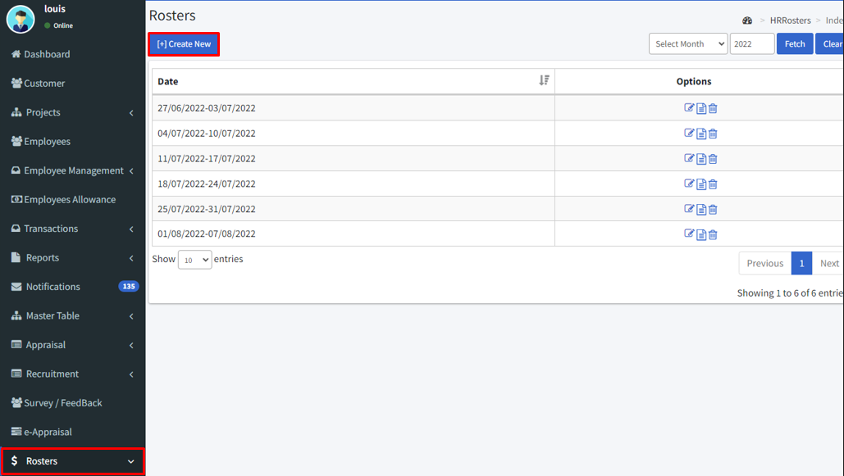

* Now click the **“staff”** icon to assign the roster by staff base.
* Then select the employee then enter the start and end time.
* Then add location.
* To add another employee, click the **“Add employee”** icon.

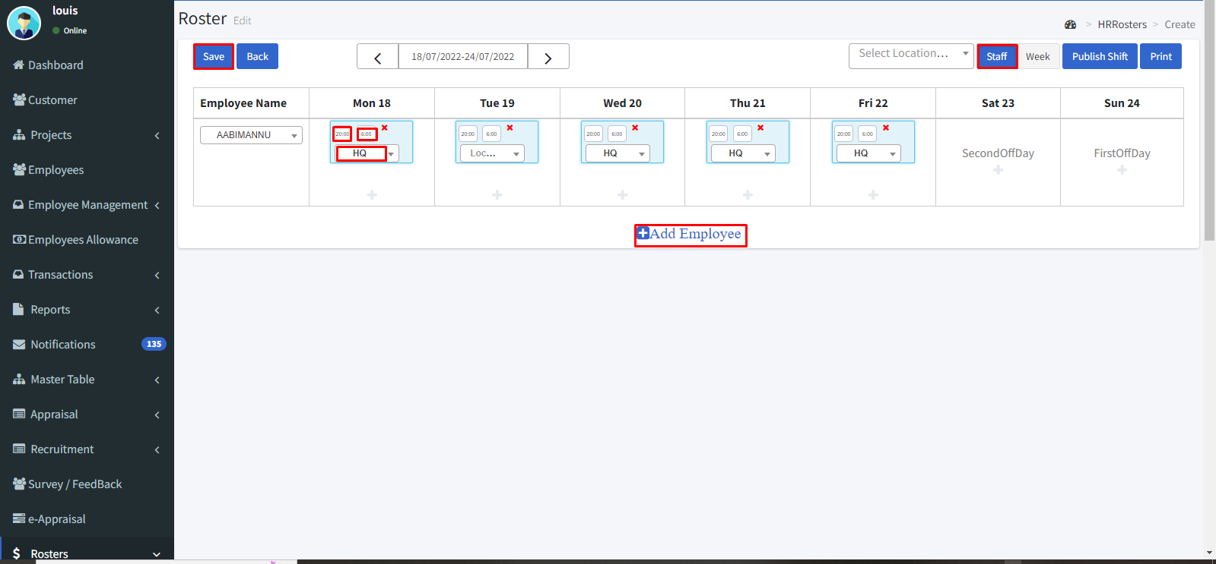

* Now click the **“Week”** icon to assign the roster by week base.
* Then select the employee from the drop-down and enter the start and end times.
* Then add location.
* Then click the **“Publish”** icon and proceed to the Roster.
* Print option can be done by clicking the **“Print”** icon.
* Then click the **“Save”** button.

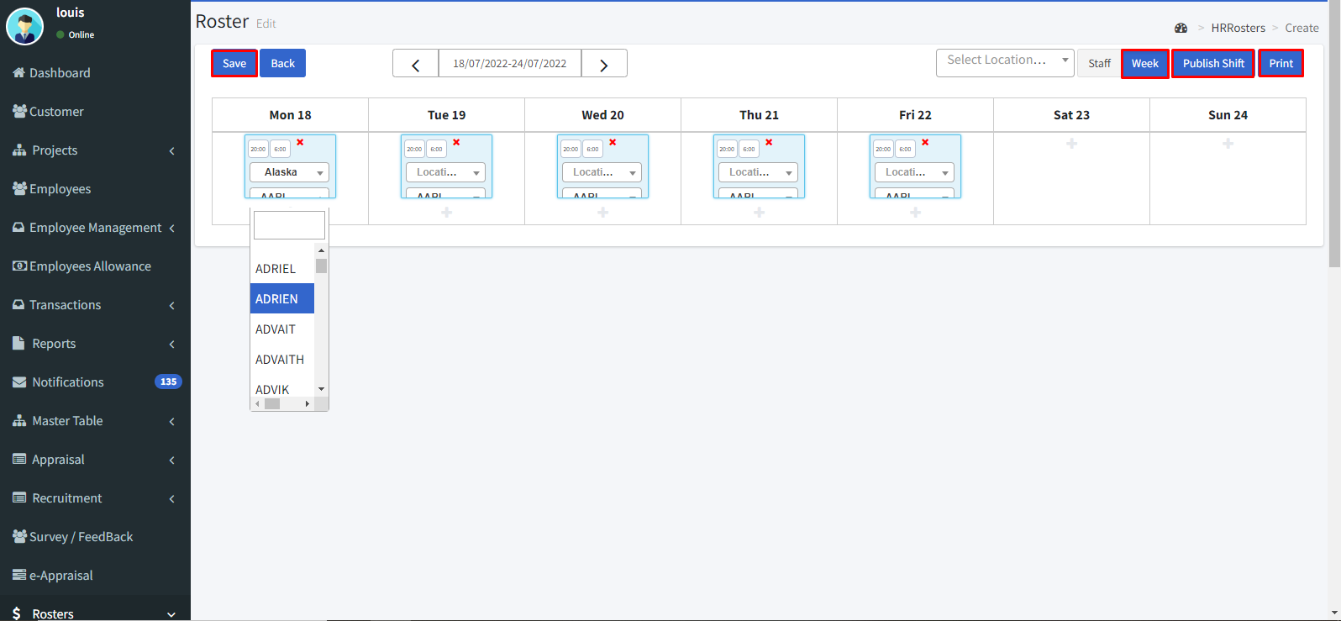

* By clicking the icon we can view the details.

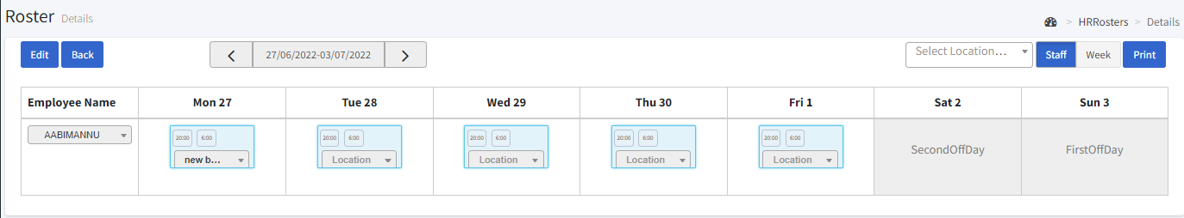

* By clicking the icon we can delete it.

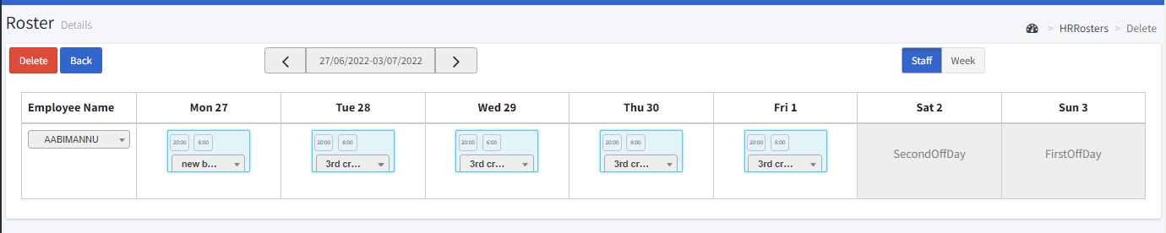

**3.2. Employee week off**

* Roster > Employee week off.
* You can filter the list by department, employee type, month, year, zone and location by clicking the **fetch** button and clear the filter by **clear** button.
* Enter the employee name and click the **“Fetch”** button.
* Then assign the week off days by weekly.
* After assigning click the **“Save”** button.

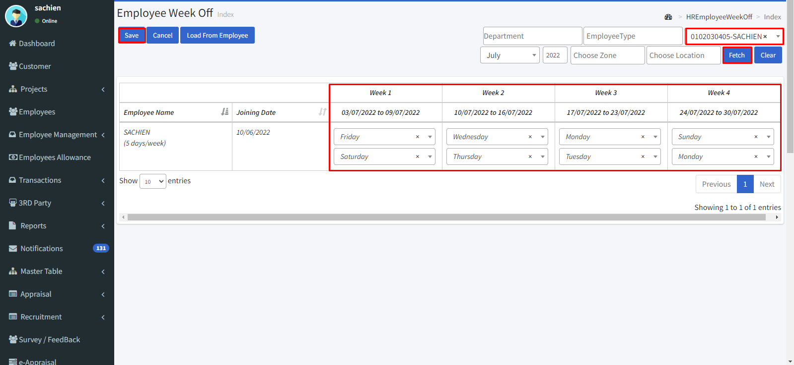

**3.3. Monthly View**

* To view the roster in a month view.
* Go to Roster > Monthly view.
* Select the month and location.
* Then click the “**Fetch**” icon.

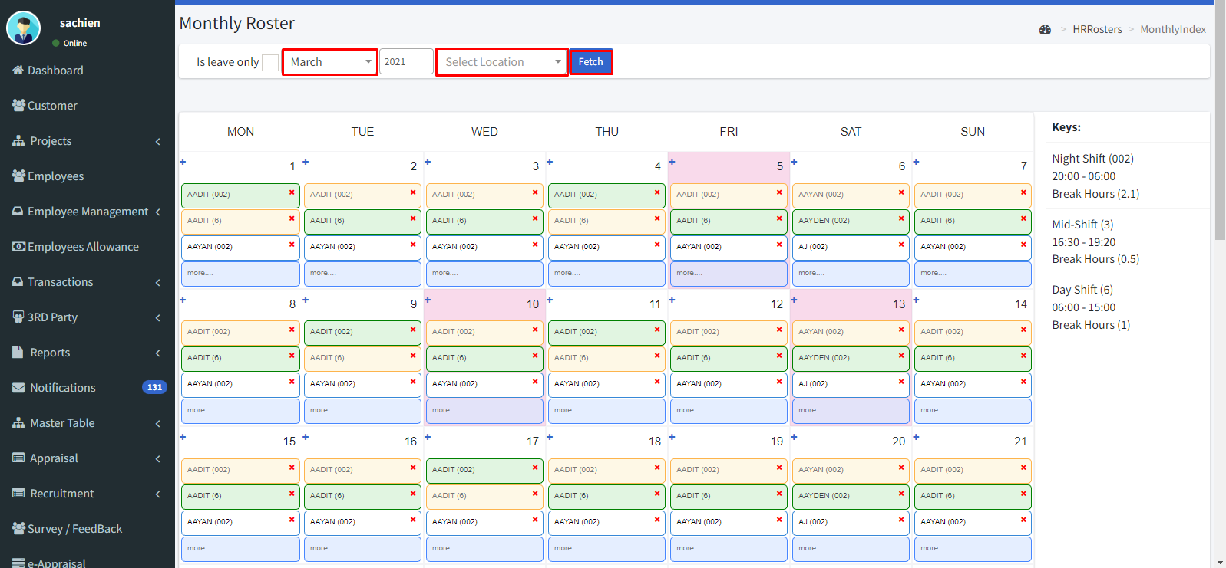

**3.4. Monthly Comparison**

* Go to Roster > Monthly comparison.
* In monthly comparison, you can view employee-wise and shift-wise.
* Select date and employee to view employee wise or select shift to view shift wise.
* Then click the **“Fetch”** button to view.
* By clicking the **Export excel** button can download a file in excel format.
* By clicking the **Print** button, it allows to take a hard copy.

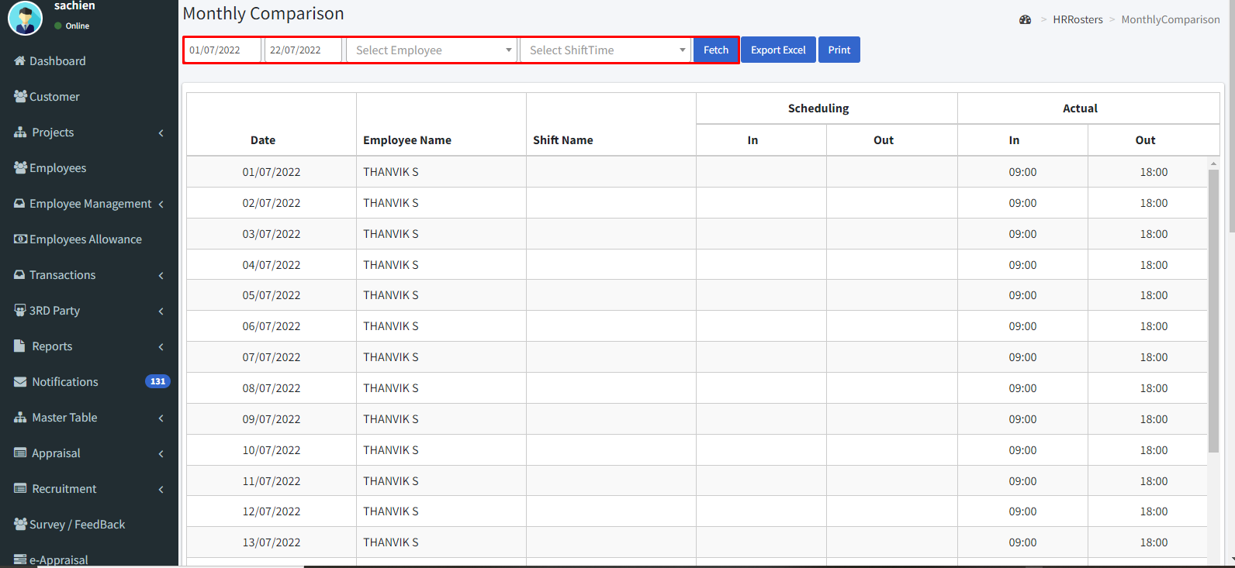

**4. Recruitment**

**4.1. Resume template:**

* Go to Recruitment > Settings > Resume Template.
* Click the create new icon.
* Enter the template name.
* Select Group as per your needs.
* Enable the check box which you need.
* If the detail is mandatory then enable the starred check box.
* Then click “Save Template”.

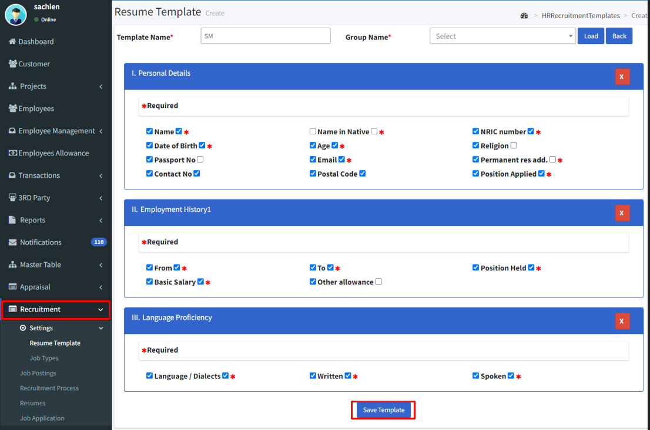

**4.2. Job type**

* You can filter the list by job title, grade, active and inactive by clicking the **fetch** button and clear the filter by **clear** button.

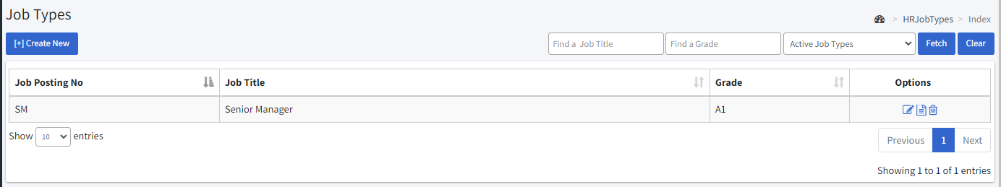

* By clicking the icon we can edit.
* Select the Job type.
* Enter the job title.
* Enter the job description and duties.
* Select type of employment.
* Enter the skills required.
* Select the minimum and maximum qualifications.
* Select the grade level.
* Enter the minimum years of experience.
* Click the **“Add file”** icon to add an attachment.

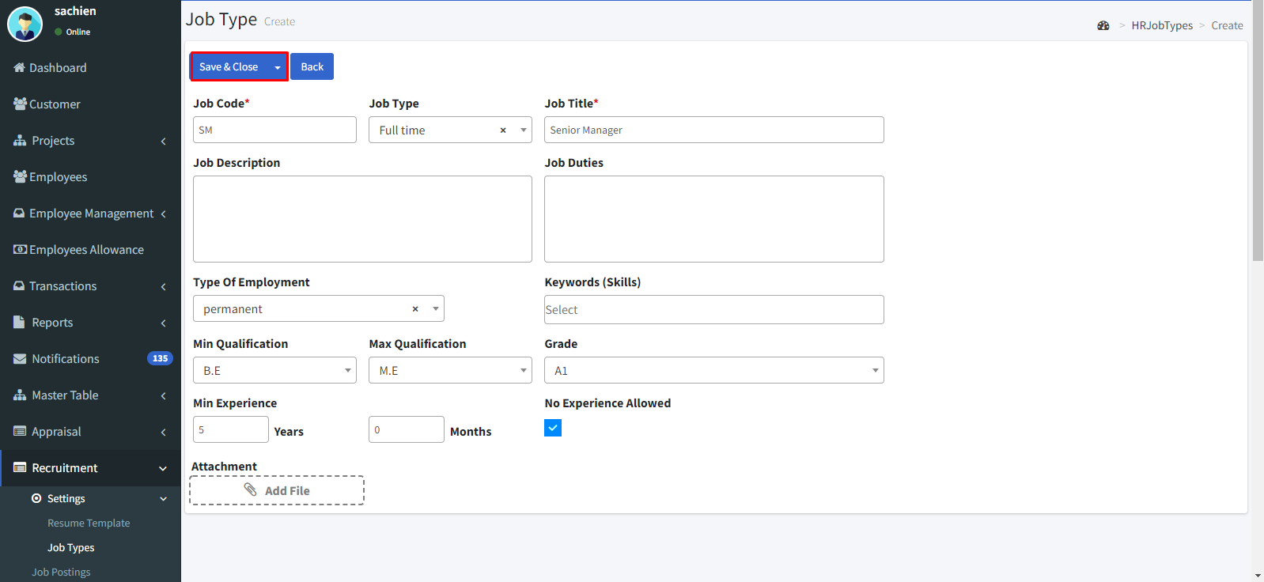

* By clicking the icon we can view the details.

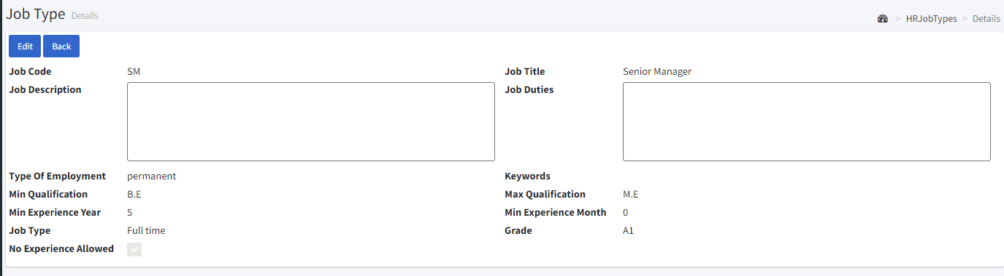

* By clicking the icon we can delete it.

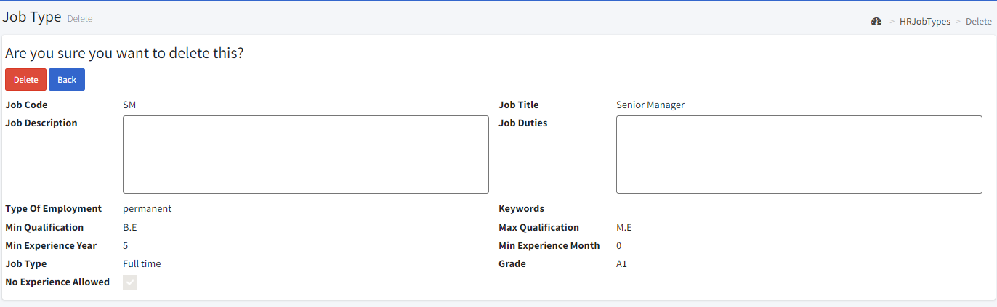

**4.3. Job Postings:**

* You can filter the list by job title, grade, new and posted by clicking the **fetch** button and clear the filter by **clear** button.
* By clicking the icon we can edit.
* Click the create a new icon to create.

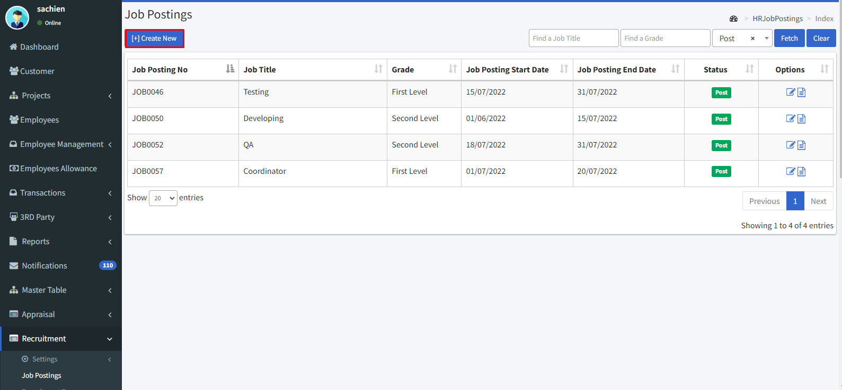

**Job Title Template**

Select the job template.

**Job Title**

Enter the Job title.

**Job Posting No**

Enter the Job Posting Number.

**Resume Template**

Select the resume template.

**No of Vacancy**

Enter the vacancy for the job.

**Job Posting Start Date**

Enter the posting start date.

**Job Posting End Date**

Enter the posting end date.

**Project Location**

Select the project location.

**Job Type**

Select the job type.

**Type of Employment**

Select the type of employment.

**Keywords (Skills)**

Enter the required skills.

**Grade**

Select the grade.

**Min Qualification**

Select the minimum qualification.

**Max Qualification**

Select the maximum qualification.

**Min Experience**

Select the minimum level of experience.

**Salary Range**

Enter the range of salary.

**No Experience Allowed**

Enable the check box if experience candidates are not allowed to apply for posting.

**Intern Allowed**

Enable the check box if internship candidates are allowed.

**Expected Joining Period**

Enter the expected joining date.

**Estimated Joining Date**

Enter the estimated joining date.

**User Name**

It shows which person posted this job.

**Job Description**

Enter Job Description.

**Job Duties**

Enter Job Duties.

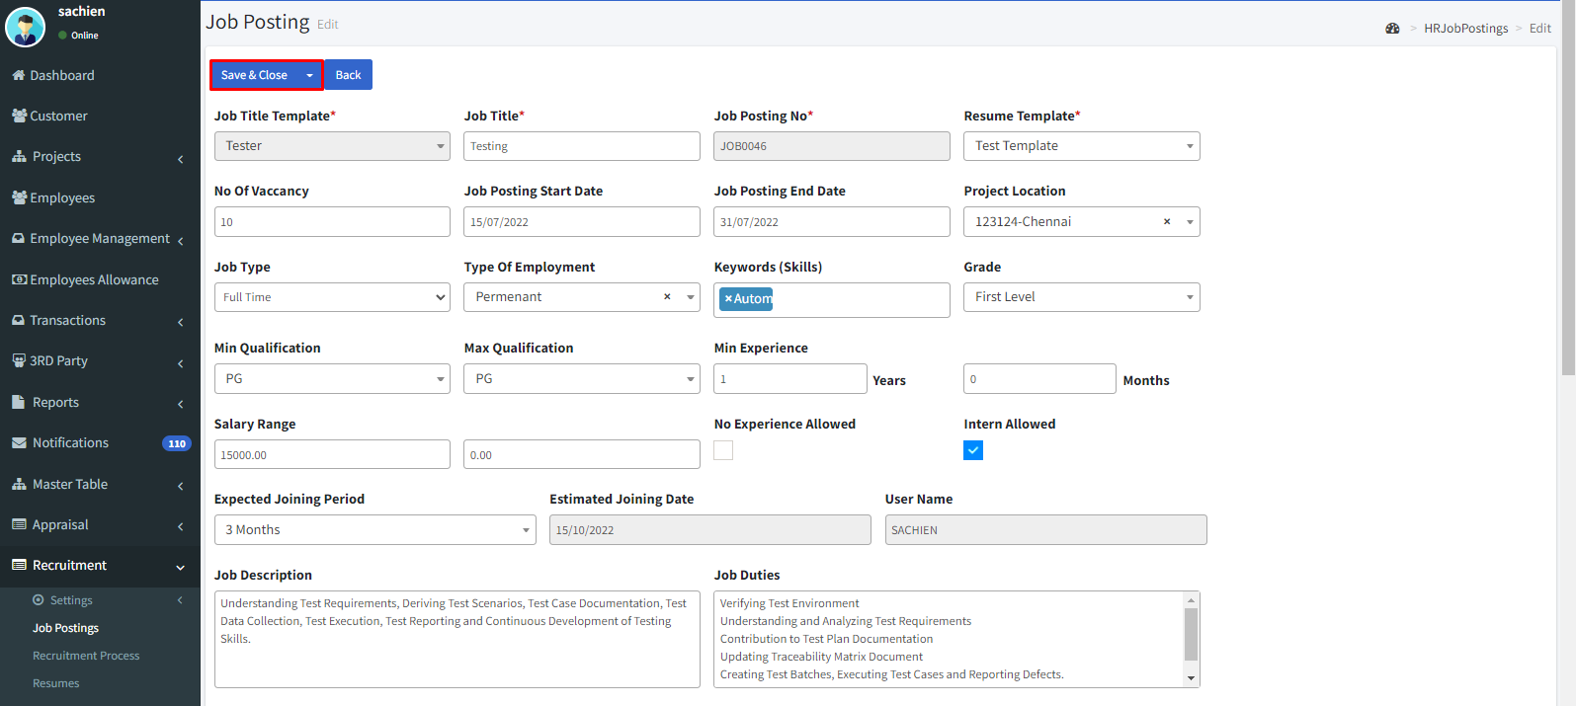

* By clicking the icon we can view the details.

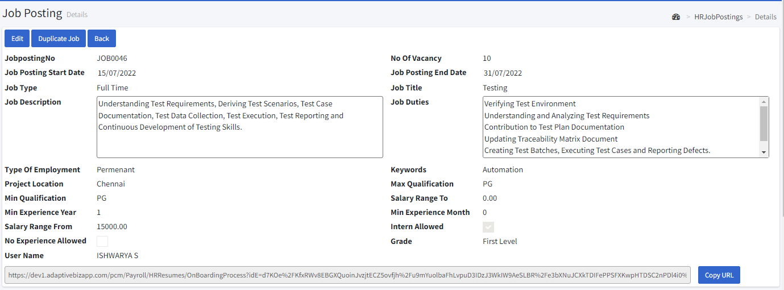

* By clicking the icon we can delete it.

**4.4. Recruitment Process:**

Select the project location and job title of the job posting then click the **“Fetch”** icon.

Click the details icon to view the process.

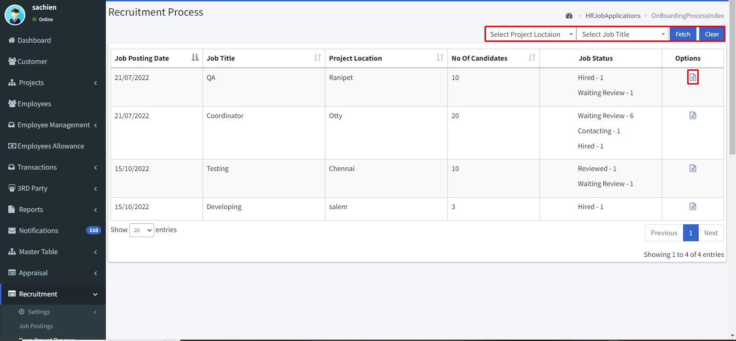

* Click the candidates.
* Click the **“view”** icon to view the status.

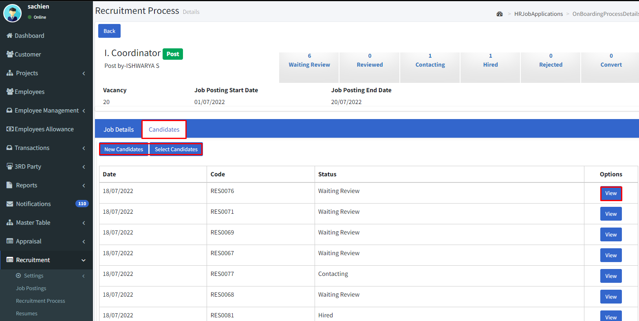

* After reviewing the applicant change the status to the next process.
* Then click the **“Save & Close”** icon.
* **Choose Print** button to take hard copy.

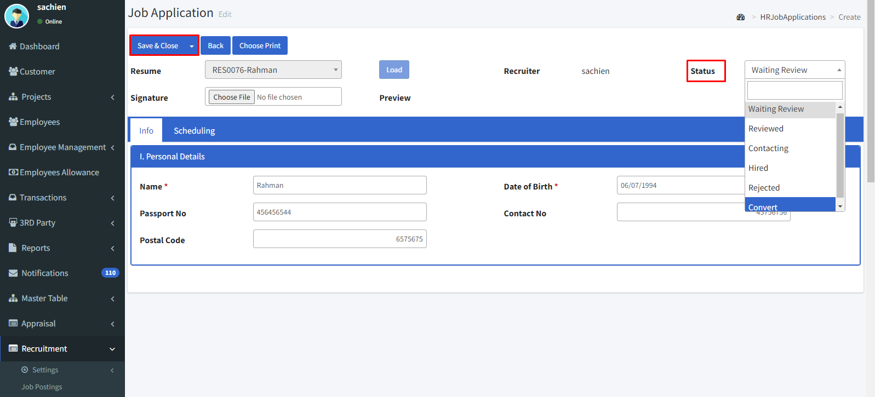

* Click the scheduling.
* Enter the start time and end time.
* Select the interview type.
* Select the status.
* Assign an interviewer.
* By clicking theicon can edit then icon to add another schedule and icon to delete.
* Then click the **“Save & Close”** icon.

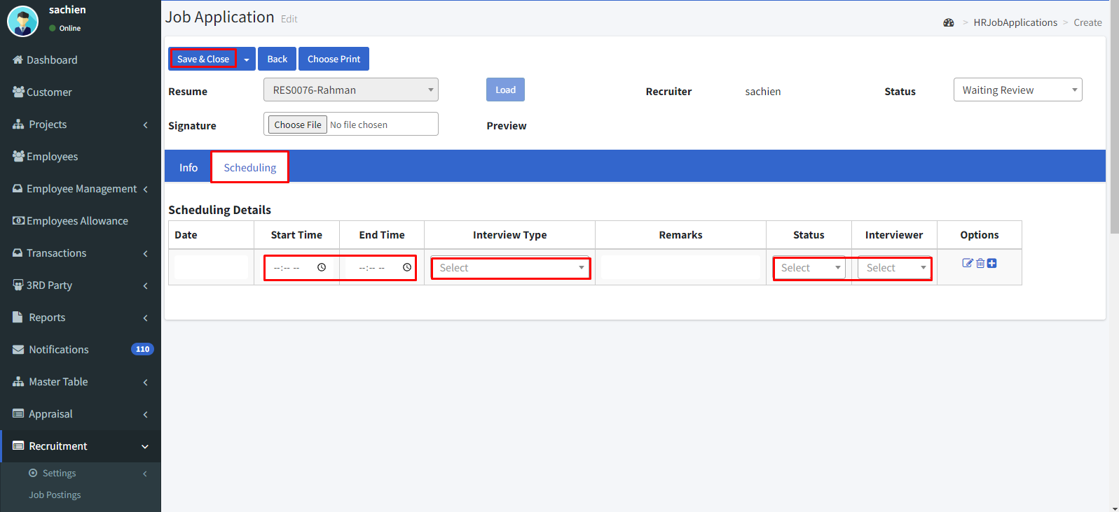

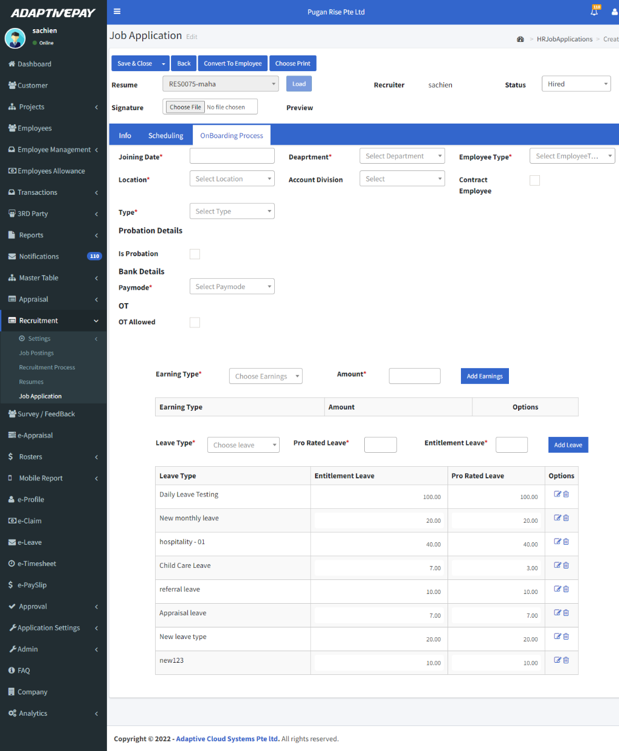

* If a candidate has been hired click the **“onboarding process”.**
* Then fill in the details like joining date, department, employee type, etc.
* Click the **Add Earnings** button to add a earnings and **Add Leave** button to add leave.
* Then click the **“Convert to employee”.**
* By clicking the **Choose** **Print** button to take a hard copy.
* Then click the **“Save & Close”**.

**4.5. Resume Master:**

* You can filter the list by code and active/inactive by clicking the **fetch** button and clear the filter by **clear** button.
* By clicking the icon we can edit.
* Click the **“Create New”** icon to create a new resume master or enter the code and click the **“Fetch”** icon to get the existing resume master.

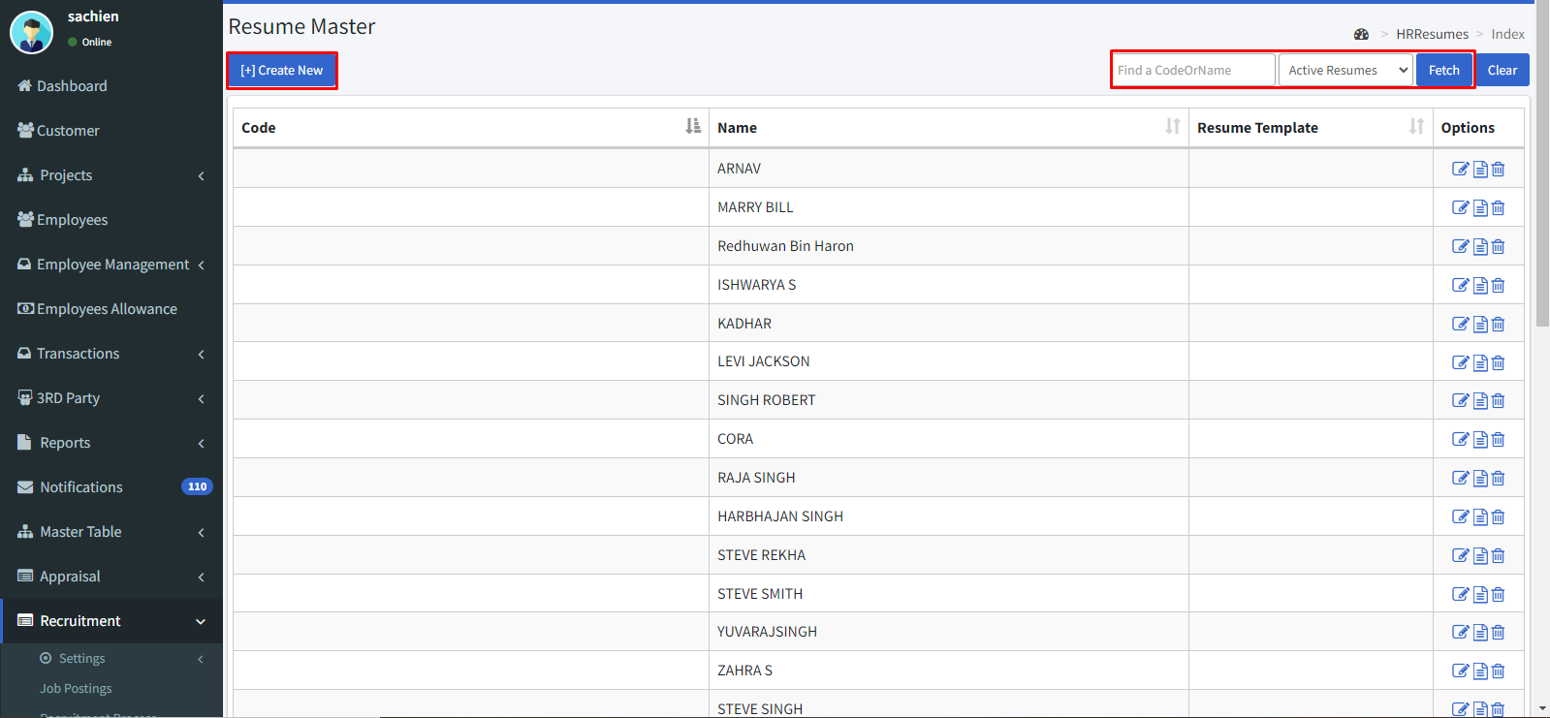

* Select a resume template.
* Then click the **“Load”** button.

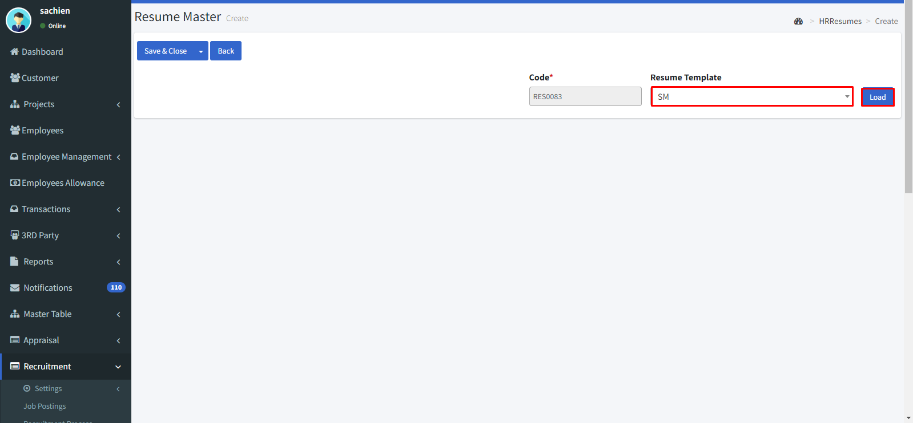

* Then enter the details e.g.: name, date of birth, etc.

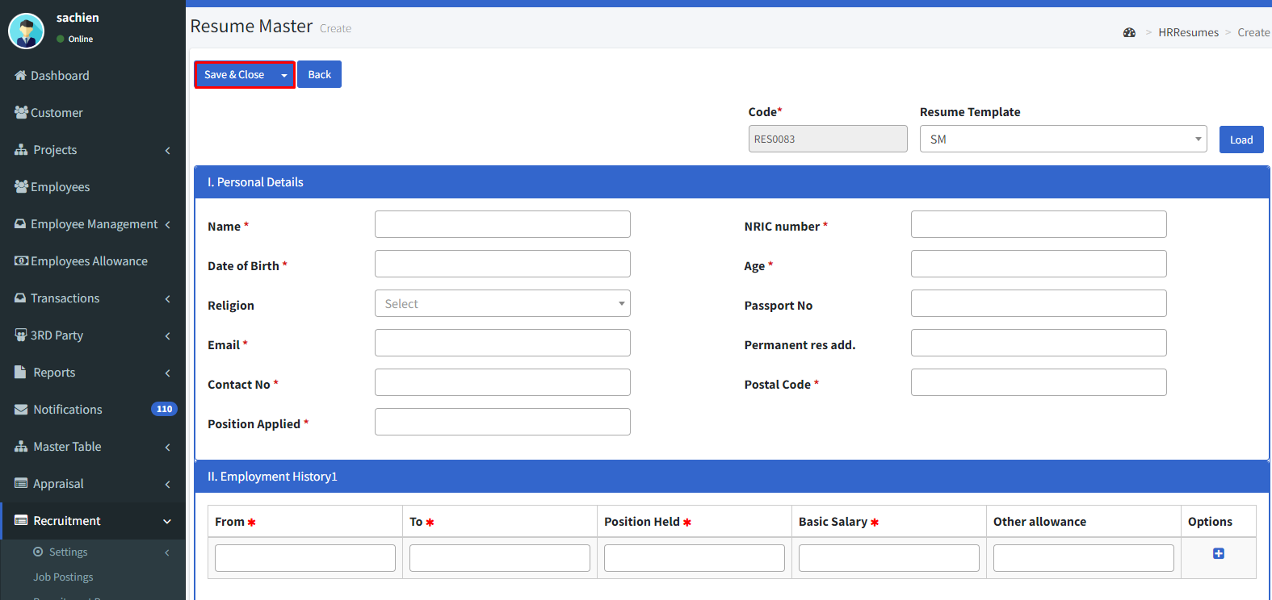

* By clicking the icon we can view the details.

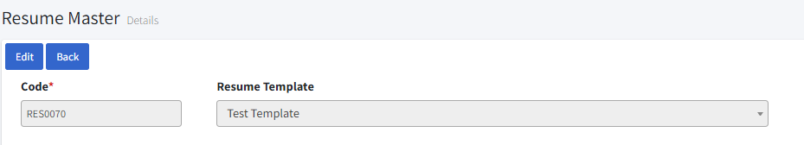

* By clicking the icon we can delete it.

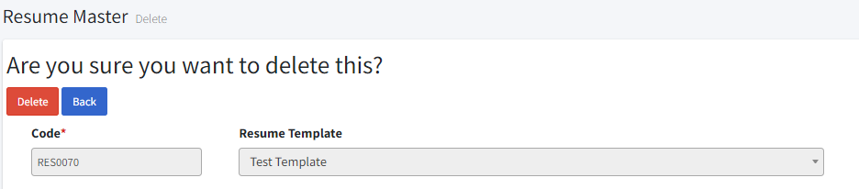

**4.6. Job Application:**

* You can filter the list by find a code by clicking the **fetch** button and clear the filter by **clear** button.
* By clicking the icon we can edit.
* Click the **“Create New”** icon to create a new application or enter the code and click the **“Fetch”** icon to get the existing application.

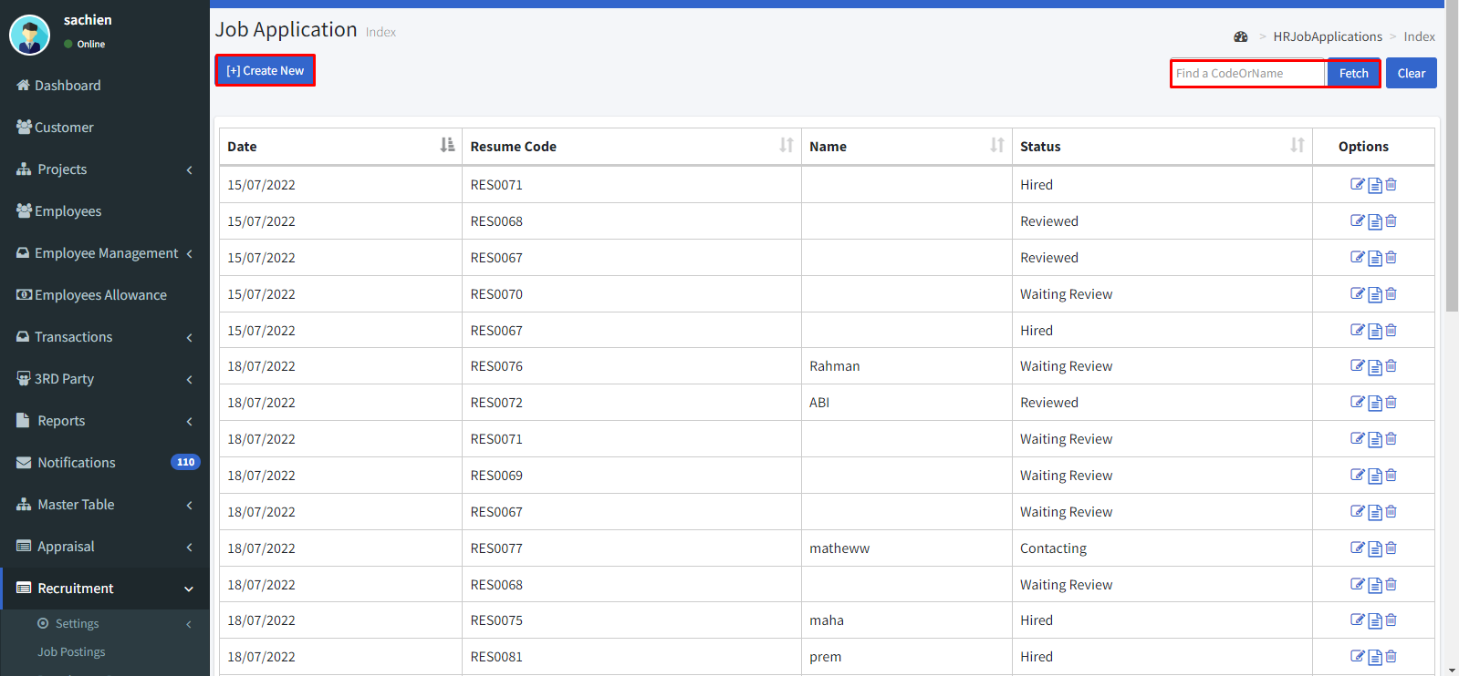

* Select the resume and click the **“Load”** icon.
* Check the details of the candidate in the **info**.
* Then click the **scheduling.**

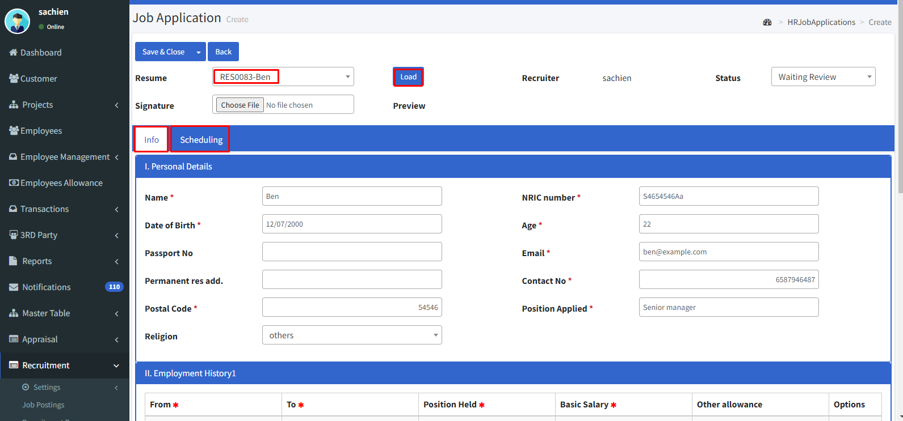

* Enter the start time and end time.
* Select the interview type from the drop-down.
* Select the status and interviewer.
* Then click the **“Save & Close”** icon.

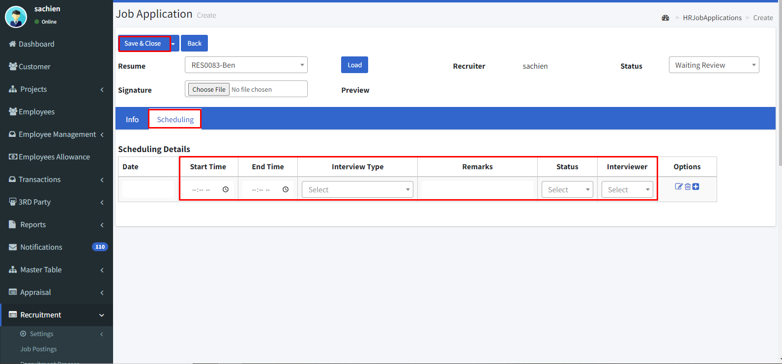

* By clicking the icon we can view the details.

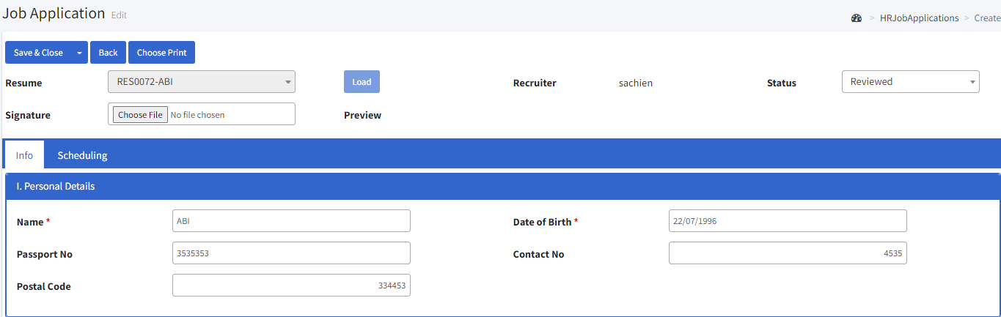

* We can schedule the time by clicking the **scheduling**.

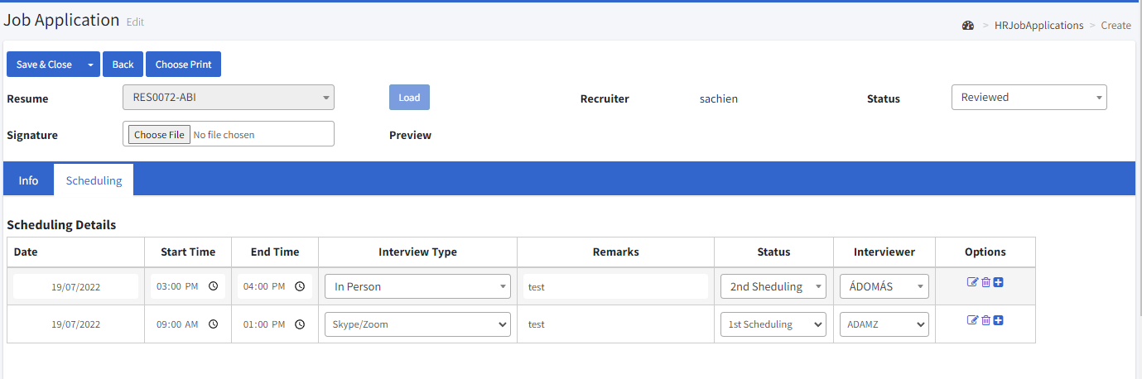

* Click the **Choose Print** button to take a hard copy.
* By clicking the icon we can delete it.

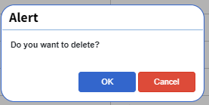

**5. e-Leave**

**Applying e-Leave:**

* Go to e-Leave.
* By clicking the icon we can edit.
* Click the **“Make leave request”** icon.

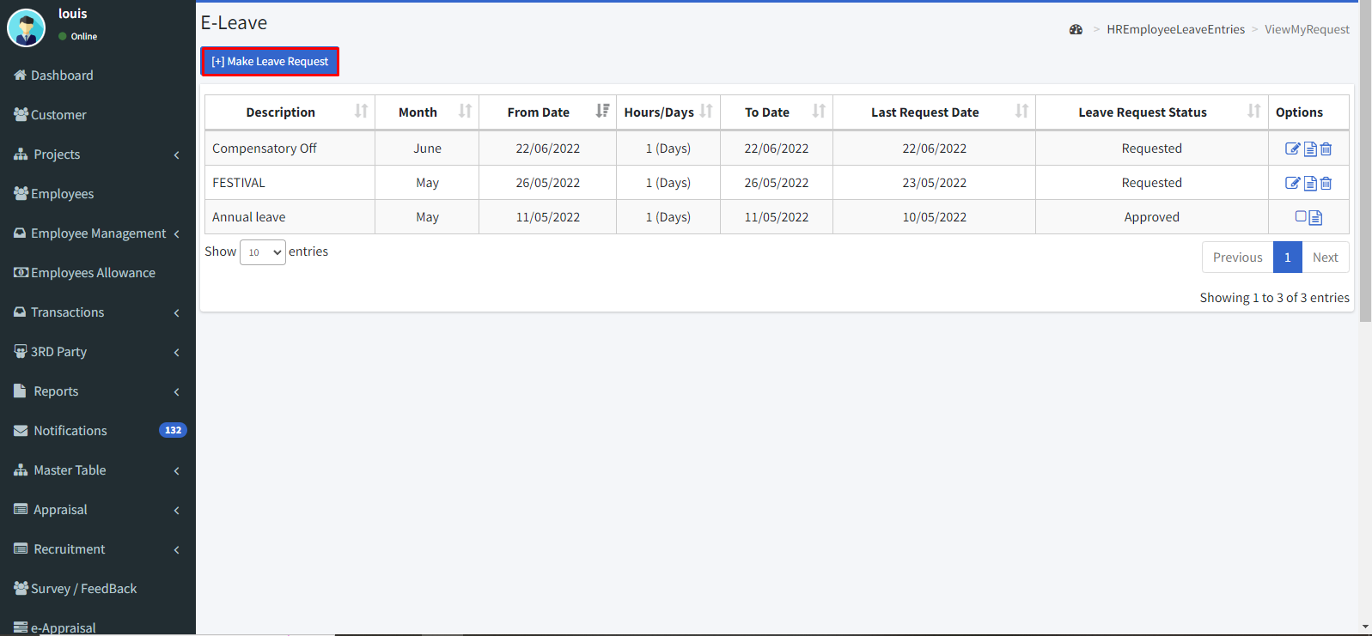

* Select the from and to date.
* Select the leave type.
* Enter the number of days.

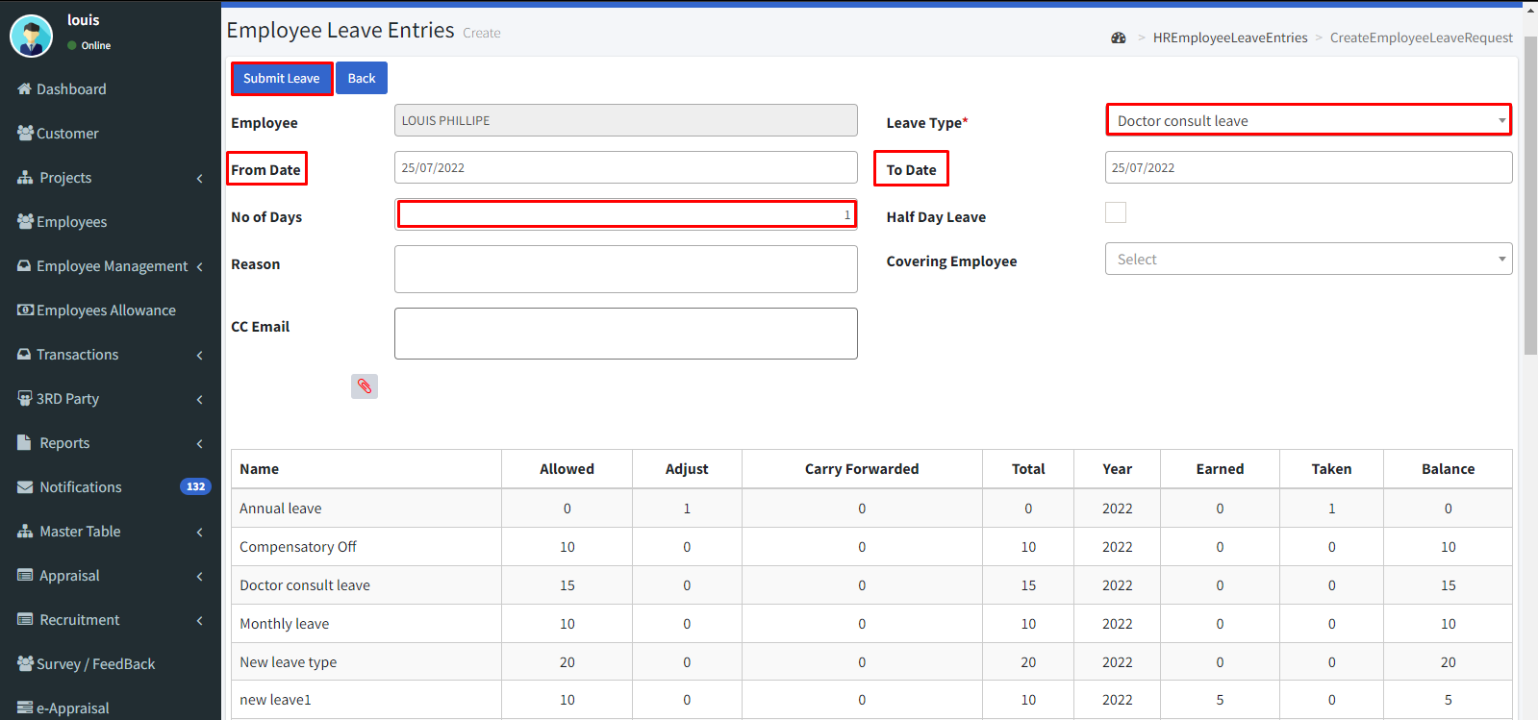

* Is employee taking half day leave means enable the **Half day leave** check box.
* Enter the Reason for leave.
* Select the covering employee.
* Enter the email id of the CC person in the CC email.
* Click the icon to add attachments.
* Then click the **Submit leave** button.
* By clicking the icon we can view the details.

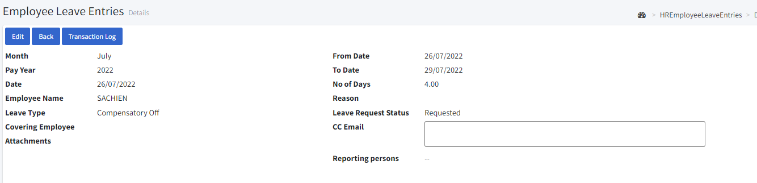

* By clicking the icon we can delete it.

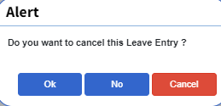

**6. e-Claim**

**Applying e****-Claim:**

* Go to e-Claim.
* By clicking the icon we can edit and click the **“Make claim request”** icon.

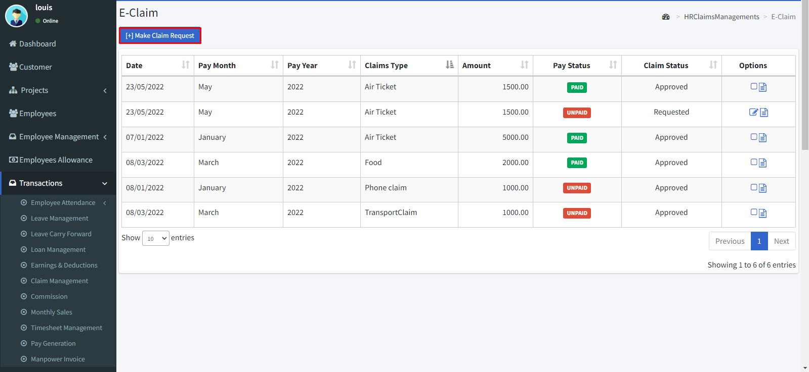

* Select the month, year, and date.
* Then select the claim type then enter the amount.
* Then click the **“Save”** button.

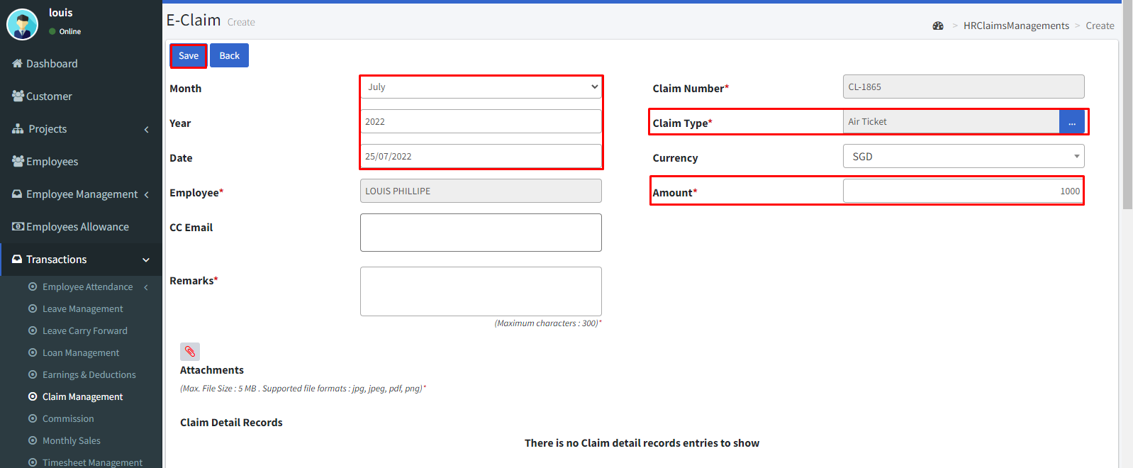

* By clicking the icon we can view the details.

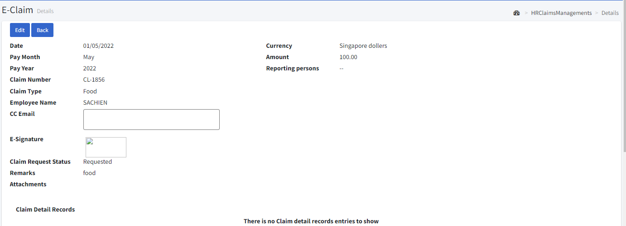

**7. e-Timesheet**

**Applying e-Timesheet:**

* Go to e-Timesheet.
* You can filter the list by selecting date by clicking the **fetch** button and clear the filter by **clear** button.
* By clicking the icon we can edit.
* Click the **“Create New”** icon.
* Select the Weekly dates.
* Select the Project.
* Select the Project Task.
* Enter the working hours for the respective days.
* Then click the clock symbol in the option to add OT time.

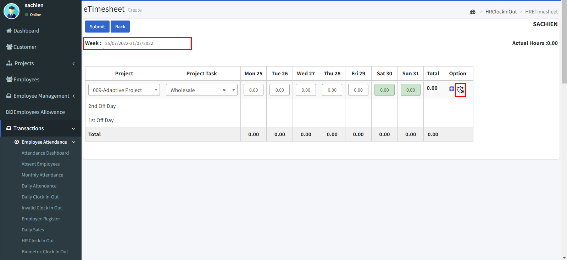

* If you want to delete click the Bin icon.
* Click the **“+”** icon to add another project to the time sheet.
* Then click the **“Submit”** icon.

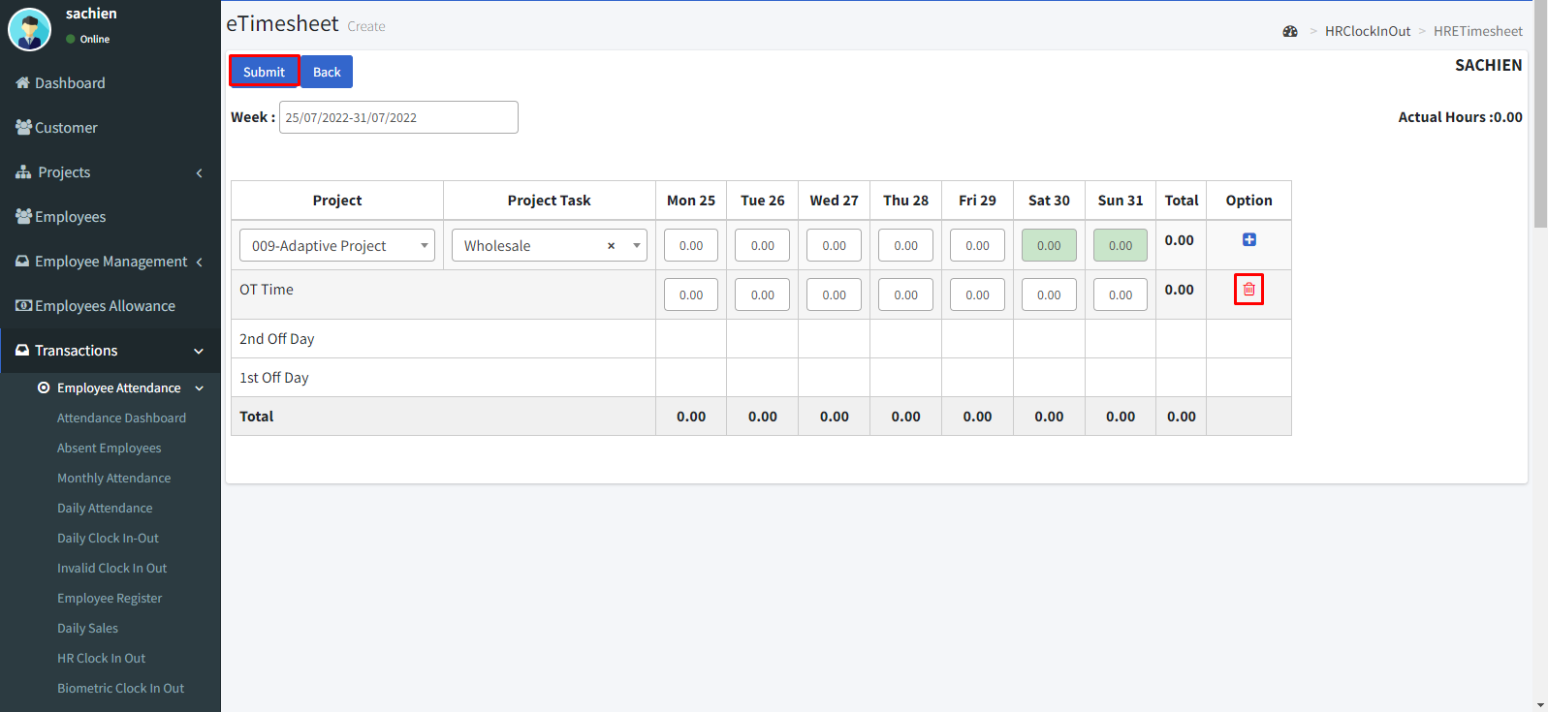

* By clicking the icon we can view the details.

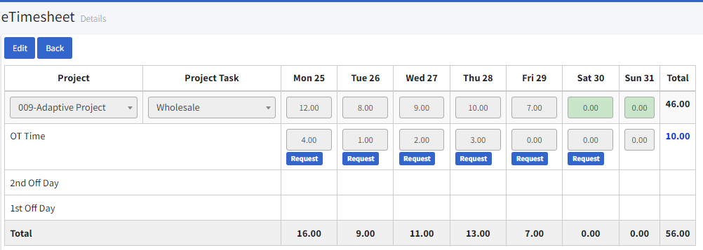

* By clicking the icon we can delete it.

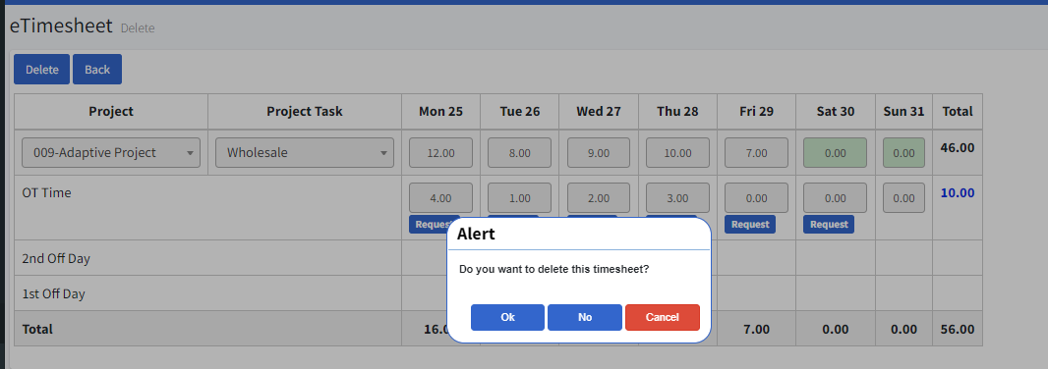

**8. e-Appraisal**

* Go to e-Appraisal.
* You can filter the list by date, appraisal, status by clicking the **fetch** button and clear the filter by **clear** button.
* By clicking the icon we can edit.
* Click the **“Create New”** icon.
* Select the appraisal code and project
* Then click the **“Load”** icon and fill in the details and click the **“Submit”** icon to finish.
* By clicking the icon we can view the details and click the **Print** button to take hard copy.
* By clicking the icon we can delete it.

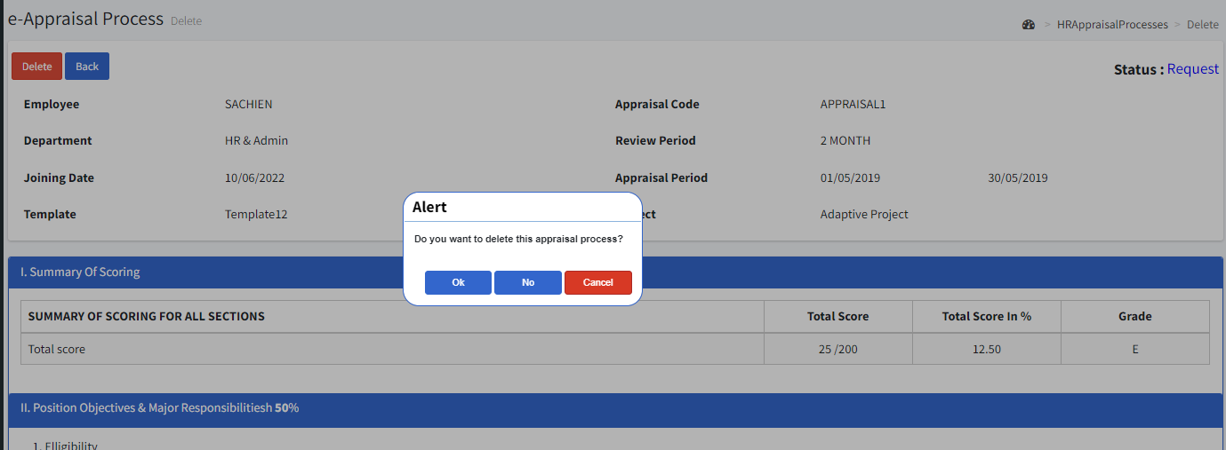

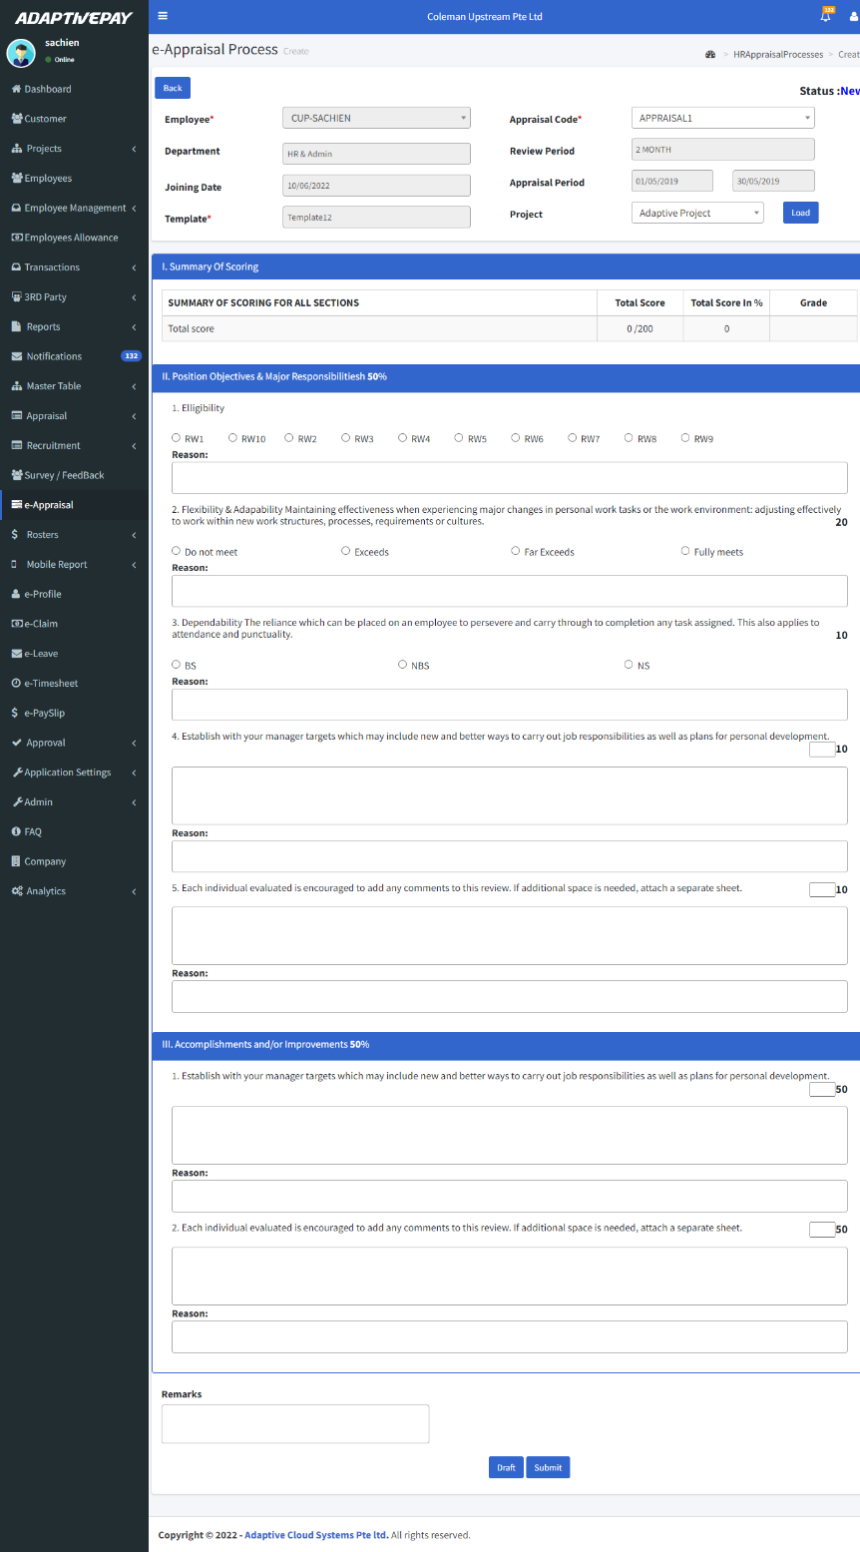

**9. Approval**

**9.1. e-Claim Approval:**

* Go to Approval 🡪 e-claim approval.
* You can filter the list by status, month, year, employee name, location and city by clicking the **fetch** button and clear the filter by **clear** button.
* Select the claim
* Then click the **“Approve”** icon toapproveor the **“Reject”** icon to reject the claim.

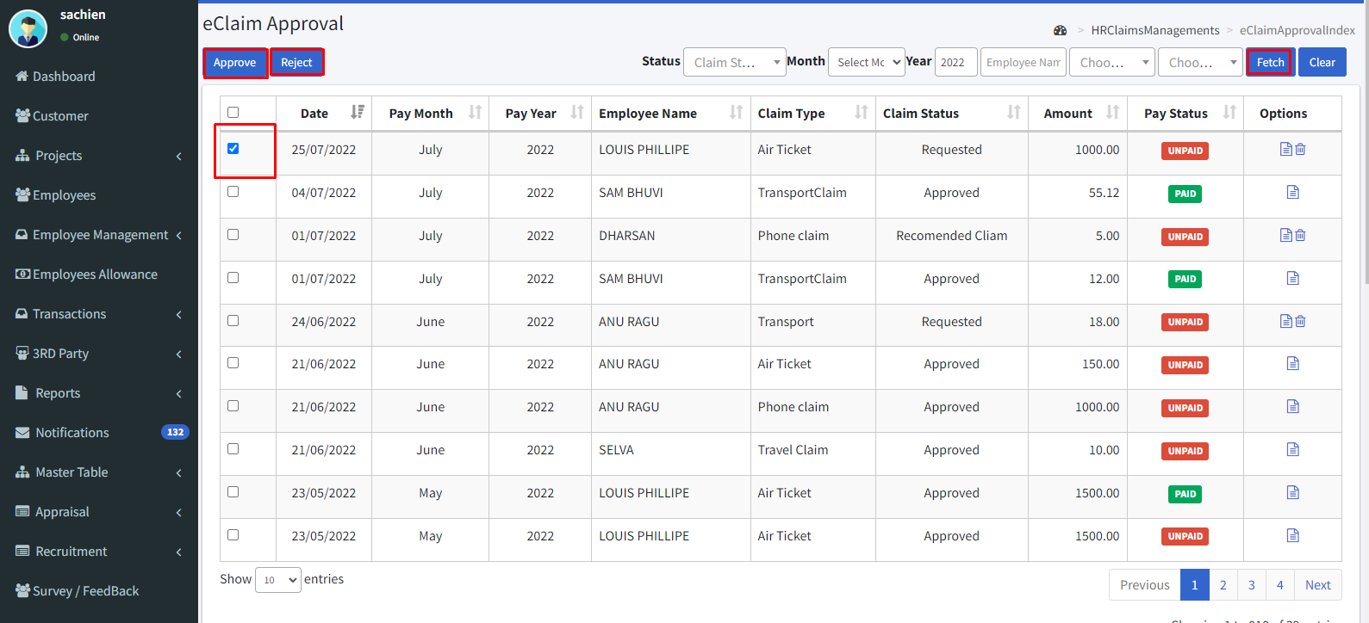

* By clicking the icon we can view the details by clicking the **Approve** button can approve the claim and **Reject** button can reject the claim.

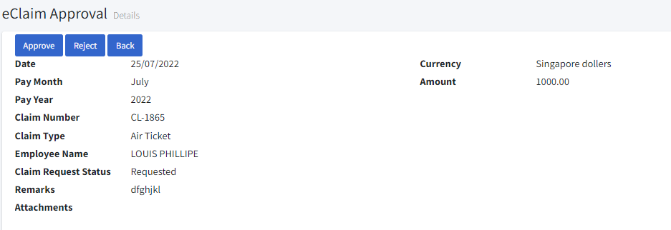

* By clicking the icon we can delete it.

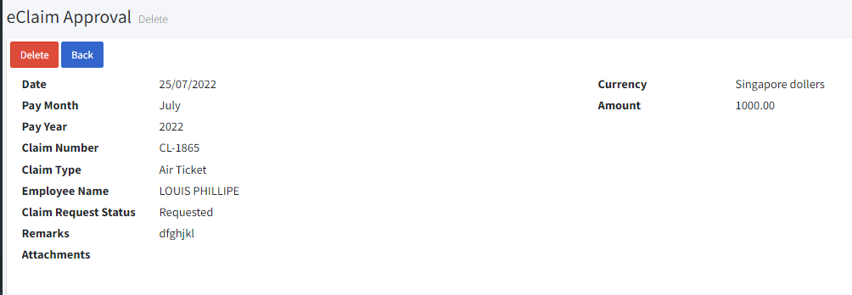

**9.2. e-Leave Approval:**

* Go to Approval 🡪 e-leave approval.
* You can filter the list by status, month, year, employee name, location and city by clicking the **fetch** button and clear the filter by **clear** button.
* Select the claim.
* Then click the **“Approve”** icon toapproveor the **“Reject”** icon to reject the claim.

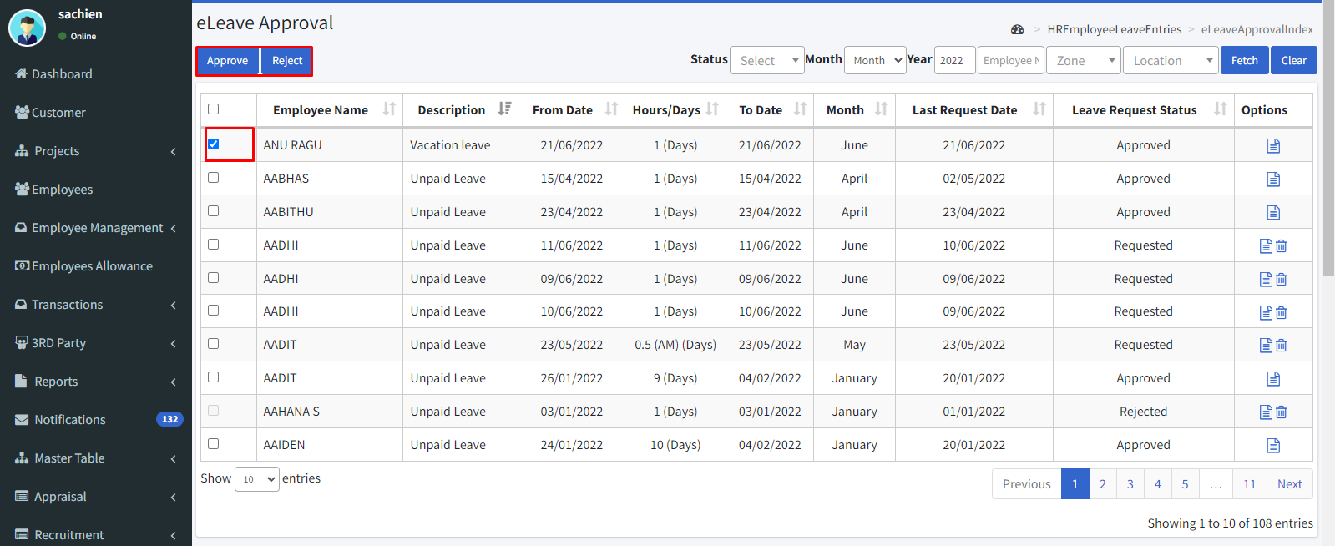

* By clicking the icon we can view the details by clicking the **Approve** button can approve the claim and **Reject** button can reject the claim.

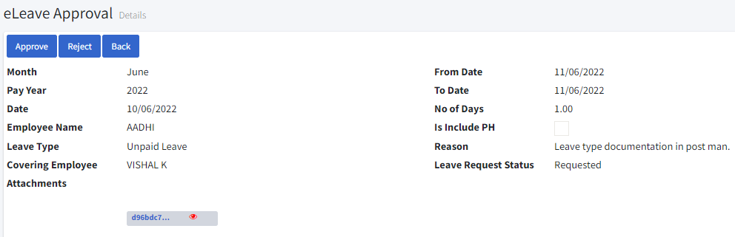

* By clicking the icon we can delete it.

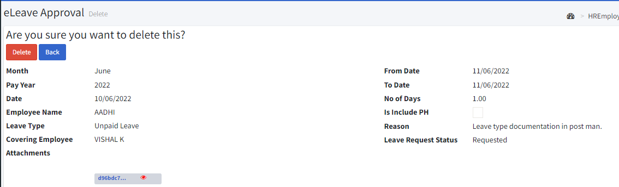

**9.3. e-Timesheet Approval:**

* Go to Approval 🡪e-timesheet approval.
* You can filter the list by year, employee name, request status, and date by clicking the **fetch** button and clearing the filter by the **clear** button.
* By clicking the **Export excel** button can get a file in excel format.
* By clicking the **Print** button can print a hard copy.
* Enter the employee name or select the date and then click the fetch icon.
* Click the details icon.

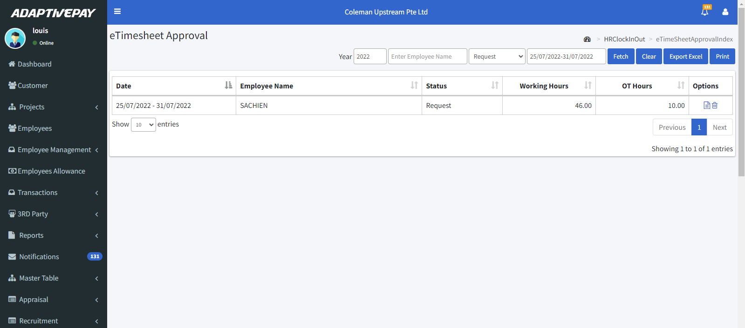

* After reviewing click the **“Approve”** icon toapproveor the **“Reject”** icon to reject the Timesheet.

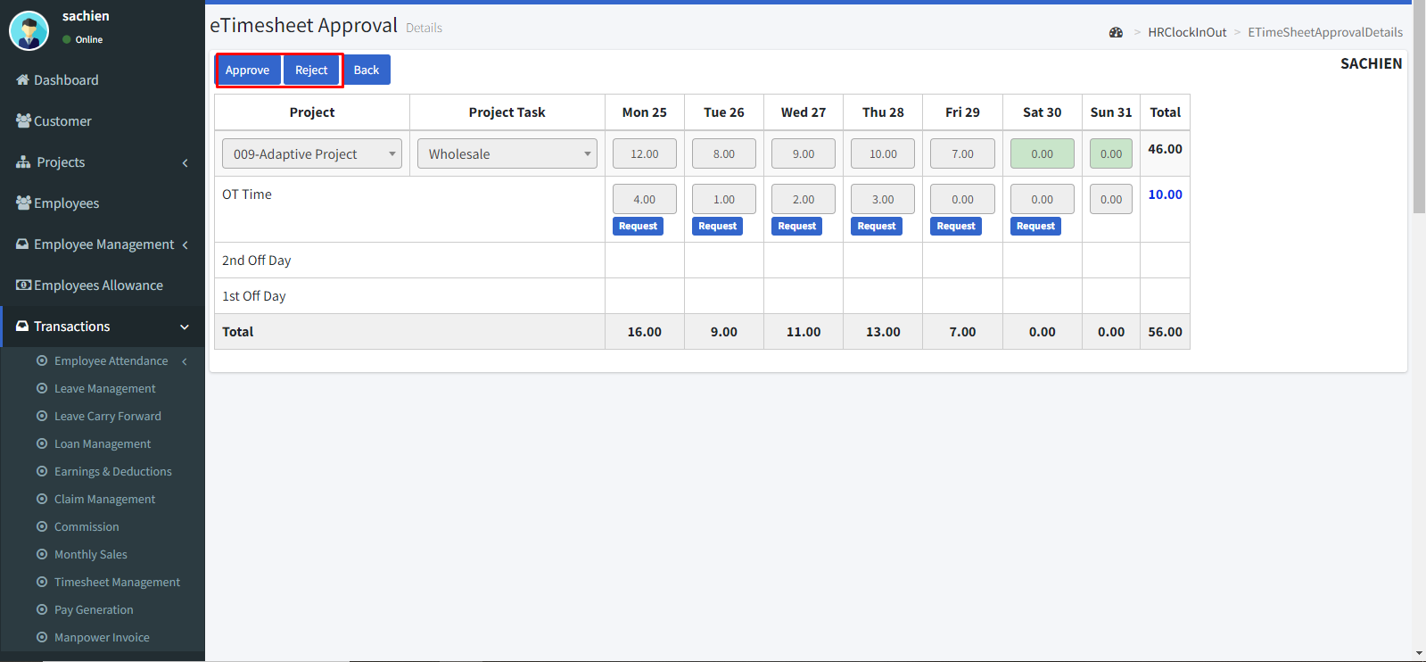

* By clicking the icon we can delete it.

**9.4. e-Appraisal Approval:**

* Go to Approval 🡪 e-Appraisal approval.
* Enter the employee name or select the date and then click the fetch icon.
* Click the details icon.
* If you want edit score you can edit otherwise click the copy score button to copy the same score.
* Then click the **completed** button to approve the appraisal.
* **Print** button to prin.
* **Delete** button to delete.

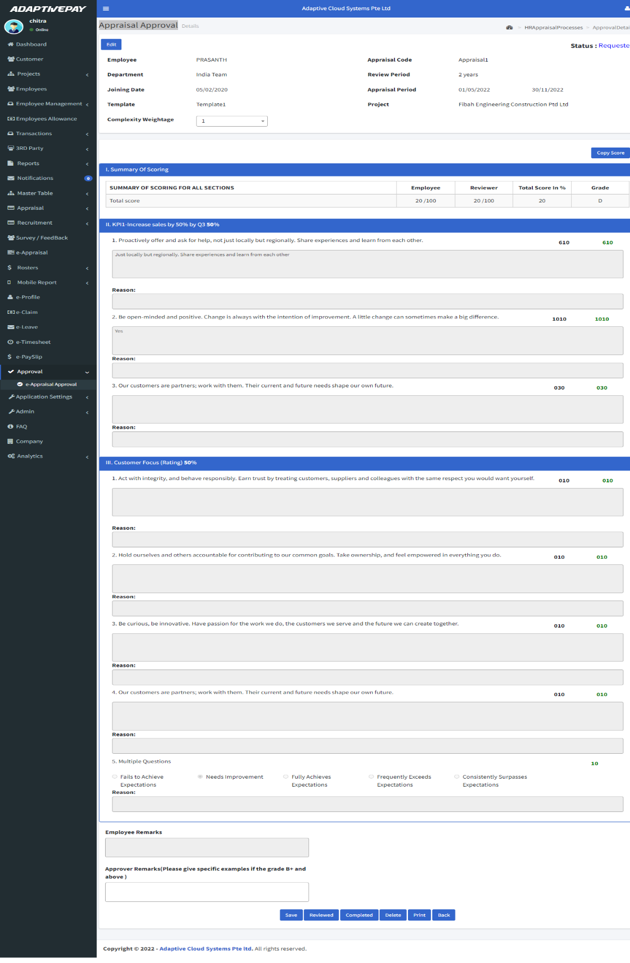

**9.5. e-Timesheet OT Approval:**

* Go to Approval 🡪e-Timesheet approval.
* You can filter the list by date, name, project, status by clicking the **fetch** button and clear the filter by **clear** button.
* Enter the employee name or select the date and then click the fetch icon.
* After reviewing click the **“Approve”** icon toapproveor the **“Reject”** icon to reject the Timesheet.

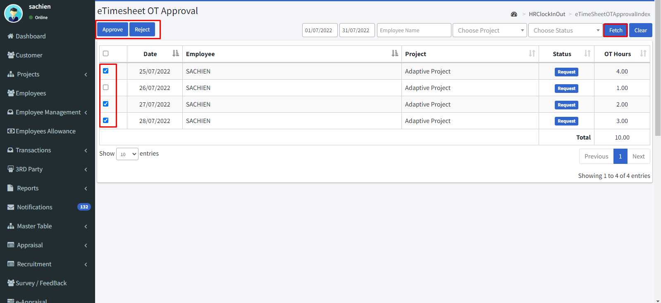

**9.6. e-Loan Approval:**

* Go to Approval 🡪 e-Loan approval.
* You can filter the list by loan status, month, year, employee name, zone, location by clicking the **fetch** button and clear the filter by **clear** button.
* Enter the employee name or select the date and then click the fetch icon.
* After reviewing click the **“Approve”** icon toapproveor the **“Reject”** icon to reject the Timesheet.

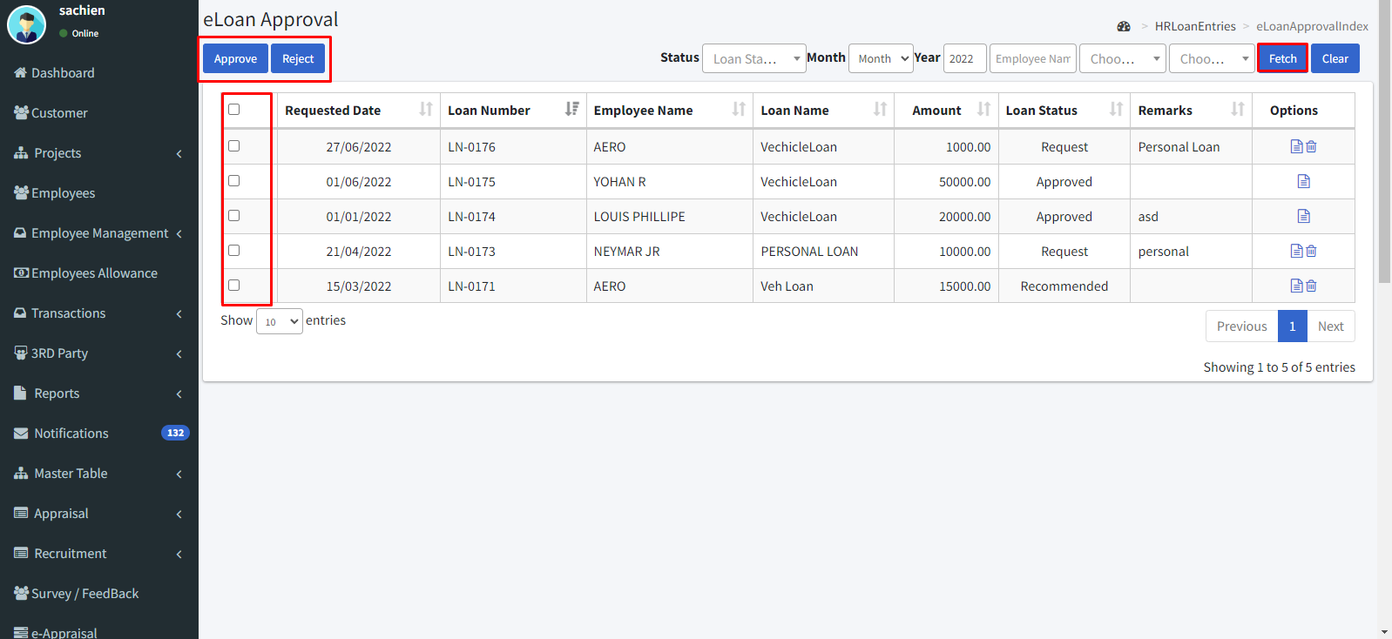

**10. Application Settings**

**10.1. Country:**

* Go to Application settings 🡪 Country.
* By clicking the icon we can edit.
* Click the **“Create new”** icon.
* Enter a code.
* Then enter the country name.
* Enable the check box if the country is the default.

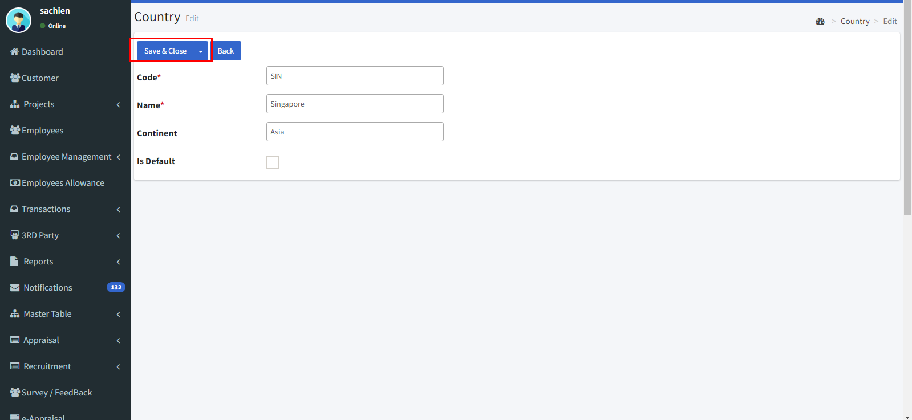

* By clicking the icon we can view the details.

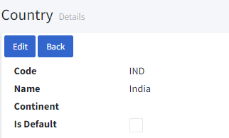

* By clicking the icon we can delete it.

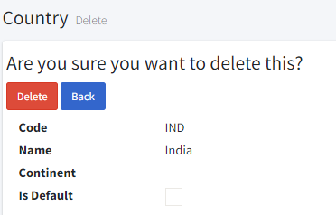

**10.2. Picklist:**

* Go to Application settings > Pick list.
* Click the **“Create new”** icon.
* Select the model & attribute.
* Assign the display order.
* E3nter the pick list value.
* Then click the **“Save & Close”** icon.

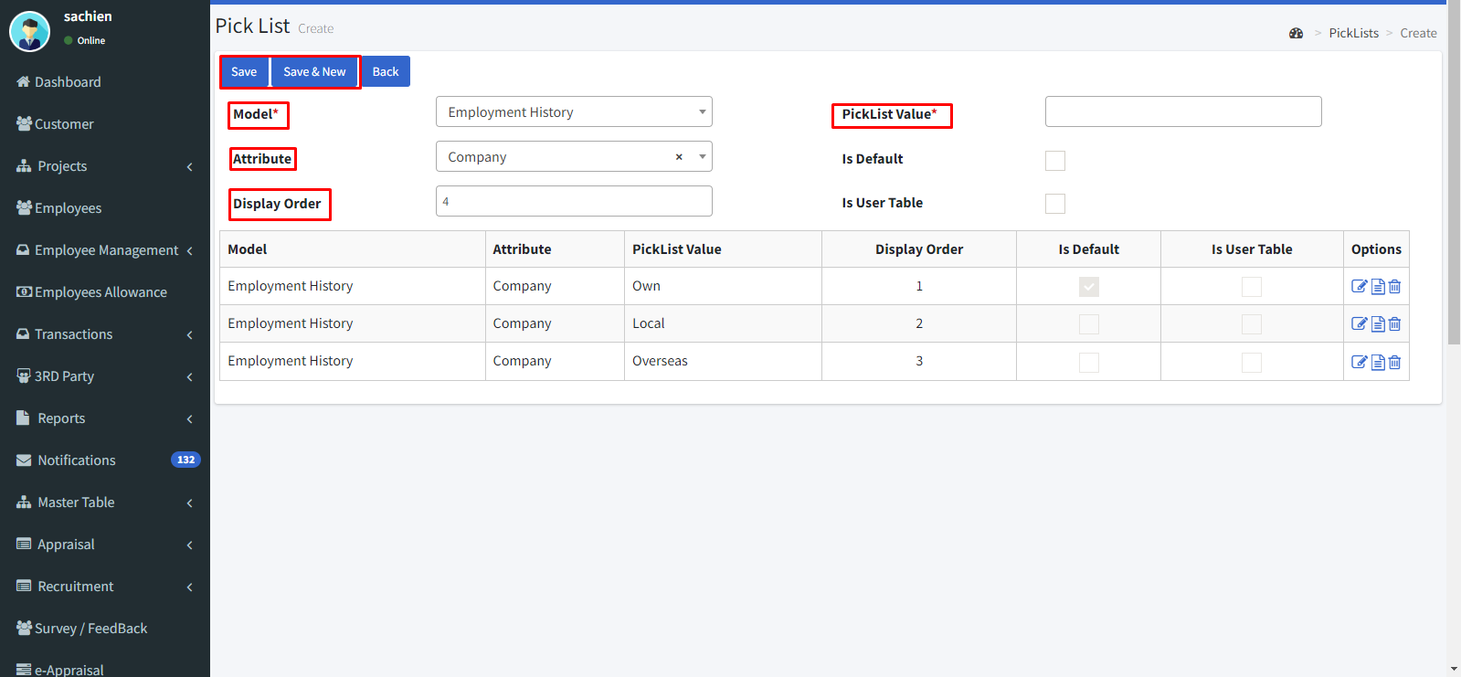

* By clicking the icon we can view the details.

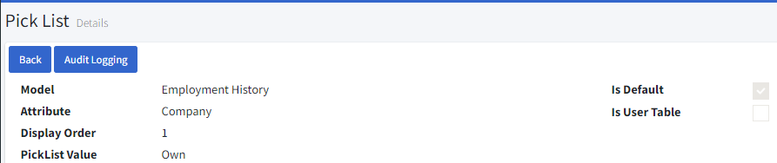

* By clicking the icon we can delete it.

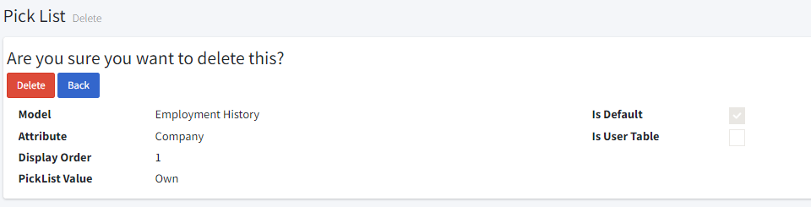

**10.3. System Settings:**

* Go to Application settings > System Settings.
* Click the **“Create new”** icon.
* Select the model to enter the “Param Code”, Description, “Param Value Type” and click the “**Save**” button.

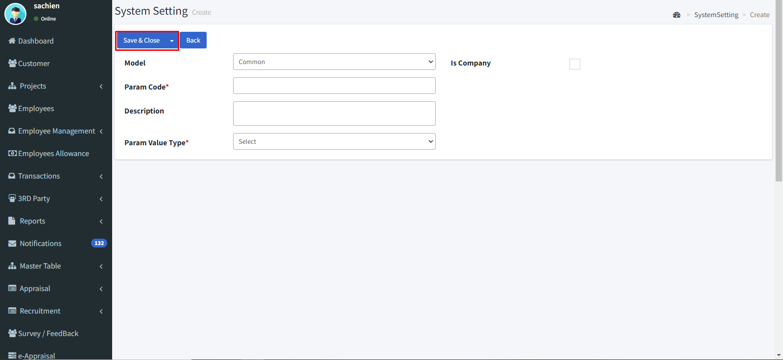

* By clicking the icon we can edit then click save & close.

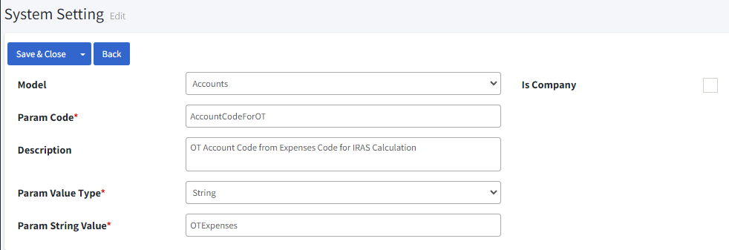

* By clicking the icon we can view the details.

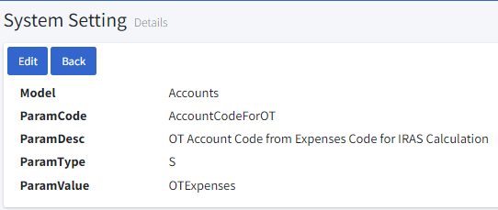

* By clicking the icon we can delete it.

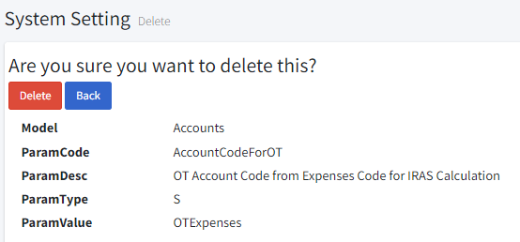

**10.4. Auto numbers:**

* You can filter the list by Find table name by clicking the **fetch** button and clear the filter by **clear** button.
* By clicking the icon we can edit.
* Click the **Create new** icon.

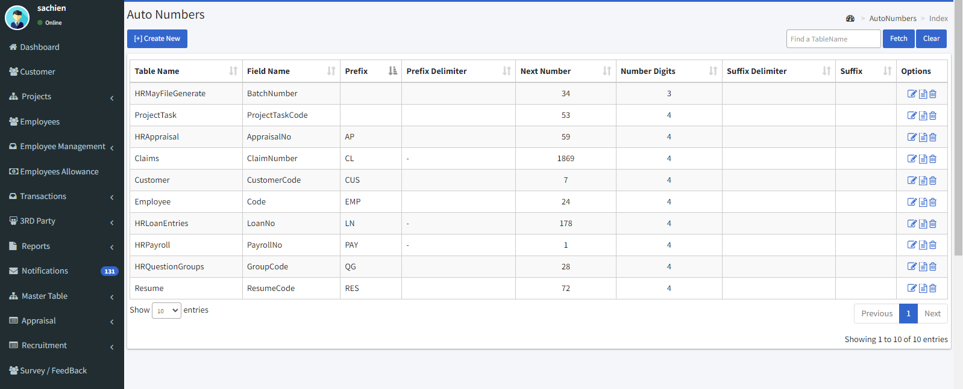

* Enter the table & field name.
* Enter the next number and no of digits.
* Enter Prefix & suffix.
* Enter delimiter for Prefix & Suffix.
* To enable this auto number, check the **Is Enable** check box.
* Then click the **“Save & Close”** icon to save.

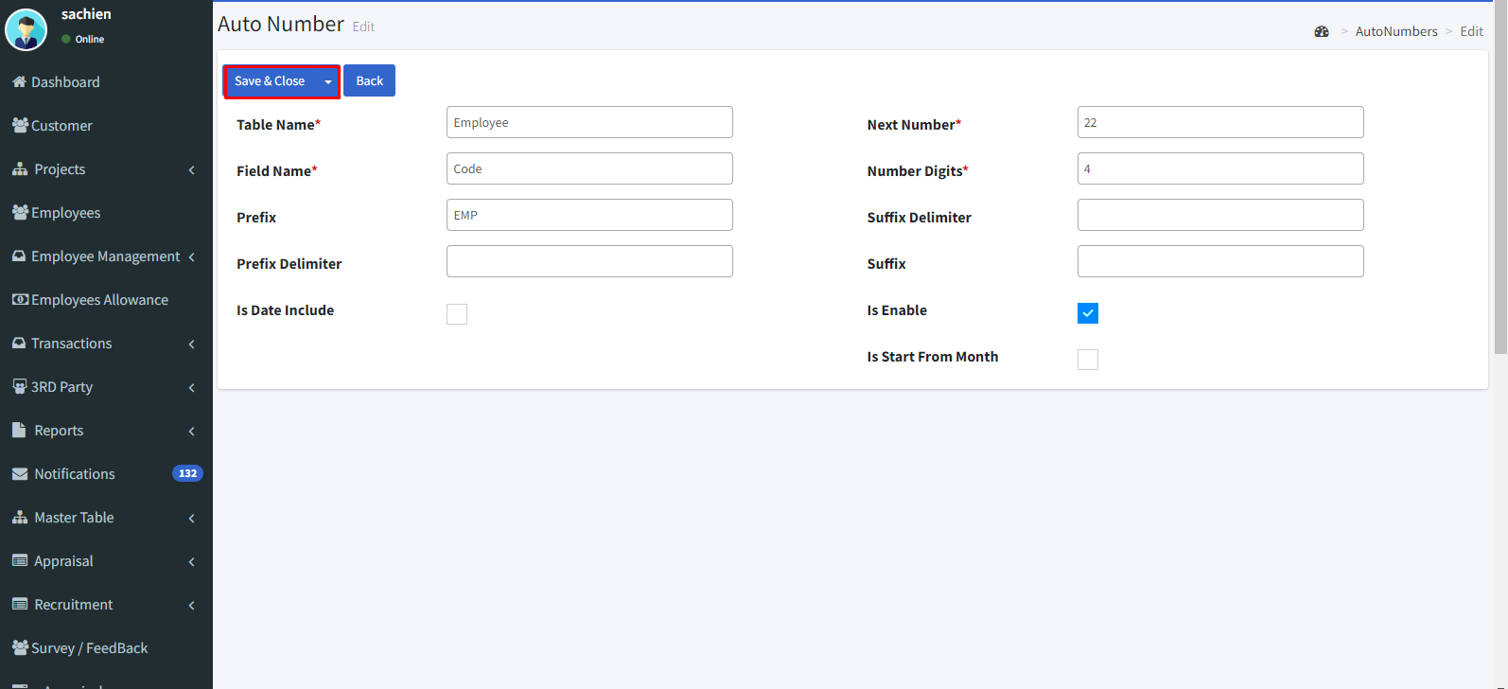

* By clicking the icon we can view the details.

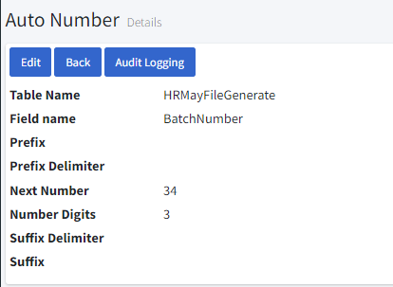

* By clicking the icon we can delete it.

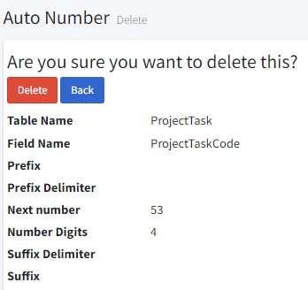

**11. Transactions**

**11.1. Employee attendance:**

**11.1.1. Monthly attendance:**

* Monthly attendance allows you to enter the attendance on a monthly basis.
* Go to Transaction 🡪 Employee Attendance 🡪 Monthly Attendance.
* You can filter the list by project, employee type, department, employee, pay period, month, and year by clicking the **fetch** button and clear the filter by **clear** button.
* We can get a excel format file by clicking the **Import excel** button.
* To delete multiple entries, click the **multi delete** button.
* Click the **“Create New”** icon to create a monthly attendance.
* By clicking the icon we can edit.

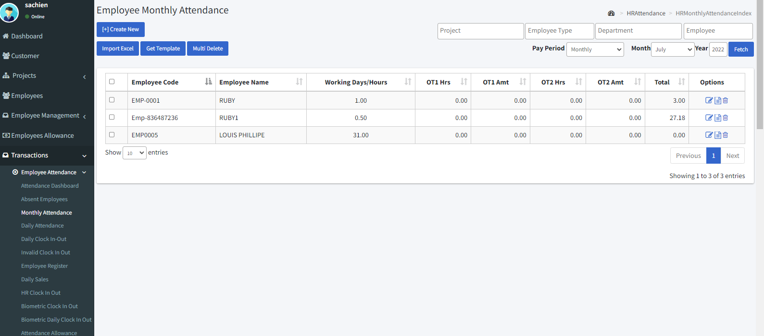

* Select the month, year, and pay period.
* Select the employee.
* Then click the **“Save”** icon.
* Once the Pay is generated you cannot edit, or delete the entry which is used in the pay generation. But if you delete the Pay then you can edit, or delete the entry.

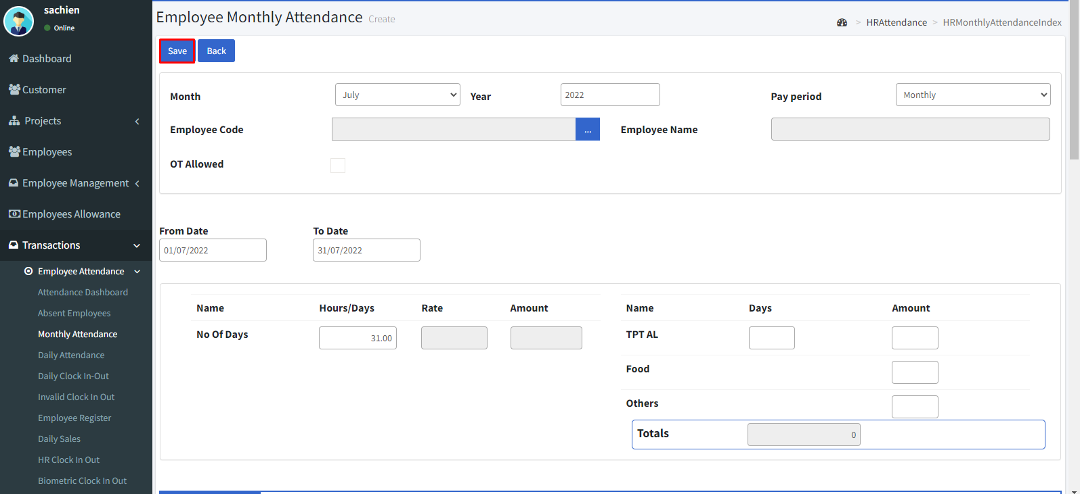

* By clicking the icon we can view the details.

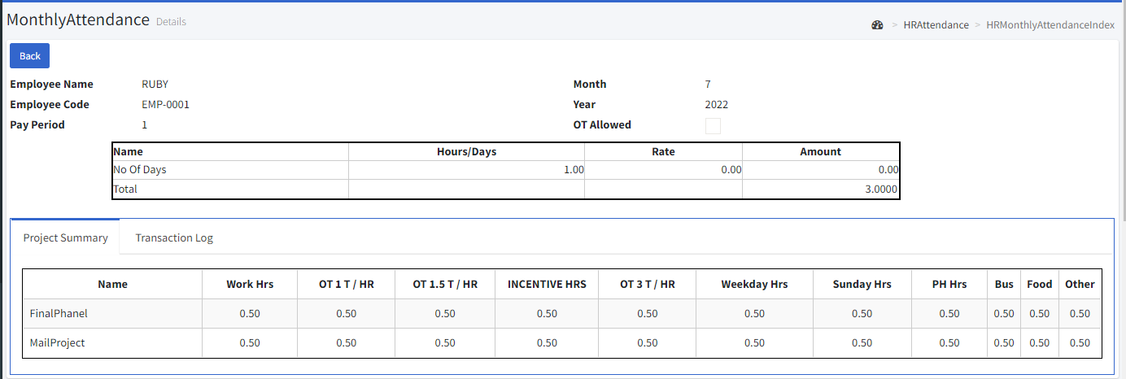

* By clicking the icon we can delete it.

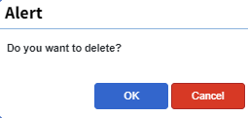

**11.1.2. Daily attendance:**

* Daily attendance allows you to enter the attendance on multiple days.
* Go to Transaction 🡪 Employee Attendance 🡪 Daily Attendance.
* You can filter the list by pay period, month, year, zone, location, employee type, by clicking the **fetch** button.
* To delete multiple entries, click the **multi delete** button.
* Click the **“Create New”** icon to create a daily attendance.
* By clicking the icon we can edit.

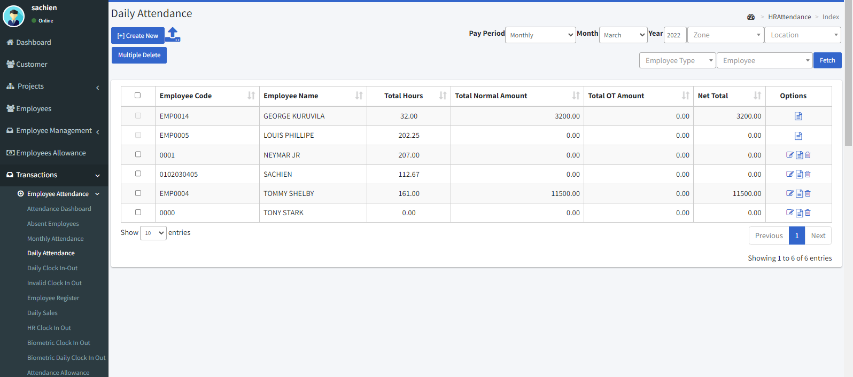

* Select the pay month, year, and pay period.
* Select the employee.
* Enable **Is off day** or **Is public holiday** check boxes as per your needs.
* Enter the from and to dates.
* Enter the in and out time.
* Then click the **“Create”** button.
* And finally click the **“Save”** button.

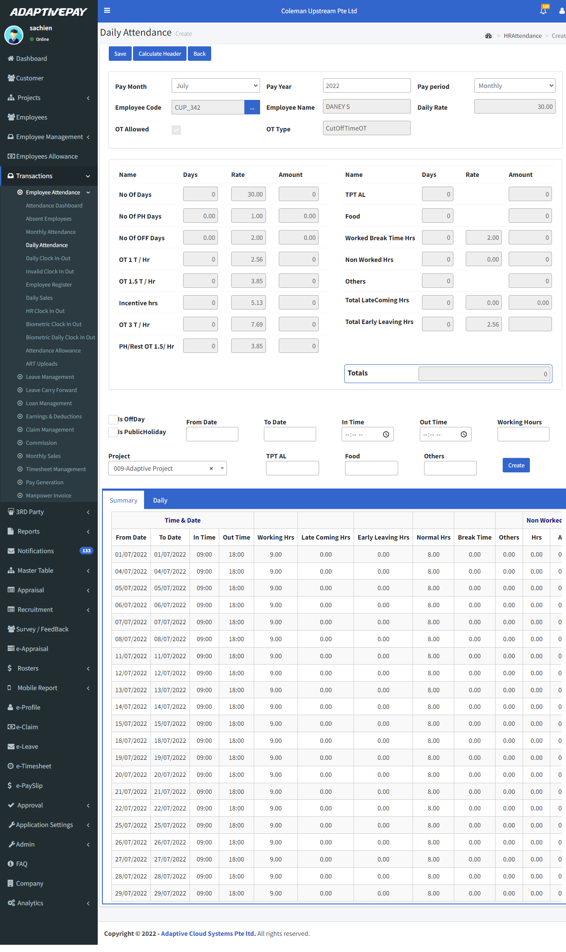

* By clicking the icon we can view the details.

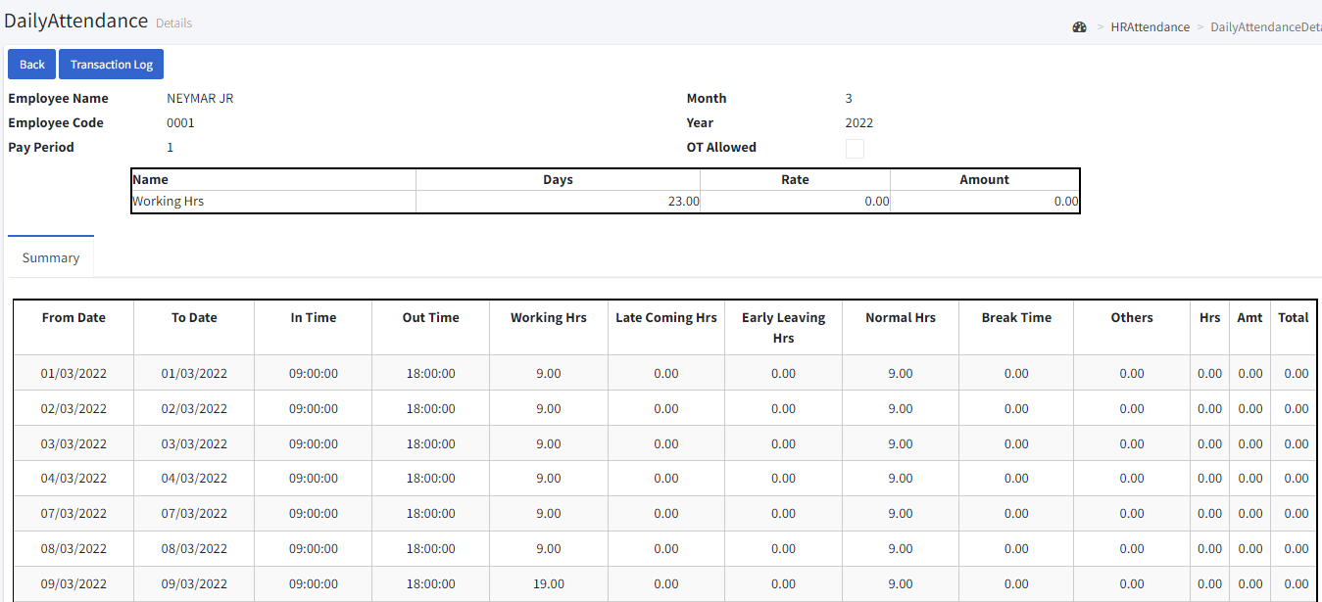

* By clicking the icon we can delete it.

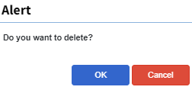

**11.1.3. Daily clock In-Out:**

* Daily clock in-out allows you to enter the in-out entries on a daily basis.
* Go to Transaction 🡪 Employee Attendance 🡪 Daily Clock in-out.
* You can filter the list by month filter, employee type, name, project and, zone by clicking the **fetch** button and clear the filter by **clear** button.
* By clicking the **Convert** button, it converts to attendance.
* Clicking the **Sync** **from** **Biometric** button allows us to retrieve the entries from the biometric.
* By clicking the icon we can edit.
* Click the **“Create”** icon to create a daily clock in-out.

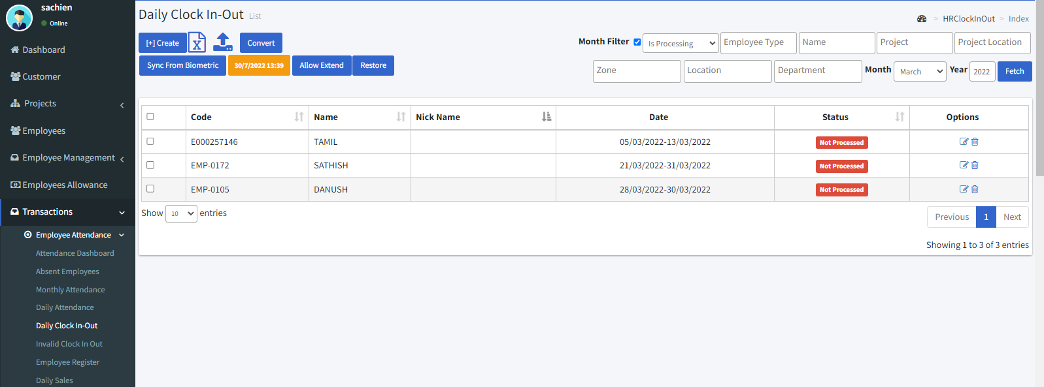

* Select the date and enter the in and out time.
* Select the department.
* Select the employee name and choose the project.
* Select the pay period whether the employee is monthly or bi weekly.
* Then click the **“Fetch”** icon.
* Check the check box which is near the code and edit the time if needed.
* Then click the **“Save”** icon.

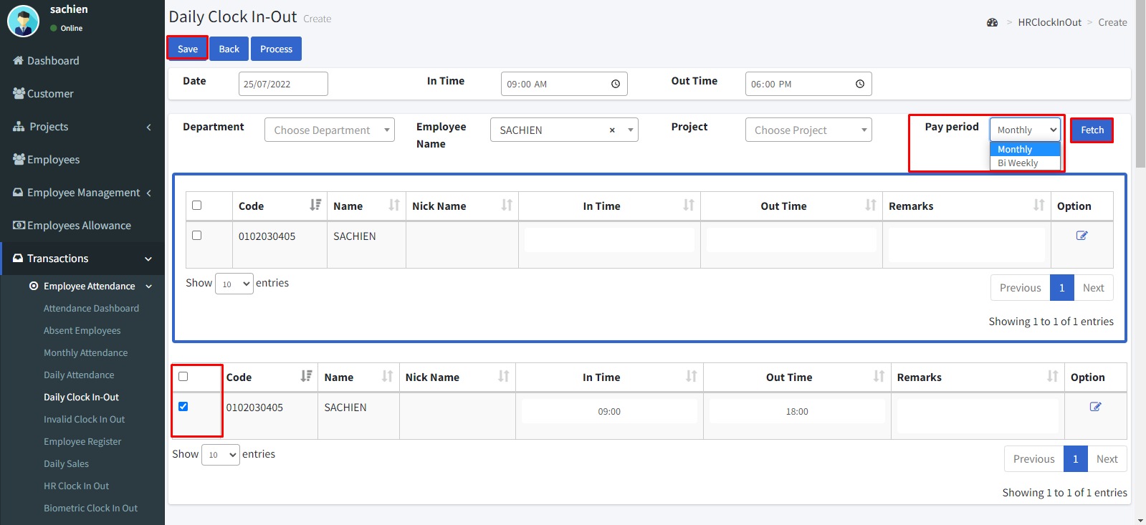

* By clicking the icon we can delete it.

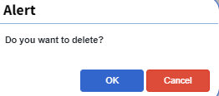

**11.2. Leave Management:**

* Go to Transactions 🡪 Leave management.
* We can filter the entries by clicking the Status and filter by requested, approved, and rejected.
* Select the month or year.
* Enter the employee’s name.
* Select the leave type.
* Select the project, zone, and location.
* Then click the **“fetch”** button.

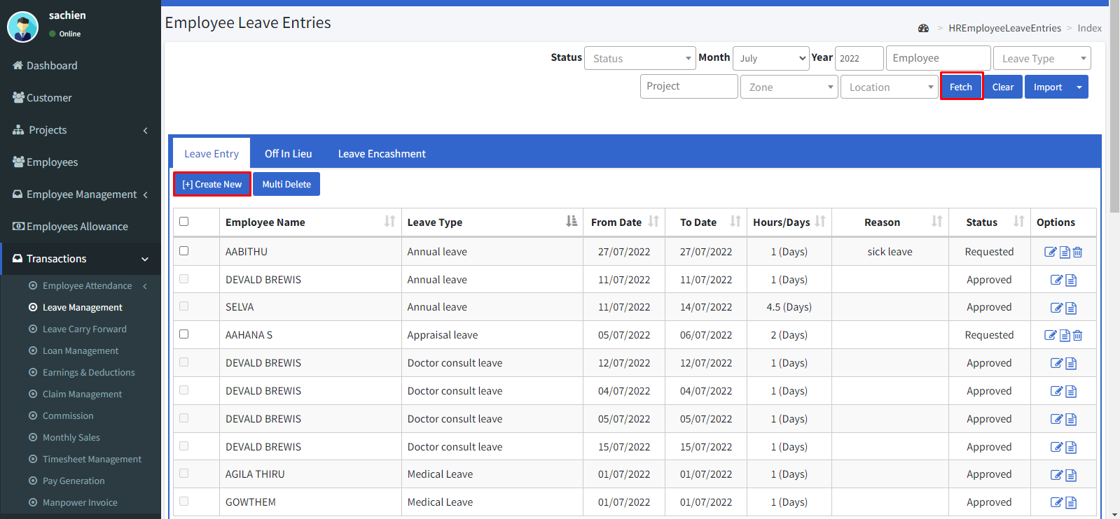

**Leave entry:**

* Click the leave entry and then click the create new icon.
* Select the employee.
* Select the year, month, and date.
* Select the leave type.
* Enter the reason for the leave.
* Enter the from and to date of the leave.
* The no of days is automatically calculated by the system.
* If the leave taken for half day means enable the check box **“Is Half day leave”.**
* Enable the **“Is** **include** **PH”** check box the leave lies on a public holiday.
* Select the leave request status.
* Then click the **“save”** button to save or the **“save & new”** button to save and add another leave.

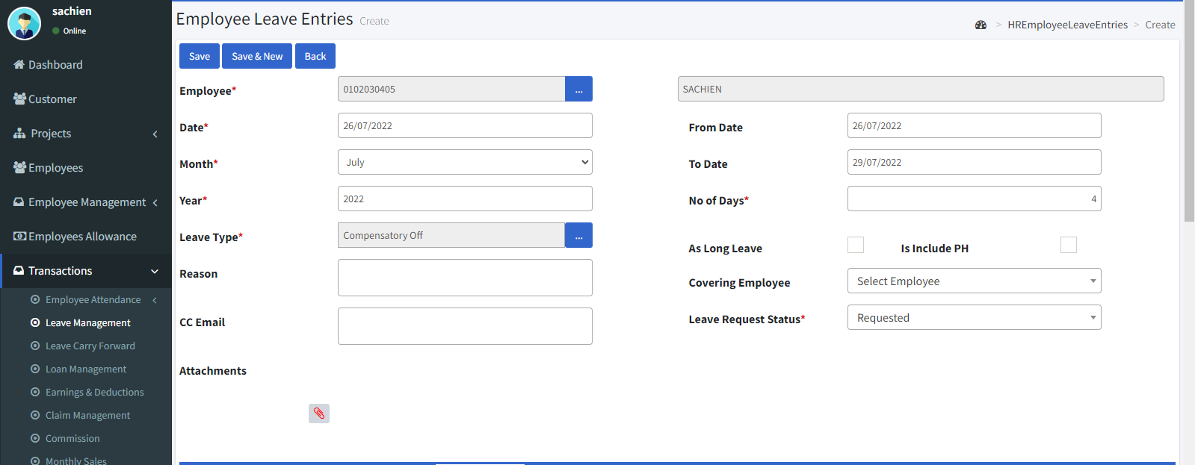

**Off in lieu:**

* Click the off in lieu.
* Then click the **“Create new”** button.

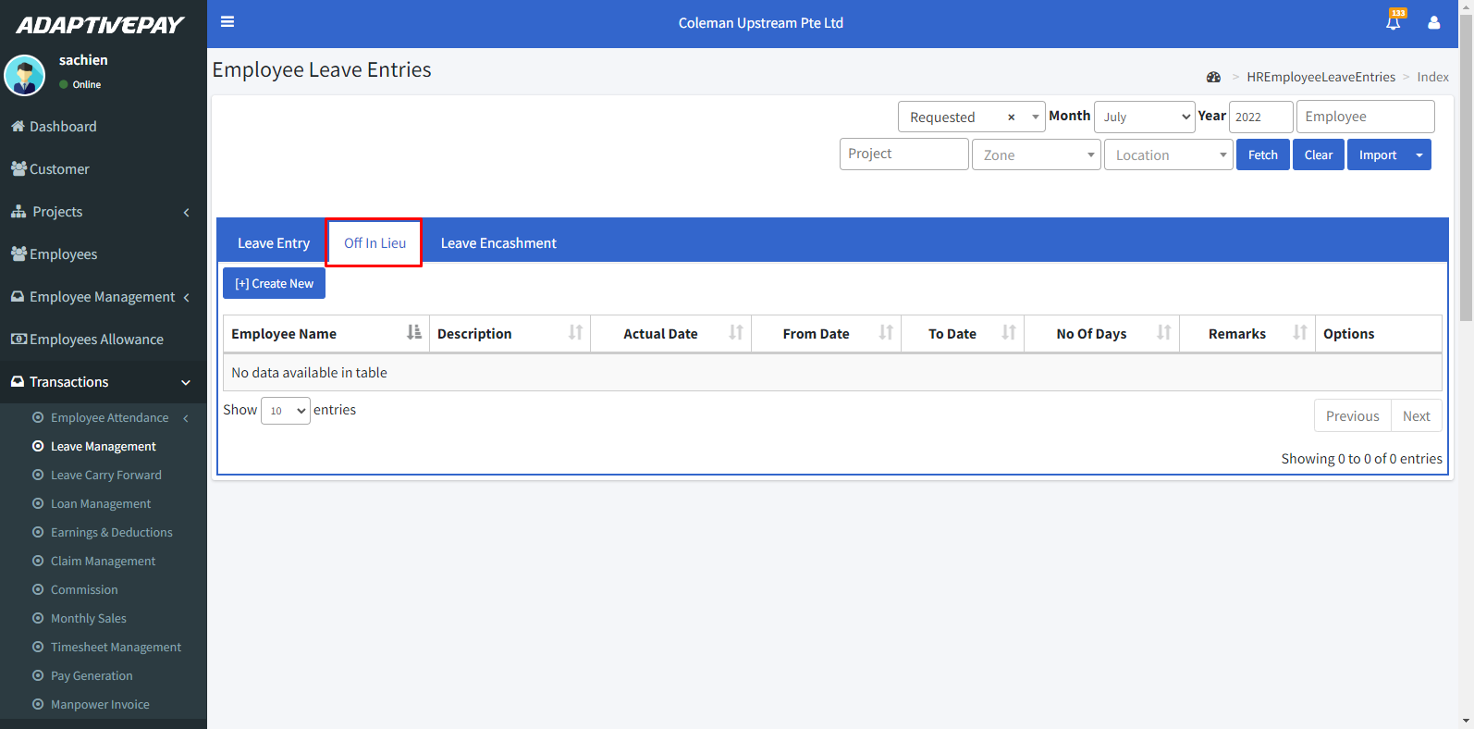

* Select the pay month and year.
* Select the employee.
* Enable the **Multiple employee** check box to add off in lieu for multiple employees.
* Enable the **Public holiday** check box if needed.
* Select the from date and to date.
* The no of days is automatically calculated by the system.
* Enable the **Add to extra leave** check box to add the off in lieu in leave type by clicking the drop-down.
* Then click the **save** button.

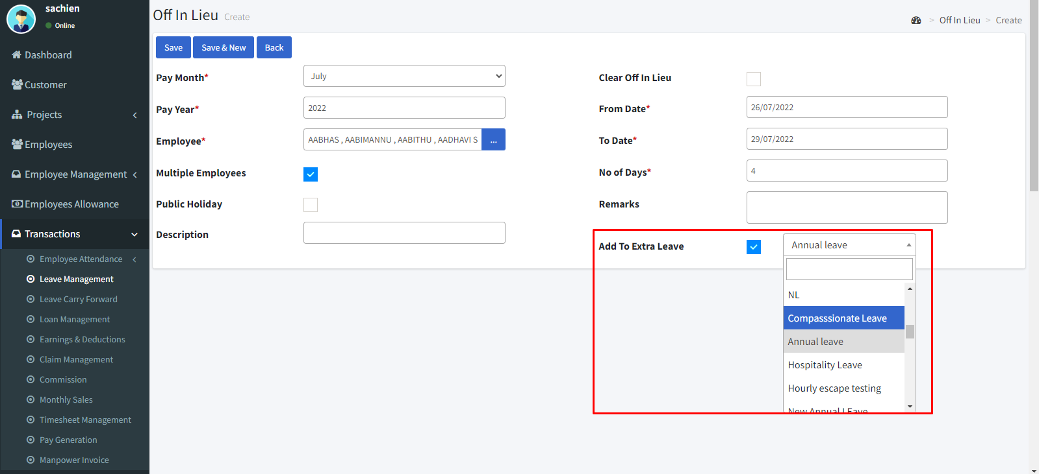

**Leave encashment:**

* Click the leave encashment.
* Then click the **“create new”** icon**.**

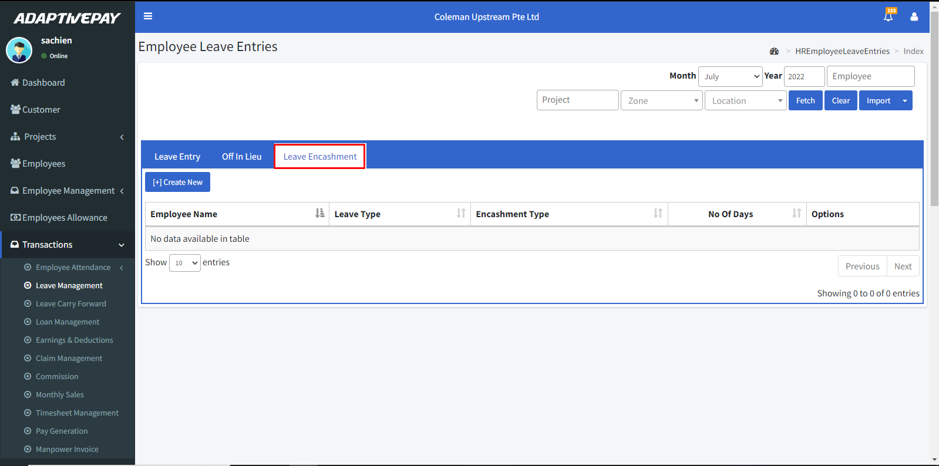

* Select the pay month and year.
* Select the employee and leave type.
* Select the leave month and year.
* The leave balance was shown automatically.
* Select the encashment type.
* Enter the from and to dates.
* Then click the **save** button.

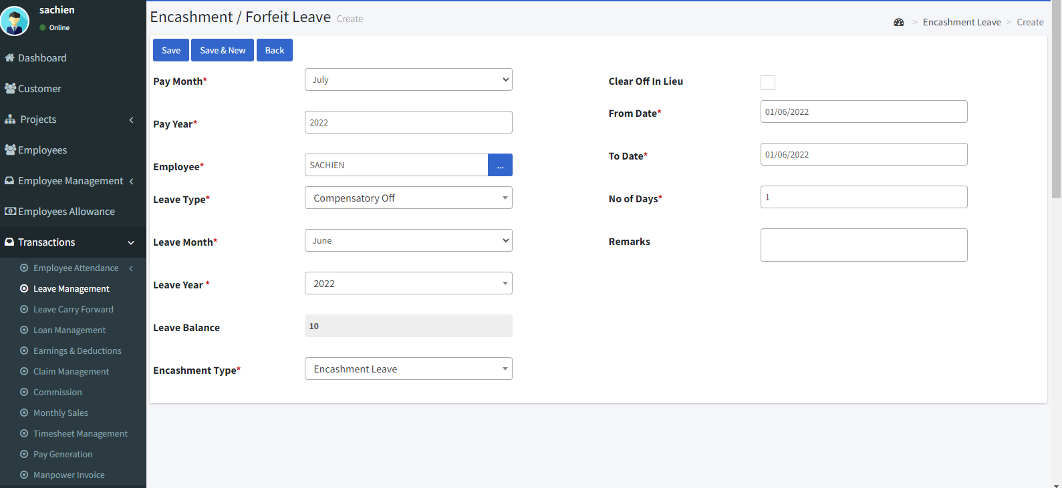

* By clicking the icon we can view the details.

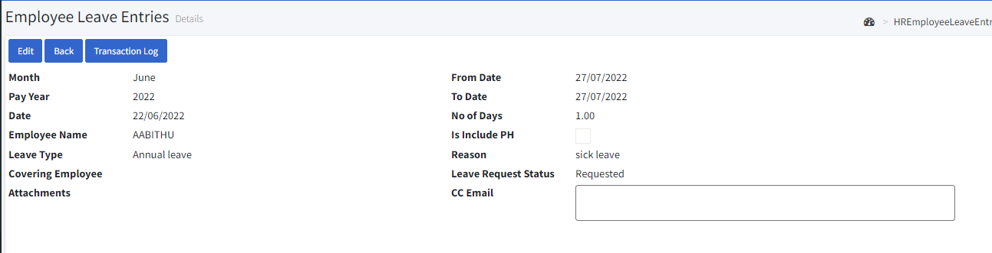

* By clicking the icon we can delete it.

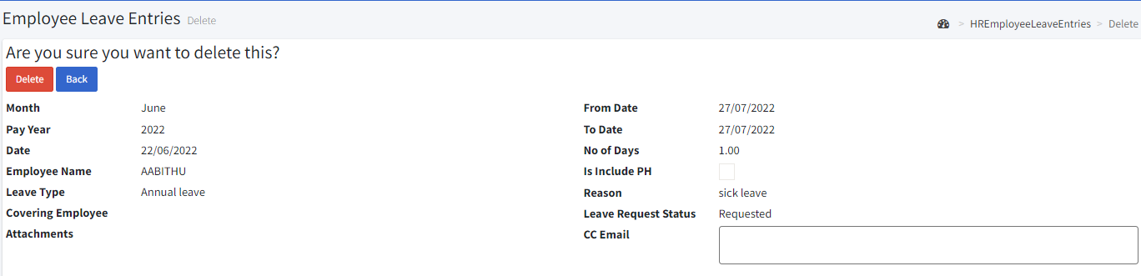

**11.3. Leave Carry Forward:**

* Go to transactions > Leave carry forward.
* We can view by basis of department, employee, leave type, zone, and location wise by selecting the drop-down and clicking the fetch icon.
* By clicking the **export** **excel** icon we can get a report in an excel format.
* By selecting an entry and clicking the **Complete** button the carry forward be processed.
* Click the **“Create new”** icon.

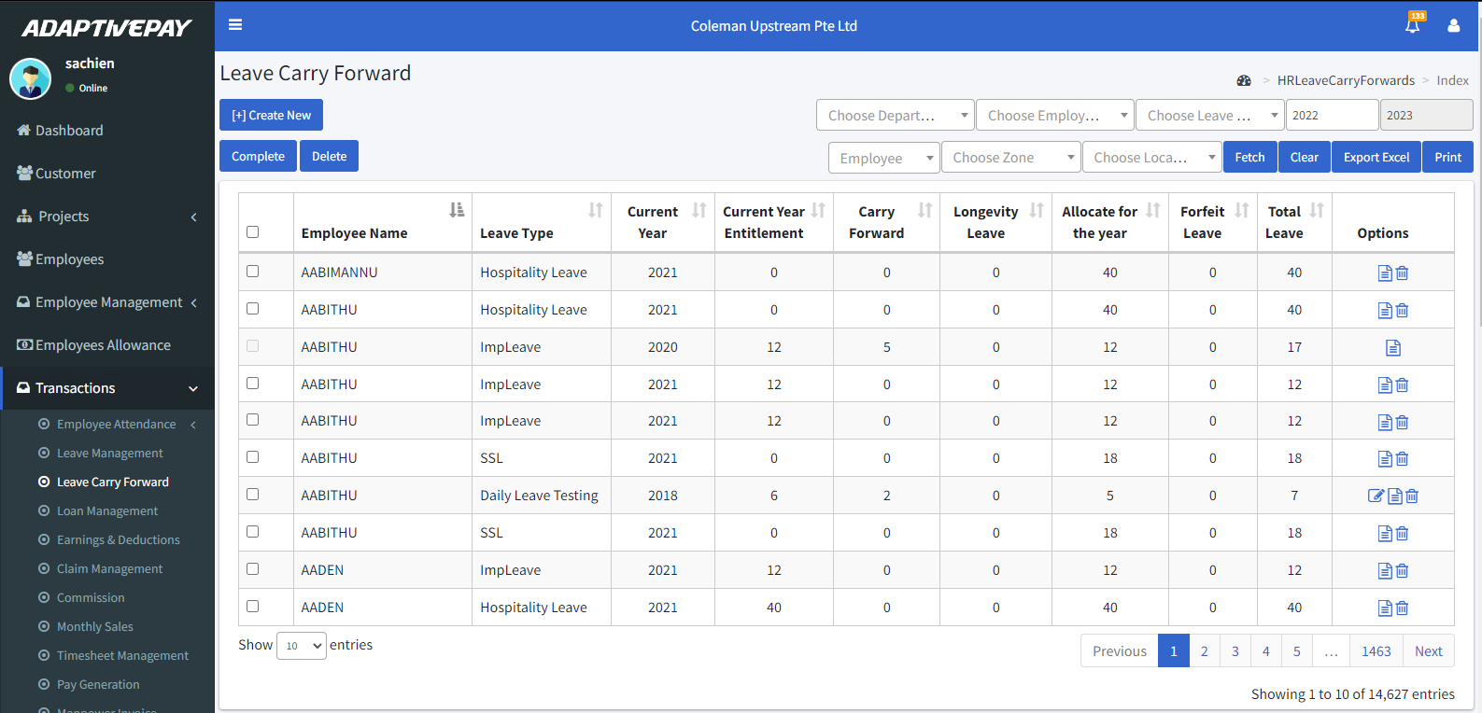

* Choose the department and employee type.
* Choose the employee and leave type.
* Enter the year.
* Then click the **fetch** icon.
* Then click the **save** icon.

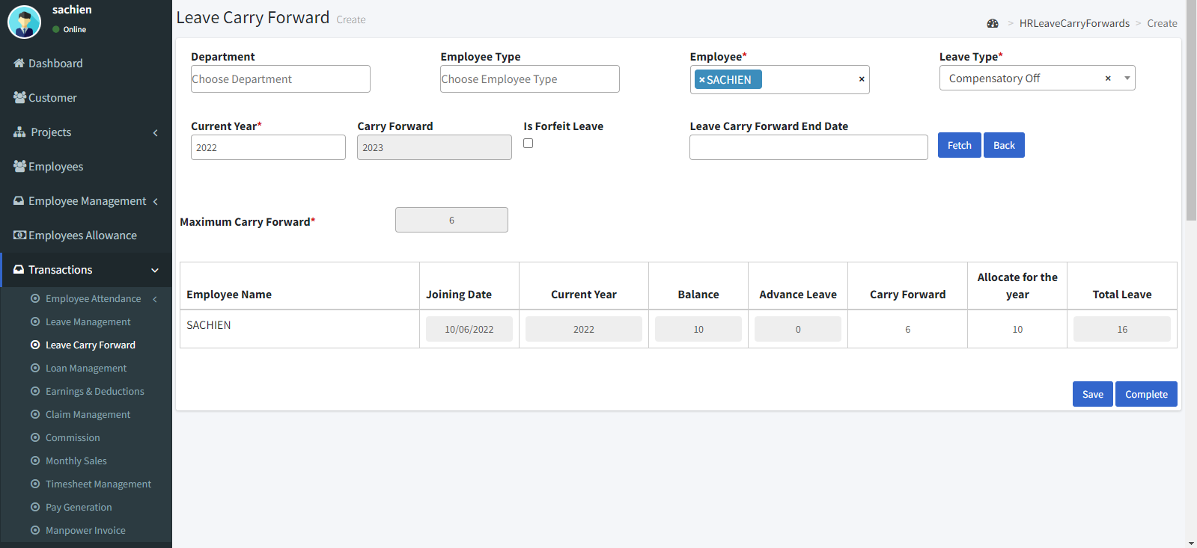

* By clicking the icon we can view the details.

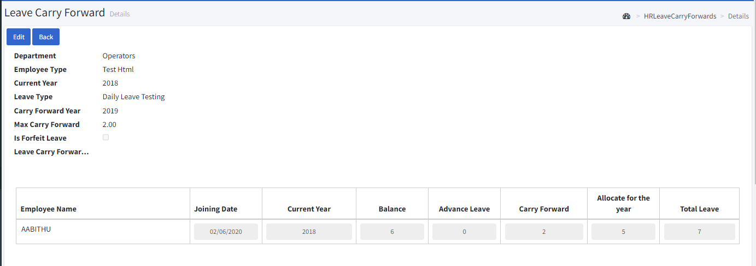

* By clicking the icon we can delete it.

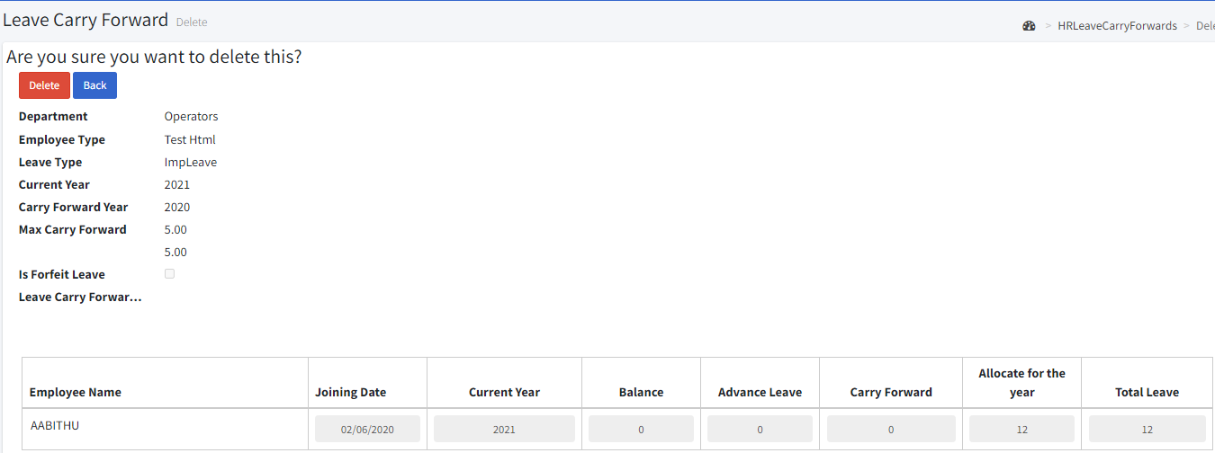

**11.4. Loan management:**

* Go to transactions 🡪 Loan management.
* You can use Month, Year, and Employee Name and Loan Type filters to narrow down the list. According to your filtering options the employee loan entries will be shown in the table.
* select any approved entry and click the pay icon to pay the loan.
* Click the “create new” icon.

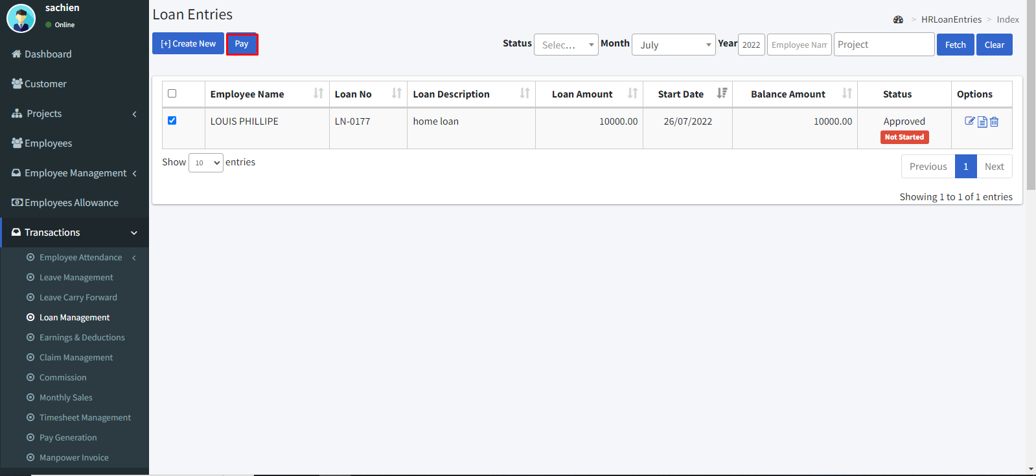

* Select Enter the employee.
* Select the loan code.
* Enter the loan amount.
* The balance amount will be shown automatically.
* Select the pay mode.
* Update the loan status.
* Then click the **“save & close”** icon**.**

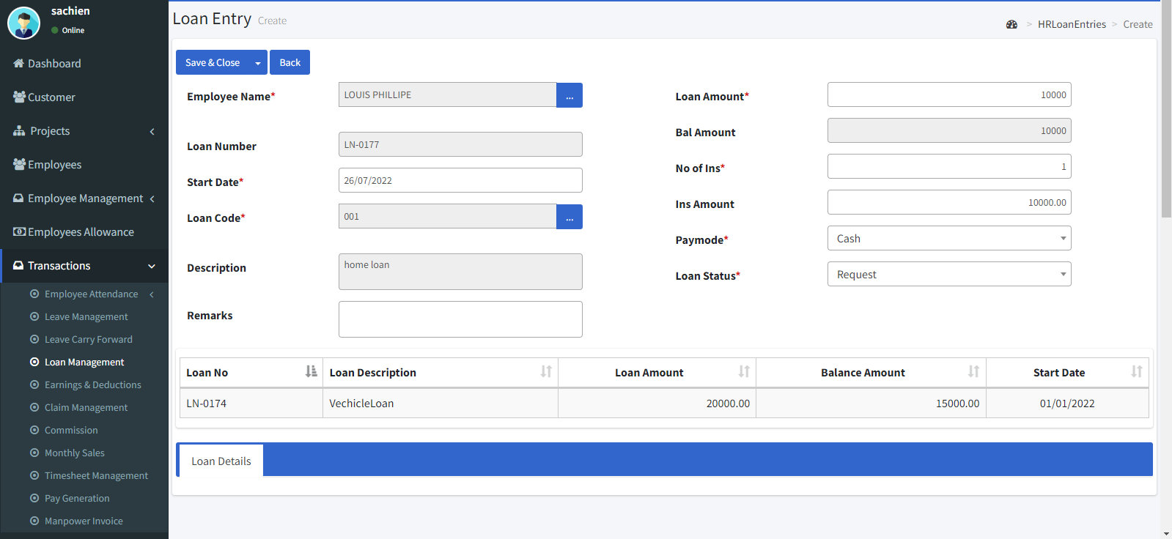

* By clicking the icon we can view the details.

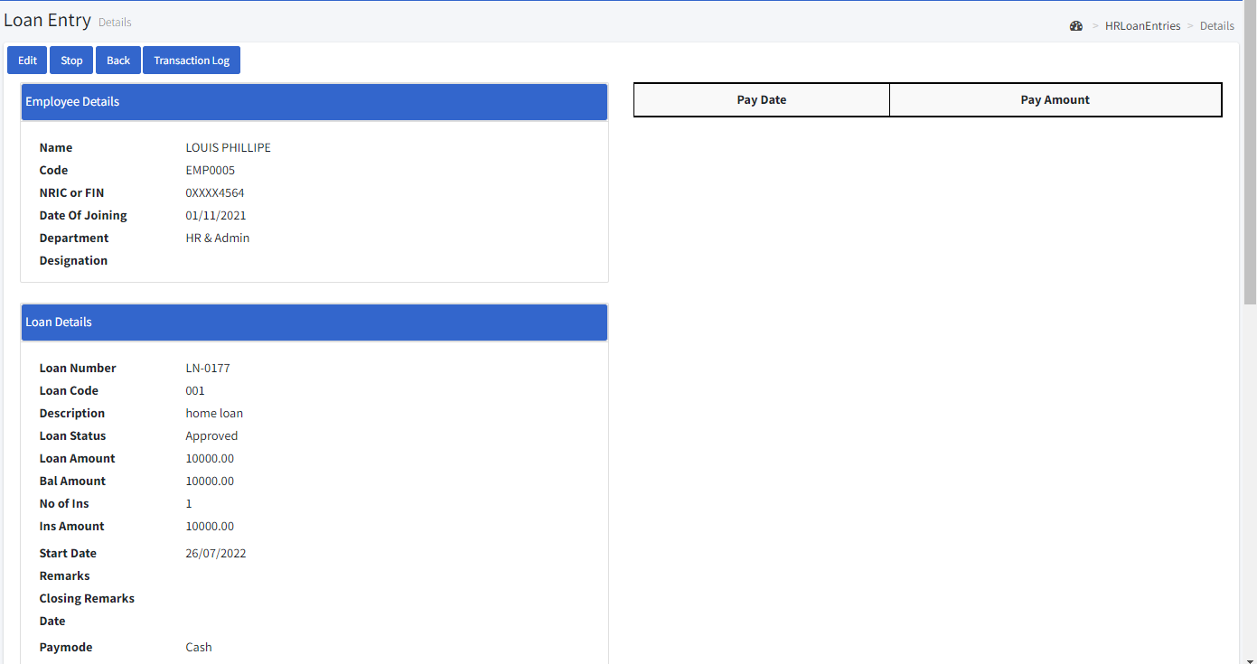

* By clicking the icon we can delete it.

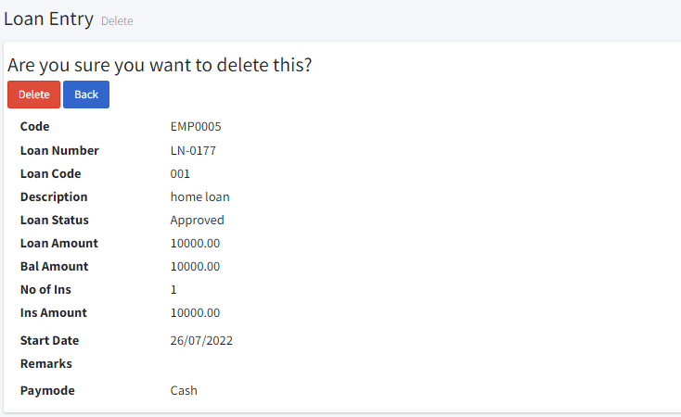

**11.5. Earnings and Deductions:**

* Go to transactions > Earnings & Deductions.
* You can use Month, Year, and Employee Name and Earning/Deduction Type filters to narrow down the list. According to your filtering options, the Earnings and Deductions entries will be shown in the table.
* To delete multiple entries, click the **multi delete** button.
* Click the **“create new”** icon.

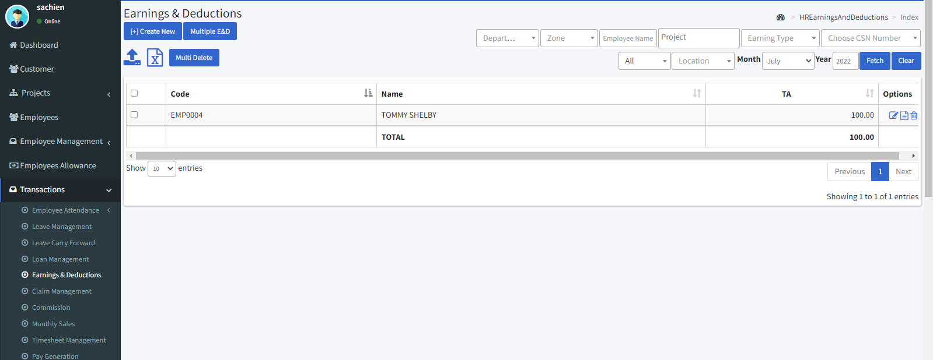

* Select the month.
* Select the employee name and enter the amount.
* Select the earning type.
* And click the **Add Detail** icon.
* Finally, click the **Save** button.

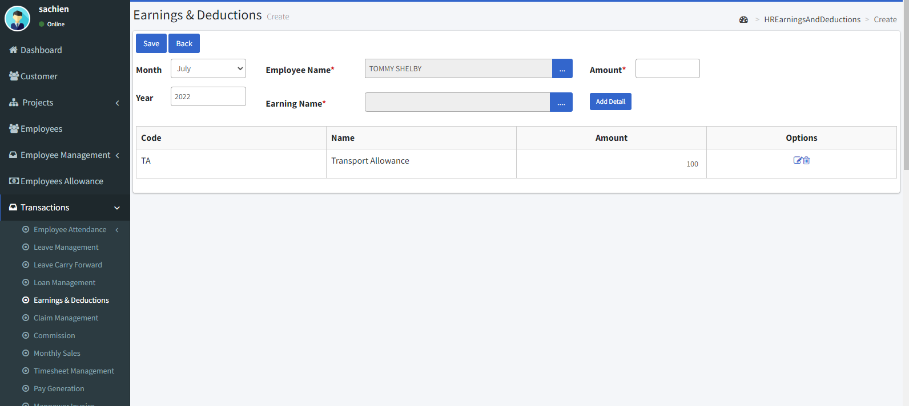

* By clicking the icon we can view the details.

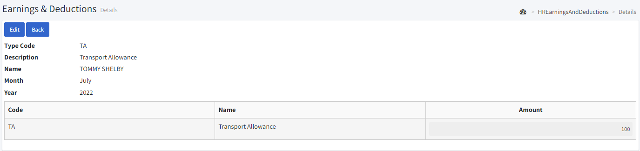

* By clicking the icon we can delete it.

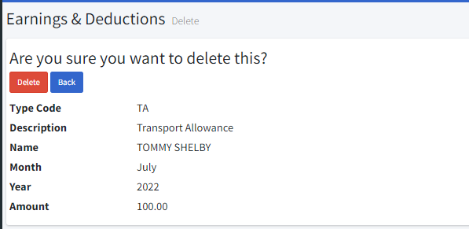

**11.6. Claim management:**

* Go to Transactions > Claim management.
* You can use Month, Year, and Employee Name and Claim Type filters to narrow down the list. According to your filtering options, the Claims entries will be shown in the table.
* Select any approved entry and click **pay** button to pay claim of the employee.
* Click **Excel** button to download a excel format file.
* Click **Print** button to print a hard copy.
* Click the “**create** **new**” icon.

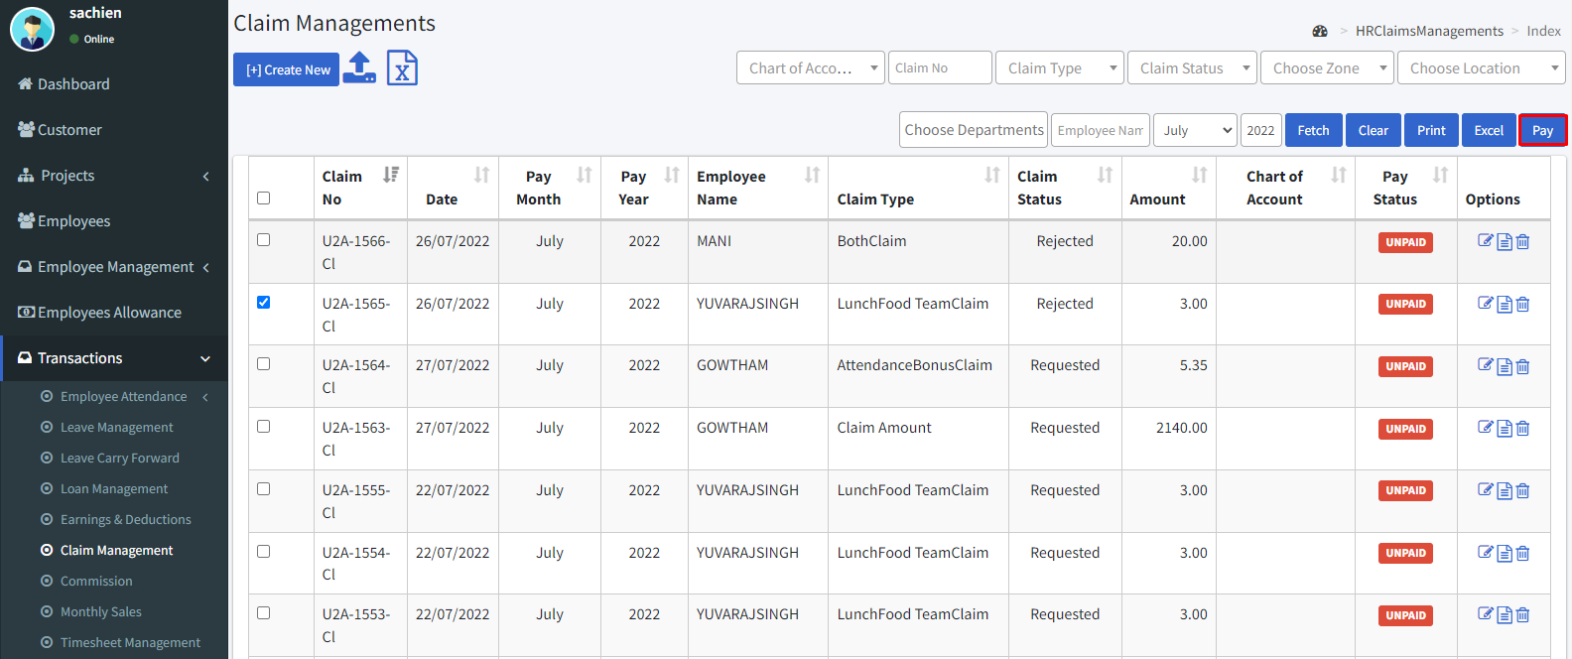

* Select the month, year, and date.
* Select the employee.
* Select the claim type.
* Enter the claim amount.
* Choose the project.
* Select the pay mode and if payment through bank means enter the bank name.
* Select the transaction type.
* Select the claim request status.
* Finally, click the save button.
* After approving the claim select the claim and click the pay button to pay the claim.

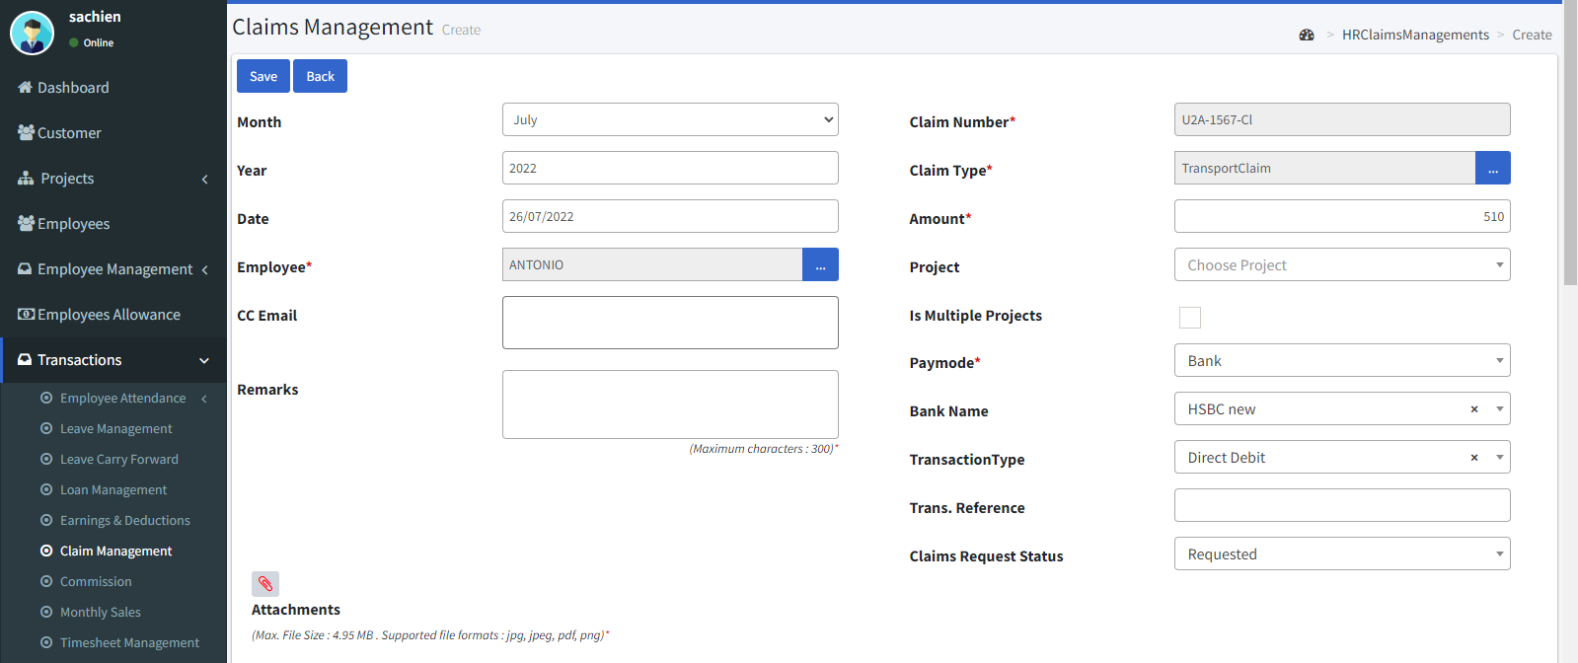

* By clicking the icon we can view the details.

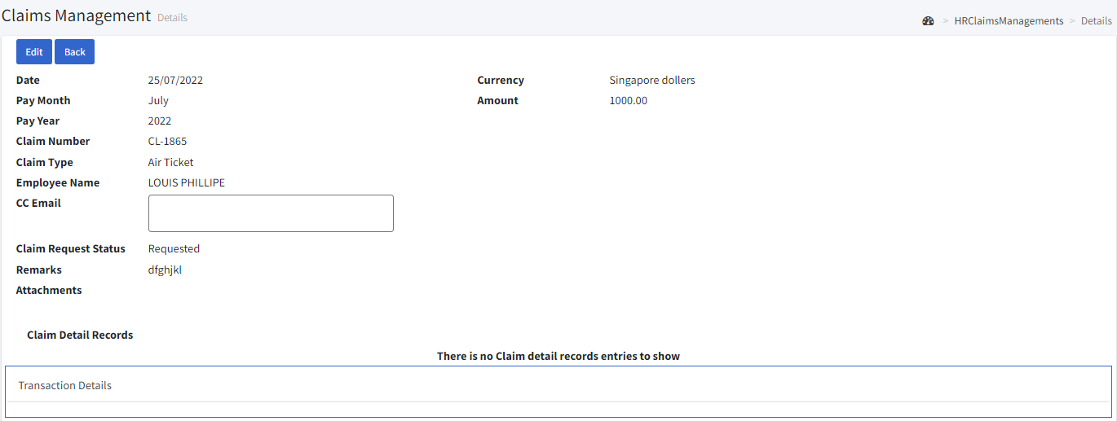

* By clicking the icon we can delete it.

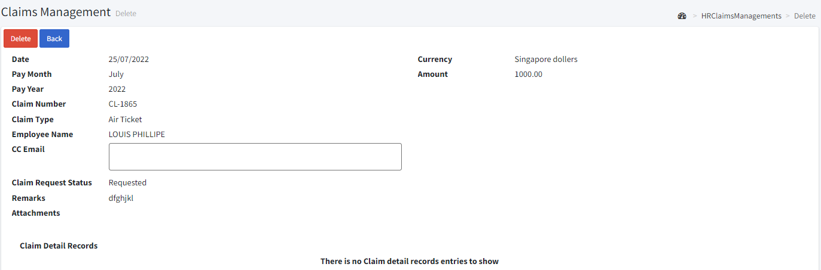

**11.7. Pay Generation:**

**Monthly employee**

* Go to transactions > Pay generation.
* You can use Month, Year and Employee Name, Pay Period and Department filters to narrow down the list.
* Before you generate the pay, you have to create all the attendance, leave, loan, earnings/deductions and claims for which month you want to generate the pay.
* If you want to generate for all the employees then just click **“Generate”** icon, else click on the carrousel dots to open the pop-up window like the following one for Employees.
* After selecting employees click the **Submit** icon.

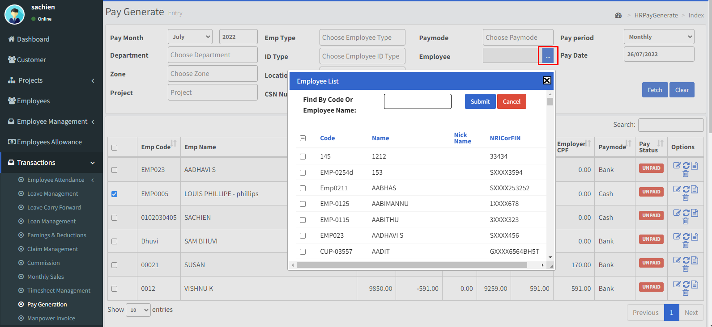

* Now click the **Generate** icon.
* If any of employees’ pay is generated already then there will be message indicating those employees are already generated. If there is any employee who are in daily / hourly pay basis then you must create attendance for him/her, otherwise you cannot create pay for him/her.
* Once the pay is generated all the generated pay will be shown in the table.
* Now if you want to edit any employee’s pay you may edit by clicking the edit icon.

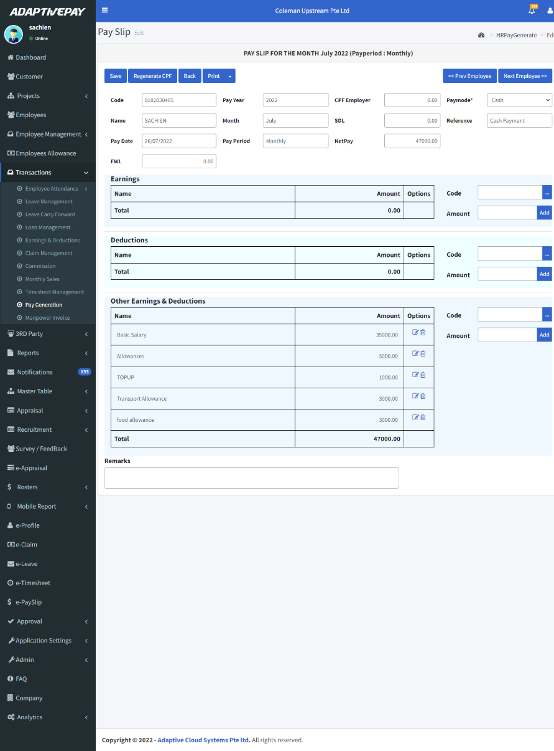

* Here you can also add, modify and delete any of the entries. Once you have changed any entry you need to save it. If you want to add any of the section’s entries just click the carrousel dots next to the section. You will see the following popup window

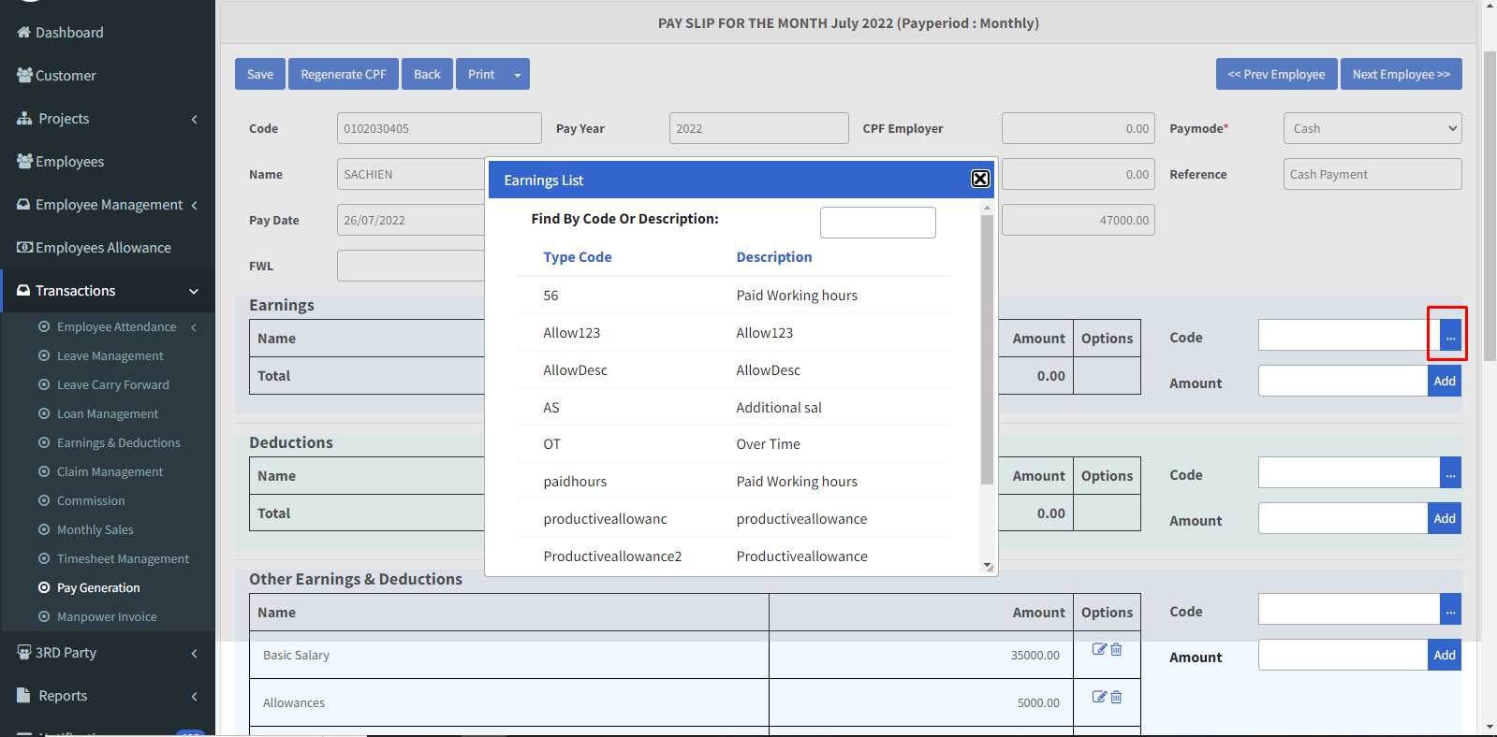

* Choose any earning/ deduction list and enter the amount click **Add**. Once you have changed any entry you need to it save. The difference between **Save** and **Regenerate CPF** is that saves save the modification in the sections, de, tails not to the header (Employer CPF, SDF and Net Pay) but Regenerate calculate the header part and saves.
* Finally, select the pay and click the down arrow in **Print Payslip** clickacknowledge, and then click pay to pay the employee**.**

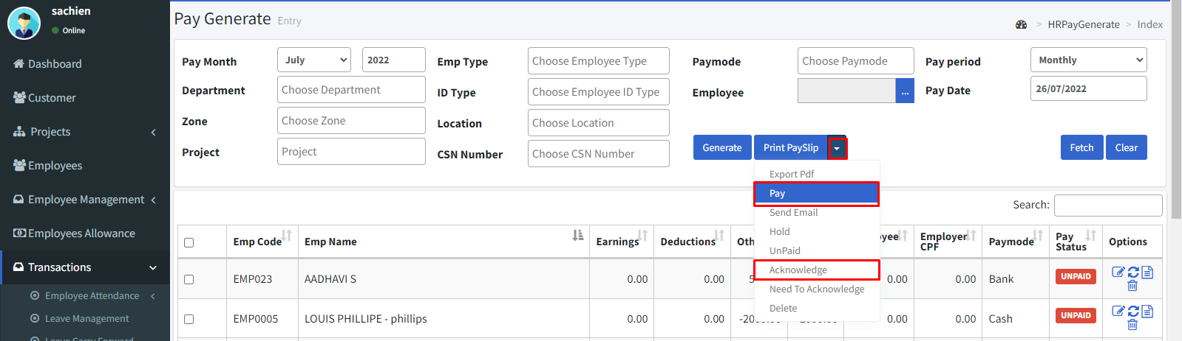

**Bi weekly employee**

* Select the pay period to first half or second half.
* Select the employee and then click the **Generate** button.

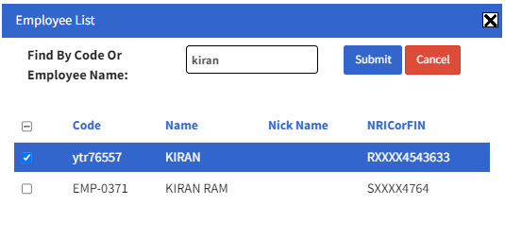

* Once the pay is generated all the generated pay will be shown in the table.

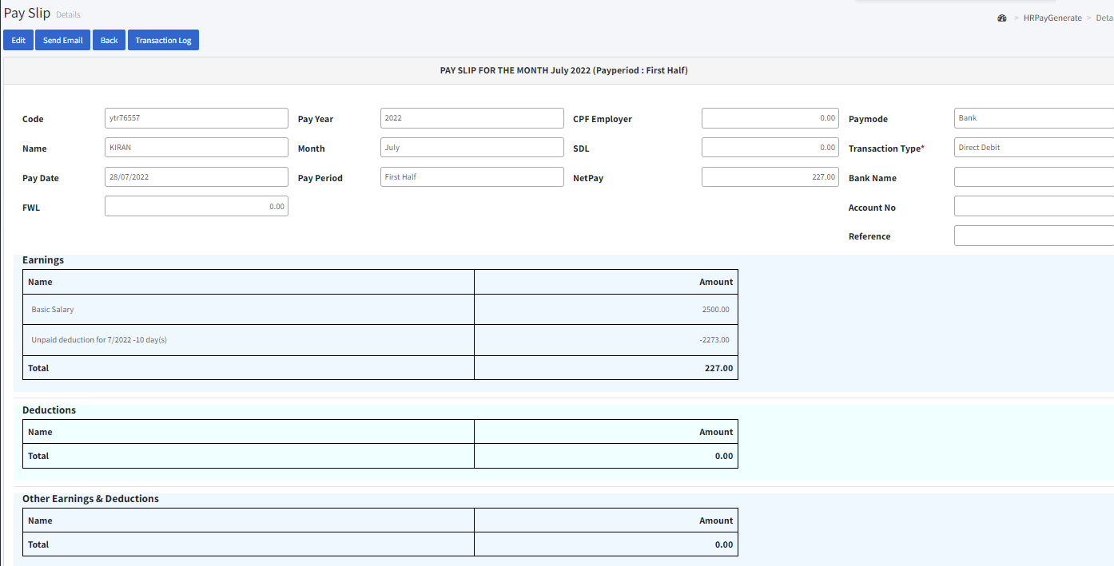

* Now if you want to edit any employee’s pay you may edit by clicking the edit icon.
* Here you can also add, modify and delete any of the entries. Once you have changed any entry you need to save it. If you want to add any of the section’s entries just click the carrousel dots next to the section. You will see the following popup window
* Choose any earning/ deduction list and enter the amount click **Add**. Once you have changed any entry you need to it save. The difference between **Save** and **Regenerate CPF** is that saves save the modification in the sections, de, tails not to the header (Employer CPF, SDF and Net Pay) but Regenerate calculate the header part and saves.
* Finally, select the pay and click the down arrow in **Print Pay slip** clickacknowledge, and then click pay to pay the employee**.**

**12. Admin**

**12.1. Users:**

* Go to Admin > Users.
* By clicking the **Export** button can able to print.
* Click the **“Create New”** icon to create a new user.

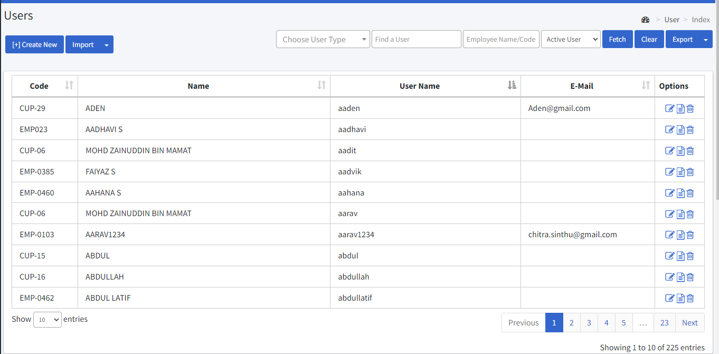

* You can use User type, user, employee name, and active user filters to narrow down the list.
* To insert a profile picture, click the **browse** icon or click the **remove** icon to remove the image.
* Enter the user name.
* Enter the email of the user.
* Create a strong password.
* Renter the password for confirmation.
* Choose the employee.
* Assign the user type either a web user, app user, or both user.
* Select the time zone.
* Enable the Is active check box if the user was active.
* Select the user group.
* Finally, click the **Create** button to create the user.

